Islamic Finance

Name:

Institution:

**Islamic Finance**

**What Islamic Finance Entails**

Islamic financing is also referred to as sharia compliant finance. It is the kind of financing or banking that abides by the sharia law (Islamic law). It operates under five modes. They include Mudarabah, Wadiah, Musharaka, Murabahah and Ijara (Ayub, 2013).

Mudarabah dwells on loss and profit bearing while Wadiah focuses on safekeeping. Musharaka digs on how the joint venture should work. Murabah focuses on cost plus while ijara deals with leasing. Islamic finance prohibits any form of interest paid on all money loans (Zubairi & Board of Islamic Publications, 2009). This is known as usury or riba. There is still some questions amongst mainly Muslim scholars of whether this is equivalent to some form of commission levied on the financing medium being offered or not. Investment in a business that provide goods or services that go against Islamic principles are branded as haram which means prohibited or sinful.

These vetoes have been applied through generations in varying degrees in various Muslim countries mostly to ensure non Islamic practices are not carried out. Towards the end of 20th century several Islamic banks applied to use these principles within the Islam fraternity. This figure has increased exponentially that by the year 2009, there were over 301 banks and over 250 mutual funds that had complied with Islamic principles (Ayub, 2013). The Shariah compliant financial institutions have grown and represent about 1% of total world assets. Mostly, these are found in the Gulf Cooperation Council (GCC) countries like Iran and Malaysia. The Sharia banking industry has been hailed for giving ‘celestial guidance’ in the rejection of governmental and commercial dominance of the Western countries. It is pegged on the promise of no inflation, no joblessness, no taking advantage and no insufficiency where it is carried out. The law has however been condemned for its failure to formulate a profit and loss distribution or more principled methods of investment but rather promoting banking products that comply with Islamic law and which use subterfuges and ruses to hide interest and pose bigger risks and higher costs that the conventional banks.

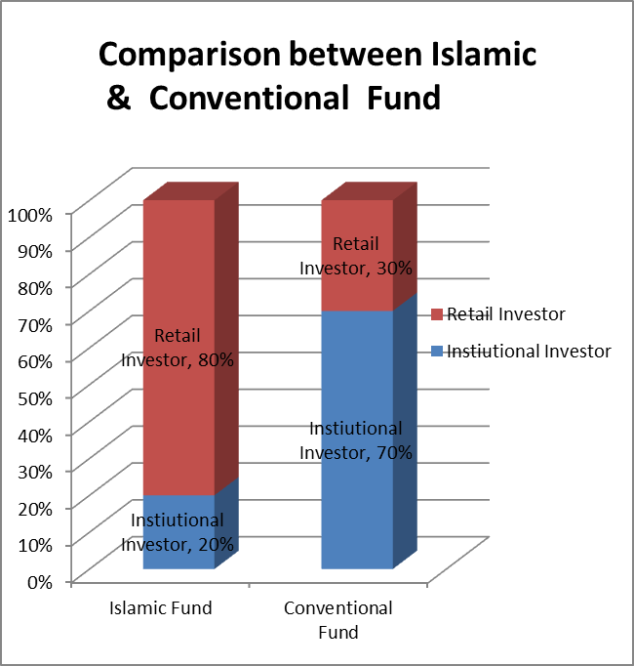

**Islamic Finance Products**

Islamic financial products are based on Islamic law (Sharia) and follow definite forms of contracts. The Sharia accommodating contracts do not bring about debt, accrue interest and ought to have a basis of sharing risk and accountability between the parties concerned. Below are some of the pacts deployed in Islamic finance. The products are broken down into contracts of partnership, contracts of exchange and contracts of safety and security

**Contract of Partnership**

**Mudaraba**

In this kind of contract, one party gives the other money that is invested in an economic activity or a business. The two parties share any profit that comes from the investment in accordance to an agreed ratio. If the investment fails, the investor is the one who loses the money. The fund administrator loses the value of the effort and time he had committed to the deal. The fund administrator however shoulders financial obligation in case the loss stems from his slackness.

**Musharaka**

It refers to a contract that involves a combined undertaking where both members offer entrepreneurial skills, investment capital and labor and then all share the loss or gain of the bustle.

**Contracts of Exchange**

It refers to sales agreements which allows for the transference of an article of trade for another article of trade. It may also involve transfer of money for money. It includes the following.

**Murabaha**

This is a cost plus kind of contract. In this scenario, an Islamic monetary body trades an article of trade to a purchaser taking into account the cost and the profit. Both parties happen to be aware of the fee and the profit before. Postponed costs are made by the buyer in this set up.

**Salam**

In this kind of contract, the purchaser, normally an Islamic commercial establishment, reimburses for goods in full and then they are provided in future.

**Istisna**

It is a form of forward sale agreement which permits an Islamic organization to purchase a venture that is going through a construction phase and that will be finished and conveyed on a future given date, on the purchaser’s behalf.

**Contracts of Safety and Security**

These kinds of contracts assist individuals and corporate clienteles preserve their funds safe.

**Wadia**

It involves a property holder giving assets to a different party for the resolve of upkeep. The Islamic current and savings account are founded on the wadia account.

**Hiwala**

In this set up, debt is moved from a borrower to another. Once it is moved, the first debtor becomes free from the obligation. It is the kind of contract employed by Islamic financial organizations to send cash between people.

**Kafala**

This set up involves accepting a prevailing compulsion and becoming accountable for accomplishing somebody’s liability by a third party.

**Rahn**

Involves pledging a property alongside a commitment. A surety or a pledge is offered by a customer through a Rahn contract so as to secure a financial liability.

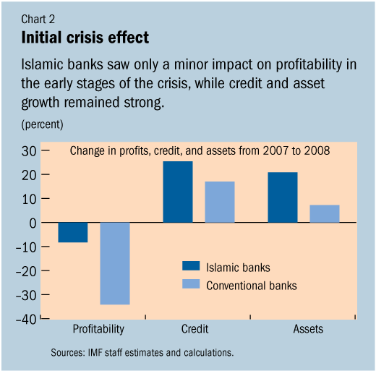

**Saudi Arabia, Egypt and Morocco and Their differences in Islamic Banking.**

In spite of the trend to have the Saudi Arabian banking market to convert to fully fledged sharia banking, there are only four of the 12 licensed banks that are pure Islamic banks (Visser, 2015).  They include Al-Rajhi bank, Al Jazeera bank, Al Bilad bank and Alinma bank. The two largest Islamic banks the Dar al Maal al Islami and Al Barak bank do not operate in Saudi Arabia. This is not withstanding that they are owned by prominent Saudis. Saudi Arabia does not recognize the concept of Islamic banking. The argument is that if some banks were regarded as Islamic, then the rest would be deemed anti-Islamic. The Saudi banks deliver corporate banking, investment services, brokerage services and derivative transactions (Visser, 2015). On top of this, it also has a flourishing stock market. The whole worth of shares transacted is in the figure f $16 billion. The Tadawul All share index (TASI) is the most capitalized stock exchange in the world. In this country, banking and investment is masterminded by a couple of government organizations. The finance ministry oversees economic strategies. The Saudi Arabian Monetary Association (SAMA) oversees economic policy and issues the Saudi legal tender, Riyal and also regulates the conventional banks. The state has also put five dedicated credit organizations that give loans to inhabitants for projects like construction, farming and the industries.

**Egypt**

Islamic financing in Egypt is modest at local, global and regional levels. This is mainly due to severe government controls and high manipulation over the legal, religious and economic institutions. This high control over the financial institutions is not only due to government hand but also the Islamic financial institutions that carry out practices that divert them from their intended goal. The government highly regulates the financial sector so as to maintain the stability of its economic system. It also does this to curb the links between the financial institutions and Islamist groups. Due to the severe legal and administrative measures taken on the banking institutions, they mostly play an Islamic role more than a developmental role.

**Morocco**

Morocco has for a long time rejected Islamic banking in the country and only warmed up to the idea in 2017. The rejection of Islamic banking was due to the concern of funding Islamic movements. The country has now set up new legislation, a sharia board and Islamic scholars to oversee the sector. Umnia bank has already opened up in the country.

**Luxembourg**

Luxembourg is not an Islamic country itself but it embraced Islamic finance way back in 1978. The country is now one of the leading European countries that have embraced Sharia banking and insurance. In 2002, the country listed Sukuk, a form of stock exchange means. The Luxembourg government has encouraged the Islamic financing in the country to a great deal. In 2008, the government set up a task force to identify obstacles that hindered the development of Islamic finance in the country (Karim & Archer, 2011). Among the recommendations was tax waiver for shariah compliant vehicles, the research into eligible assets for sharia compliant funds and the development of the best practice guidelines for financial services. In addition, there is also the formulation of guidelines for financial services and establishment of training courses through the Luxembourg Institute for Training in Banking (IFBL). The country is also the first one to become a member of the Islamic Financial Services board and is nowadays operating steadfastly to get know-how of supervisory training in this area. It is also pinpointing mechanisms, solutions and practices of how to manage liquidity in a sharia compliant manner (Karim & Archer, 2011).

Luxembourg takes the credit of experience of dealing with Islamic financing outside the Arab world and in dealing with a large client base. It has also established a well-defined legal framework that other countries that intend to implement the same can borrow from. It also boasts of clear guidelines on tax treatment for Islamic finance products. Lastly, it has a good political climate irrespective of the sharia banking as it has not created divisions.

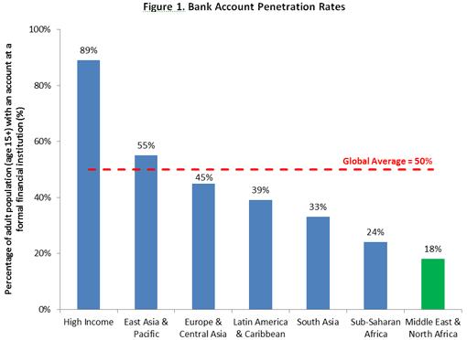

**Challenges Facing Sharia Banking**

Islamic banks are mainly under the authority of sharia boards who constitute of religious scholars. They are the one who dictate the laws to govern the system and if a product is sharia compliant (Visser, 2015). It is therefore difficult to understand what should be permitted as this varies depending on jurisdictions and Islamic scholars.

The increased growth of Islamic banking over the period of time has seen the introduction of complex structures and products and this now calls for sharia harmonization at a global event. This is clearly lacking currently. For instance, the Islamic contract of Tawwaruq or commodity Murabaha is only permitted by some particular scholars (Karim & Archer, 2011). Last year, a renowned Muslim scholar said that about 85% of Sukuks in the market fall short of the basic Sharia principles.

Most countries have a Central bank that spells out the approved regulatory standards that should be followed and this makes it easier for them to conduct operations in different markets (Karim & Archer, 2011). There is no approved sharia banking law that is applicable amongst different countries. As a result of prohibition of interest, the Sharia compliant banks have to employ and utilize funds through Sharia compliant instruments that are not normally used by the conventional banks.

**What Needs to be Done for the Industry to Succeed**

**Development of Separate Legal and Regulatory Framework.**

Countries like Oman, Bahrain and Malaysia have developed a distinct regulatory and legal framework that Islamic banks have to follow. A country like Qatar has separated Islamic banking from the conventional one (Karim & Archer, 2011). Turkey and United Arab Emirates have focused on supporting the Islamic banking industry in the meantime.

**Drive to Form Regulations to Govern Sharia Banking**

The Islamic Development Bank (IDB) has continued to implore countries to establish a global Sharia advisory board that will offer uniform regulations to govern the industry.

**How can the Industry be Pushed to Higher Levels**

The industry should lay emphasis on the expansion of products that nurture market amalgamation and that entice venture capitalists. There should also be a drive to push for harmonized products and services through putting a central board at the global level that is inclusive of all school of thoughts.

**Conclusion**

Islamic financing has been emulated by many countries other than those that practice largely the Muslim faith. They have moved from the traditional banking. However as countries adopt this financing model, they should go ahead and put proper legislations to govern the process. There should also be a move to form globally accepted rules that can be applied across board.

**References**

Ayub, M. (2013). *Understanding islamic finance*. Hoboken, N.J: Wiley.

Zubairi, S., & Board of Islamic Publications (New Delhi, India). (2009). *Islamic finance*. New Delhi: Markazi Maktaba Islami Publishers. Karim, R. A. A., & Archer, S. (2011).

Visser, H. (2015). *Islamic finance: Principles and practice*. Cheltenham: Edward Elgar.

*Islamic Finance*. Newark: Wiley.