Deliverable 1: percentile table based on # of total citations of an author in a particular scientific field.
Below is an example for a scientific field ‘material science’ – I want you to make the same table for 1) polymers & plastics 2) membrane science, and oil, petroleum, and natural gas
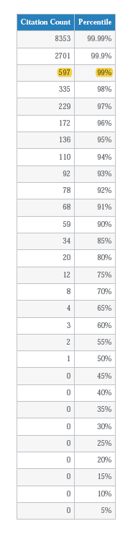

Deliverable 2: total citation analysis – exemplary analysis below shows Ms. Yihui Zhang is within the top 0.25% of authors published in the field of Material Science based on # of citations
I want you to make the same chart for 1) polymers & plastics 2) membrane science, and oil, petroleum, and natural gas

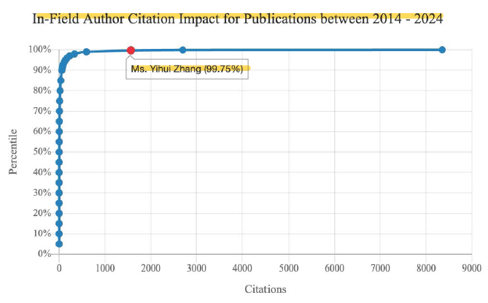

Deliverable 3: H-index analysis: the exemplary analysis below shows Mr. Hao Zeng is within the top 3% of authors publishing in Earth Science based on H-index
I want you to make the same chart for 1) polymers & plastics 2) membrane science, and oil, petroleum, and natural gas

