Assignment 1

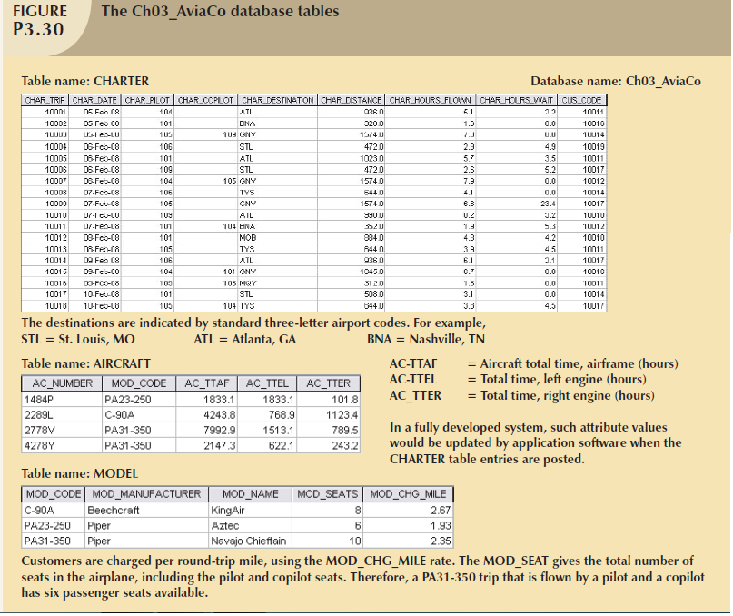

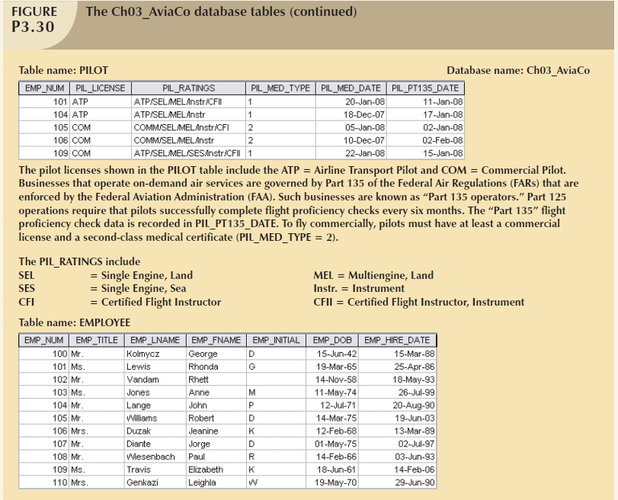

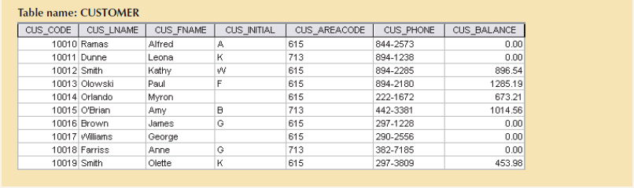

Use the database shown in the Figures above to answer the following Problems.

ROBCOR is an aircraft charter company that supplies on-demand charter flight services using a fleet of four aircraft. Aircrafts are identified by a unique registration number. Therefore, the aircraft registration number is an appropriate primary key for the AIRCRAFT table.

The nulls in the CHARTER table’s CHAR_COPILOT column indicate that a copilot is not required for some charter trips or for some aircraft.

Federal Aviation Administration (FAA) rules require a copilot on jet aircraft and on aircraft having a gross take-off weight over 12,500 pounds. None of the aircraft in the AIRCRAFT table are governed by this

requirement; however, some customers may require the presence of a copilot for insurance reasons. All charter trips are recorded in the CHARTER table.

1. For each table, where possible, identify:

a. The primary key.

b. A candidate key.

c. The foreign key(s).

2. Create the ERD. (*Hint*: Look at the table contents. You will discover that an AIRCRAFT can fly many CHARTER trips but that each CHARTER trip is flown by one AIRCRAFT, that a MODEL references many AIRCRAFT but that each AIRCRAFT references a single MODEL, etc.)

3. Modify the ERD you created in Problem 2 to eliminate the problems created by the use of synonyms. (*Hint*: Modify the CHARTER table structure by eliminating the CHAR_PILOT and CHAR_COPILOT attributes; then create a composite table named CREW to link the CHARTER and EMPLOYEE tables. Some crew members, such as flight attendants, may not be pilots. That’s why the EMPLOYEE table enters into this relationship.)

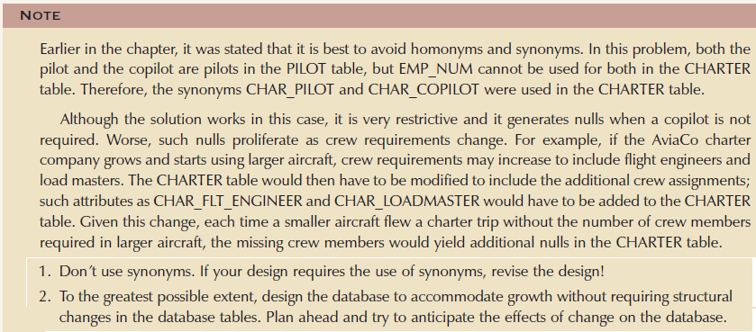

**homonyms** are similar-sounding words with different meanings, such as *boar* and *bore*, or identically spelled words with different meanings, such as *fair* (meaning “just”) and *fair* (meaning “festival”). In a database context, the word *homonym* indicates the use of the same attribute name to label different attributes. For example, you might use C_NAME to label a customer name attribute in a CUSTOMER table and also use C_NAME to label a consultant name attribute in a CONSULTANT table. To lessen confusion, you should avoid database homonyms.

In a database context, a **synonym** is the opposite of a homonym and indicates the use of different names to describe the same attribute. For example, *car* and *auto* refer to the same object. Synonyms must be avoided.