GP Individual Report: Basic Info and Structure

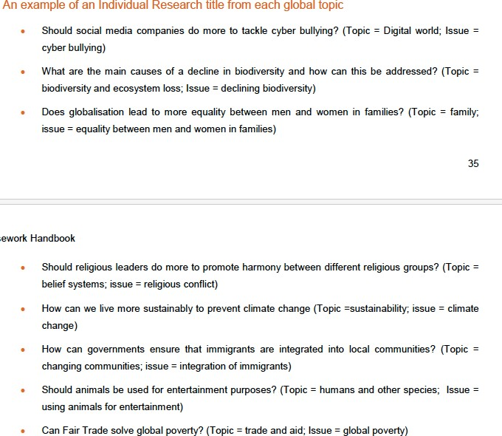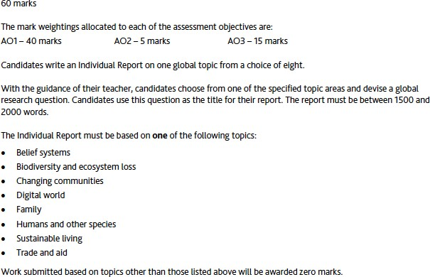

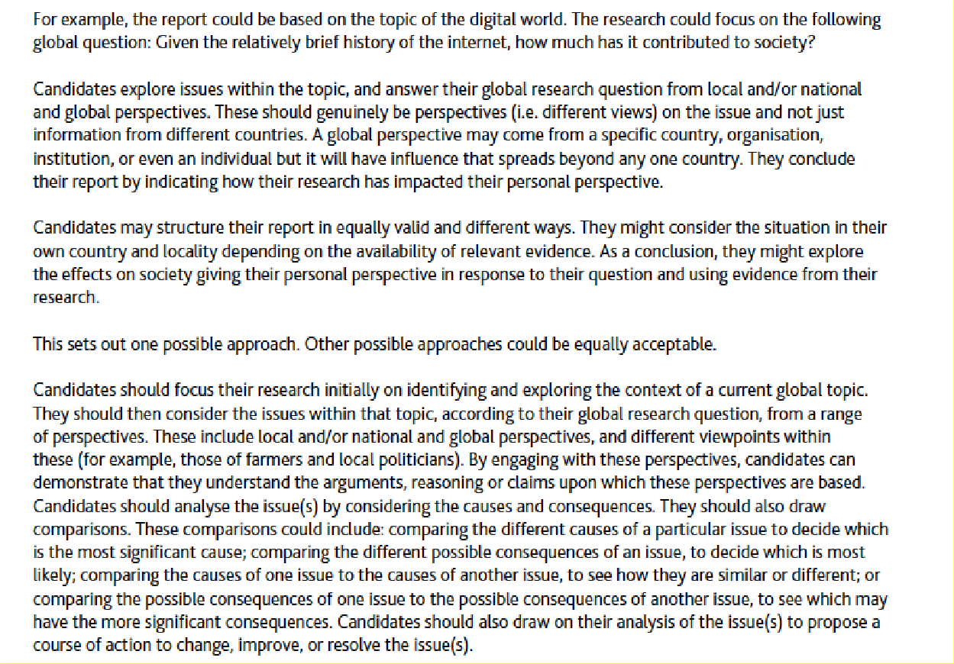

Below word limits are suggestive and can be altered. The sub-divisions of the structure are according to the Cambridge Guidelines

|  |  |  |
| --- | --- | --- |
| **Sub-**  **Section/Parts** | **Focus of the sub-section** | **Other details** |
|  |  |  |
| Question | You write the main question that you are exploring in the  Report | Centre Alignment |
|  | MAIN REPORT   * TIMES NEW ROMAN 12 * Justified * With bold sub-headings * YOU need to include references: To start with when you take an idea or definition or something from a source, then copy the link → click on References in the toolbar → Click insert foot note, paste the link where you are shown a   number at the bottom of the page: |  |

|  |  |  |
| --- | --- | --- |
|  | * CREATE a CLOUD DOCUMENT → Save it with YOUR NAME- title of the IR → Share it with me and give me edit rights |  |
| 1:Introduction to  the issue | In this section, you introduce the issue and also mention  the topic under which the question falls (one of the 8 topics).  Give the definition (in case your question has any technical terms – foreign trade or free trade or fair trade or sustainability – esports etc)  Reasons for selecting this issue- mention a personal experiences etc.  State what are you going to explore very clearly – for example – are you going to explore for  and against line of argument etc  Definition of Issue: A problem or a topic that causes disagreement, discussion or trouble between different people with different views. | 250 words approx |
| 2: Analysis of the  causes and consequences of the issue, with comparison | You should write about the causes and consequences of  the main issue.  You should explain and give examples and information about both causes and consequences.  You should include some comparison. | Can be divided in to two sub-  headings – Causes Consequences  Total words approx.- 300 |

|  |  |  |
| --- | --- | --- |
| 3:Analysis of the  issue from different perspectives | You should present different perspectives. At least one  global and one national.  These should be supported with explanation and information you have found about the issue.  **Include different viewpoints** within these (for example, those of farmers and local politicians)  **Definition: A viewpoint**: (In Global Perspectives: which is supported by explanation, examples and evidence.) | See the infographic in Part 2 for  clarification on difference perspectives  Total words Approx 700 |
| a.Personal | About you. Your own ideas or experience. Your own  reactions to things you have found out. |  |
| b. National | About one area or neighbourhood. (Usually in your own  town or city or an area nearby  **Include different viewpoints** within these (for example, those of farmers and local politicians) |  |
| c.Global | A view on an issue that has either global influence or  takes into account the nature of the issue globally.  For example, the UN’s view on climate change is a type of global issue OR the student should be able to explain why a perspective is global in nature. |  |
| 4: Course of  action to improve/resolve the issue | You should present a course of action that might solve  either the main issue, or the cause of the issue or some of the consequences of the issue.  You should give details of who might carry out the course of action and how it might be done and what effect it might have. | 200 words approx |
| 5: Evaluation of  sources of information OR | You should evaluate some of your sources. You must  make different points about them. | Total words approx. 300 |

|  |  |  |
| --- | --- | --- |
| Literature  Review | You will not be credited for repeating the same point  about different sources.  Some of the questions that can help you organise your Literature review are:   1. Is the source convincing? Why? 2. What is the perspective of the source on the issue? 3. How well does the source support the perspective or argument? 4. How useful is the source for the Individual Report? 5. Has the source provided new information and evidence to add to the argument? 6. Your Evaluation must include – whether the source included or not : biases, vested interests, prejudices etc. | Select any 3 sources for  evaluation. Could be a mix of articles from journals, e- newspapers like CNN, BBC etc,  Websites like National Geographic or Unrelated, documentaries etc, -  150 words for each source evaluation |
| 6: Conclusion | State your stand on the question à Starting sentence Summarise the report | The remaining words |
| 7:Reflection on how the research has influenced personal perspective | This is the space where you mention what you discovered on the issue as your researched.  Whether it changed your personal feeling or stand on the issue or simply strengthened your stand.  You can include what you learnt about research and writing etc.  **Reflection is:**  a form of personal response to experiences, situations, events or new information.  a 'processing' phase where thinking and learning take place. |
| **Part 2: Things to include in the Report** | | |
| 1 | The Report should be in your own words. So paraphrase it important points from an article rather than copy them. |  |

|  |  |  |
| --- | --- | --- |
|  | Citations in the form of footnotes.  Give a complete reference list in the end  Start writing. Remember you can always edit – add or delete later on on a soft copy.  Just start writing. |  |