# Randomized controlled trials of student-led social support for academic stress using recorded video podcasts versus voice messages according to Betty

**Neuman systems model**

Ogheneochuko Eburu1* , Brianna Beaujuin2, Sarinna Dommercant3, Montrice Darby5 , Diamond Wilson6 ,

1-8Helene Fuld College of Nursing, NY, USA

2Northwell Health, Manhasset, NY, USA

3Lenox Hill Hospital. New York, NY, USA 4Department of Education, Westchester, NY, USA 5Good Samaritan. West Islip, NY, USA

*Corresponding Author- Dr. Sandy Carollo

### Abstract

**Background:** Increasing numbers of nontraditional students are entering the nursing profession, and often, these same students must balance home, employment, and educational responsibilities. With the increase or change in responsibilities, the students face greater risks of maladaptive coping strategies (Kaur et al., 2020.). Students need an outlet, social support, to adequately manage academic stress they experience, and who better to do it than their peers going through it with them. It is important for students to recognize stressors that they may encounter.

**Method:** This study was conducted in randomized controlled trials to examine the comparison between student-led social support using recorded video podcasts versus WhatsApp voice messages from peers. The first group received 3 recorded video podcasts, and the second group had 3 recorded WhatsApp voice messages, following the topics outlined in the teaching plan.

**Results:** The results revealed that recorded video podcasts are better than recorded WhatsApp voice messages to improve stress management behaviors.

**Discussion:** Our participants have continued to improve for up to 4 days. This suggests that by trying to identify stressors while they occurred, and coping mechanisms through peer support, students-maintained stress management behaviors for themselves and fellow students.

**Conclusion:** Intervention is effective when it provides health education and promotes development of a certain mindset and coping strategies, for example, organization and/or time management and creating positive environments.

**Keywords:** nursing student stress, student-led support, academic stress, nursing school, randomized control trials

(Word count of the abstract: (234)

|  |  |  |
| --- | --- | --- |
| *Characteristics of Nursing Student Participants (n = 40)* |  | |
| **Demographical Factors** | ***n*** | **%** |
| Nursing Programs |  |  |
| Associate degree | 00 | 00.0 |
| Generic Bachelors’ degree | 46 | 100.0 |
| RN to Bachelors’ degree | 00 | 00.0 |

|  |  |  |  |
| --- | --- | --- | --- |
| Age (Years) | |  |  |
| 18 – 24 | | 04 | 1.8 |
| 25 – 34 | | 25 | 11.4 |
| 35 – 44 | | 09 | 33.3 |
| 45 – 54 | | 04 | 7.4 |
| ≥ 55 | | 02 | 3.7 |
|  | |  |  |
| Gender | |  |  |
|  | Male | 6 | 22.2 |
|  | Female | 21 | 77.8 |
|  | Other | 00 | 00.0 |
|  | Prefer not to say | 00 | 00.0 |
|  |  |  |  |
| Marital Status | |  |  |
| Single (never married) | | 12 | 44.4 |
| Married | | 08 | 28.6 |
| Domestic Partnership | | 03 | 11.1 |
| Divorced | | 04 | 14.8 |
| Ethnicity | |  |  |
| White | | 00 | 00.0 |
| Hispanic or Latino | | 02 | 7.4 |
| Black or African American | | 19 | 70.4 |
| American Indian or Alaskan Native | | 00 | 00.0 |
| Prefer not to say | | 01 | 3.7 |
| Native Hawaiian or Pacific Islander | | 00 | 00.0 |
| Other | | 05 | 18.5 |

### Background

Undergraduate nursing student stress is widely recognized, especially in the clinical setting (Kulland, 2014). With frequent changes and challenges in health care and technology, the clinical setting has the potential to become even more stressful (Kulland, 2014). Increasing numbers of nontraditional students are entering the nursing profession. Many of these adult students have work

and life experiences unrelated to the nursing field. Often, these same students must balance home, employment, and educational responsibilities. With the increase or change in responsibilities, the students face greater risks of maladaptive coping strategies (Kaur et al., 2020.). Students need an outlet, social support, to adequately manage academic stress they experience, and who better to do it than their peers going through it with them.

It is important for students to recognize stressors that they may encounter. Student stressors arose in the process of fulfilling didactic and clinical requirements (Kulland, 2014. This cannot be avoided. However, it is essential to find peer support during these times of multiple transitions (Salamonson et al., 2019).

### Method

This study will be conducted in randomized controlled trials to examine the comparison between student-led social support using recorded video podcasts versus WhatsApp voice messages from peers. Participants will be senior nursing students or students at their third-year level. They will be selected by convenience sampling after review and approval by the school’s research ethics committee. Based on sampling adequacy with sufficient statistical power, forty-six (46) participants will be needed out of one hundred and five (105) third-year nursing students in the GBS program.

Participants will be invited via email and WhatsApp and then randomly, they are split into intervention group (n = 20) and control group (n = 20). They will be able to access the consent for this study (available at <https://form.jotform.com/232847372728163>) along with the required information to fill out through a link in the invitation. A copy of the electronic consent form is posted on the appendix page. Anonymity will be ensured in the collection of data with strict adherence to the college’s ethical data protection, storage, and access guidelines. A separate link

will be given to each participant after the intervention to access the 12-item questionnaire (available at <https://forms.gle/7vvf8gQpmyyUvzTA7>) on 4th day and 8th day. Questionnaire items and subscales: “**Before my peers’ system can respond to any academic stressor**,” “**After my peers’ system has responded to an academic stressor**,” and “**After the academic stressor and the client’s system has been addressed**” are based on Betty Neuman systems model.

**Phase 1 (Recruitment of Study Participants and Gathering of Demographical Information)**. The inclusion criteria for recruitment are third year nursing students, while the exclusion criteria are anyone who is not a nursing student, not attending Helene Fuld College of Nursing, and who is not in their third year as a nursing student. Demographical information is collected.

**Phase 2 (Implementation of Student-led Support)**. First group will receive 3 recorded video podcasts (available at <https://youtu.be/yAbEGduRlac>, <https://youtu.be/A7J8pB4iXWw>, and

<https://youtu.be/MBeF1xCaevo>) and the second group will have 3 recorded WhatsApp voice messages (available at Student-led social support for academic stress AUDIO) following the topics outlined in the teaching plan (refer to last appendix page).

**Phase 3 (Postintervention Measurements and Group Comparison of Effects)**. Participants are required to complete posttest 1 (4 days after) and posttest 2 (8 days after) using the same online questionnaire. Both tests should take 40 minutes to complete (20 minutes each test). Descriptive statistics, Cronbach's alpha (α) and McDonald's omega (ω) calculations for reliability testing, confirmatory factor analysis, and independent samples *t*-test (between Posttest 1 and Posttest 2) to compare group scores will be performed in JASP (available at <https://jasp-stats.org/download/>).

**Expected Outcomes / Results:** For **primary outcome**, it is anticipated that after the intervention, participants will have an increase appraisal about stress management for the self and fellow students in both groups. For **secondary outcome**, participants will continue to improve up to 4 days. This may suggest that by trying to identify stressors while it’s occurring and coping

mechanisms through peer support, students can maintain stress management behaviors for themselves and fellow students.

### Results

*Statistical Test were performed by using JASP.*

For **primary outcome**, it is anticipated that after the intervention, participants will have an increase appraisal about stress management for the self and fellow students in both groups. For **secondary outcome**, participants will continue to improve up to 4 days. This may suggest that by trying to identify stressors while it’s occurring and coping mechanisms through peer support, students can maintain stress management behaviors for themselves and fellow students.

**Confirmatory Factor Analysis**

### Confirmatory Factor Analysis

A confirmatory factor analysis (CFA) was conducted at the pretest to test the 12 items **“Randomized controlled trials of student-led stress using recorded video podcasts versus voice messages according to Betty Neuman systems model**” based on a Before my peers’ system can respond/ After my peer’s system has responded/ After the academic stressor and the client’s system has been addressed, single-order, multidimensional model. In Table 2, factor loadings ranged between 0.771 and 0.832 on Factor 1/Subscale: “**Before my peers’ system can respond**,” between 0.681 and 0.751 on Factor 2/Subscale: “**After my peers’ system has responded to an academic stressor**,” and between 0.620 and 0.739 on Factor 3/Subscale: “**After the academic stressor and the client’s system has been addressed**”. All factor loadings were above the .50 threshold (Liao, Huang, & Wang, 2022).

CFA Model fit was assessed with 506.285 estimation for exact fit by chi-square index (χ2) and approximate fit by standard root mean square residual (SRMR), root mean square error of approximation (RMSEA), comparative fit index (CFI), and Tucker–Lewis index (TLI). Specifically, exact fit was statistically nonsignificant, χ2 (*df*) = 137.960, *p* < .001 indicating a poor model fit. SRMR 0.080 was acceptable based on the recommended value of <.08. RMSEA

0.206 (90% CI 0.165, 0.248] was over the acceptable range of .05 to .08. CFI 0.802 was below the .95 cutoff. TLI 0.744 was below the .90 cutoff. (Liao, Huang, & Wang, 2022; Li, Huang, & Feng, 2020).

Model fit

|  |  |  |  |
| --- | --- | --- | --- |
| **Chi-square test** |  |  |  |
| **Model** | **Χ²** | **df** | **p** |
| Baseline model | 506.285 | 66 |  |
| Factor model | 137.960 | 51 | < .001 |
| *Note.* The estimator is ML. | | |  |

*Additional fit measures*

|  |  |
| --- | --- |
| **Fit indices** |  |
| **Index** | **Value** |
| Comparative Fit Index (CFI) | 0.802 |
| Tucker-Lewis Index (TLI) | 0.744 |
| Bentler-Bonett Non-normed Fit Index (NNFI) | 0.744 |
| Bentler-Bonett Normed Fit Index (NFI) | 0.728 |
| Parsimony Normed Fit Index (PNFI) | 0.562 |
| Bollen's Relative Fit Index (RFI) | 0.647 |
| Bollen's Incremental Fit Index (IFI) | 0.809 |
| Relative Noncentrality Index (RNI) | 0.802 |

|  |  |
| --- | --- |
| **Information criteria** |  |
|  | **Value** |
| Log-likelihood | -430.242 |
| Number of free parameters | 39.000 |
| Akaike (AIC) | 938.484 |
| Bayesian (BIC) | 1004.350 |
| Sample-size adjusted Bayesian (SSABIC) | 882.309 |

|  |  |
| --- | --- |
| **Other fit measures** |  |
| **Metric** | **Value** |
| Root mean square error of approximation (RMSEA) | 0.206 |
| RMSEA 90% CI lower bound | 0.165 |
| RMSEA 90% CI upper bound | 0.248 |
| RMSEA p-value | 2.717×10-8 |
| Standardized root mean square residual (SRMR) | 0.080 |
| Hoelter's critical N (α = .05) | 20.910 |
| Hoelter's critical N (α = .01) | 23.437 |
| Goodness of fit index (GFI) | 0.908 |
| McDonald fit index (MFI) | 0.337 |
| Expected cross validation index (ECVI) | 5.399 |

|  |  |
| --- | --- |
| **Kaiser-Meyer-Olkin (KMO) test** | |
| **Indicator** | **MSA** |
| Prettest_Q1 | 0.893 |
| Prettest_Q2 | 0.816 |
| Prettest_Q3 | 0.800 |
| Prettest_Q4 | 0.813 |

|  |  |
| --- | --- |
| **Kaiser-Meyer-Olkin (KMO) test** | |
| **Indicator** | **MSA** |
| Prettest_Q5 | 0.797 |
| Prettest_Q6 | 0.718 |
| Prettest_Q7 | 0.740 |
| Prettest_Q8 | 0.849 |
| Prettest_Q9 | 0.851 |
| Prettest_Q10 | 0.882 |
| Prettest_Q11 | 0.782 |
| Prettest_Q12 | 0.803 |
| Overall | 0.811 |

|  |  |  |
| --- | --- | --- |
| **Bartlett's test of sphericity** | | |
| **Χ²** | **df** | **p** |
| 432.452 | 66 | < .001 |

|  |  |
| --- | --- |
| **R-Squared** |  |
|  | **R²** |
| Prettest_Q1 | 0.710 |
| Prettest_Q2 | 0.602 |
| Prettest_Q3 | 0.634 |
| Prettest_Q4 | 0.687 |
| Prettest_Q5 | 0.666 |
| Prettest_Q6 | 0.732 |
| Prettest_Q7 | 0.688 |
| Prettest_Q8 | 0.699 |
| Prettest_Q9 | 0.752 |

|  |  |
| --- | --- |
| **R-Squared** |  |
|  | **R²** |
| Prettest_Q10 | 0.761 |
| Prettest_Q11 | 0.810 |
| Prettest_Q12 | 0.733 |

Parameter estimates

|  |  |  |  |  |  |  |  |  |
| --- | --- | --- | --- | --- | --- | --- | --- | --- |
| **Factor loadings** |  |  |  |  |  |  |  |  |
| **95% Confidence Interval** | | | | | | | | |
| **Factor** | **Indicator** | **Estimate** | **Std. Error** | **z- value** | **p** | **Lower** | **Upper** | **Std. Est. (all)** |
| Before my peers' system can respond to any academic stressor | Prettest_Q1 | 0.832 | 0.130 | 6.403 | < .001 | 0.577 | 1.086 | 0.842 |
|  | Prettest_Q2 | 0.804 | 0.143 | 5.622 | < .001 | 0.524 | 1.085 | 0.776 |
|  | Prettest_Q3 | 0.771 | 0.132 | 5.859 | < .001 | 0.513 | 1.029 | 0.796 |
|  | Prettest_Q4 | 0.795 | 0.128 | 6.224 | < .001 | 0.544 | 1.045 | 0.829 |
| After my peers' system has responded to an academic stressor | Prettest_Q5 | 0.751 | 0.128 | 5.881 | < .001 | 0.501 | 1.002 | 0.816 |
|  | Prettest_Q6 | 0.741 | 0.115 | 6.431 | < .001 | 0.515 | 0.966 | 0.855 |
|  | Prettest_Q7 | 0.681 | 0.112 | 6.077 | < .001 | 0.461 | 0.901 | 0.829 |
|  | Prettest_Q8 | 0.658 | 0.107 | 6.142 | < .001 | 0.448 | 0.868 | 0.836 |
| After the academic stressor and the client's system has been addressed | Prettest_Q9 | 0.712 | 0.105 | 6.754 | < .001 | 0.505 | 0.919 | 0.867 |
|  | Prettest_Q10 | 0.689 | 0.101 | 6.841 | < .001 | 0.492 | 0.887 | 0.872 |
|  | Prettest_Q11 | 0.739 | 0.102 | 7.228 | < .001 | 0.539 | 0.940 | 0.900 |
|  | Prettest_Q12 | 0.620 | 0.093 | 6.660 | < .001 | 0.438 | 0.803 | 0.856 |

|  |  |  |  |  |  |  |  |
| --- | --- | --- | --- | --- | --- | --- | --- |
| **Factor variances** |  |  |  |  |  |  |  |
| **95% Confidence Interval** | | | | | | | |
| **Factor** | **Estimate** | **Std. Error** | **z- value** | **p** | **Lower** | **Upper** | **Std. Est. (all)** |
| Before my peers' system can respond to any academic stressor | 1.000 | 0.000 |  |  | 1.000 | 1.000 | 1.000 |
| After my peers' system has responded to an academic stressor | 1.000 | 0.000 |  |  | 1.000 | 1.000 | 1.000 |
| After the academic stressor and the client's system has been addressed | 1.000 | 0.000 |  |  | 1.000 | 1.000 | 1.000 |

|  |  |  |  |  |  |  |  |  |  |
| --- | --- | --- | --- | --- | --- | --- | --- | --- | --- |
| **Factor Covariances** |  |  |  |  |  |  |  |  |  |
| **95%**  **Confidence Interval** | | | | | | | | | |
|  |  | **Estimate** | | **Std. Error** | **z- value** | **p** | **Lower** | **Upper** | **Std. Est. (all)** |
| Before my peers'  system can respond to any academic stressor | ↔ | After my peers' system has responded to an academic stressor | 0.773 | 0.084 | 9.188 | < .001 | 0.608 | 0.938 | 0.773 |
| Before my peers'  system can respond to any academic stressor | ↔ | After the academic  stressor and the client's system has been  addressed | 0.792 | 0.081 | 9.803 | < .001 | 0.633 | 0.950 | 0.792 |
| After my peers' system has  responded to an academic stressor | ↔ | After the academic  stressor and the client's system has been  addressed | 0.698 | 0.101 | 6.886 | < .001 | 0.499 | 0.896 | 0.698 |

|  |  |  |  |  |  |  |  |
| --- | --- | --- | --- | --- | --- | --- | --- |
| **Residual variances** | | | | | | | |
| **95% Confidence Interval** | | | | | | | |
| **Indicator** | **Estimate** | **Std. Error** | **z-value** | **p** | **Lower** | **Upper** | **Std. Est. (all)** |
| Prettest_Q1 | 0.283 | 0.085 | 3.338 | < .001 | 0.117 | 0.449 | 0.290 |
| Prettest_Q2 | 0.428 | 0.116 | 3.680 | < .001 | 0.200 | 0.655 | 0.398 |
| Prettest_Q3 | 0.343 | 0.095 | 3.613 | < .001 | 0.157 | 0.529 | 0.366 |
| Prettest_Q4 | 0.288 | 0.085 | 3.395 | < .001 | 0.122 | 0.454 | 0.313 |
| Prettest_Q5 | 0.283 | 0.095 | 2.986 | 0.003 | 0.097 | 0.468 | 0.334 |
| Prettest_Q6 | 0.201 | 0.071 | 2.828 | 0.005 | 0.062 | 0.340 | 0.268 |
| Prettest_Q7 | 0.210 | 0.071 | 2.972 | 0.003 | 0.072 | 0.349 | 0.312 |
| Prettest_Q8 | 0.186 | 0.065 | 2.877 | 0.004 | 0.059 | 0.313 | 0.301 |
| Prettest_Q9 | 0.167 | 0.051 | 3.281 | 0.001 | 0.067 | 0.267 | 0.248 |
| Prettest_Q10 | 0.149 | 0.045 | 3.325 | < .001 | 0.061 | 0.238 | 0.239 |
| Prettest_Q11 | 0.128 | 0.042 | 3.056 | 0.002 | 0.046 | 0.210 | 0.190 |
| Prettest_Q12 | 0.140 | 0.039 | 3.554 | < .001 | 0.063 | 0.217 | 0.267 |

In Table 2, the composite reliability (CR) of each latent variable and the average variance extracted (AVE) were calculated using an Excel spreadsheet (available at [https://www.analysisinn.com/post/how-to-calculate-average-variance-extracted-and-composite-](https://www.analysisinn.com/post/how-to-calculate-average-variance-extracted-and-composite-reliability/)

[reliability/](https://www.analysisinn.com/post/how-to-calculate-average-variance-extracted-and-composite-reliability/)). CR assessed the internal consistency of indicators within a single domain while AVE measured the amount of variance in the indicators explained by each domain compared with the variance explained by measurement error (Verdugo‐Alonso et al., 2017).

In Table 3, CR of the 3 domains/subscales were ≥ .70 (Cheung et al., 2023) in the following: “**Before my peers’ system can respond to any academic stressor**” = 0.657; “**After my peer’s**

### system has responded to an academic stressor” = 0.695; and “After the academic stressor and the client’s system has been addressed” = 0.766.

|  |  |  |  |  |
| --- | --- | --- | --- | --- |
| **Table 2** | | | | |
| *Composite reliability and average variance extracted per CBI subscale* | | | | |
|  | **Subscale** | **Factor Loading**  **(Standardized)** | **CR** | **AVE** |
| **Before my peers’ system can respond to any academic stressor** | |  | **.886** | **.657** |
| 1. | I provide my peers with advice on coping mechanisms and stress management. | .842 |  |  |
| 2. | I collaborate with my cohort team to create a therapeutic environment that promotes stress reduction | .776 |  |  |
| 3. | I offer relaxation techniques like deep breathing and guided visualization customized to each patient’s needs. | .796 |  |  |
| 4. | I advise my peers to adopt good living habits and self-care to reduce stress . | .829 |  |  |
| **After my peer’s system has responded to an academic stressor** | |  | **.899** | **.695** |
| 5. | I maintain open and ongoing communication | .816 |  |  |
| 6. | I provide my peers with a safe  environment to express their sentiments safely in a way that works for them. | .855 |  |  |
| 7. | I inform my peers about psychological impact to become more self-aware | .829 |  |  |
| 8. | I educate my peers on resilience building practices. | .836 |  |  |
| **After the academic stressor and the client’s system has been addressed**. | |  | **.927** | **.766** |

|  |  |  |
| --- | --- | --- |
| 9. | I give my peers information and resources to reduce the stressor. | .867 |
| 10. | I offer my support to help my peers with their stressor. | .872 |
| 11. | I work with my peers to establish a strategy for recovery physically and emotionally. | .900 |
| 12. | I emphasize the importance of long term management avoid the initiation of any future stressor. | .856 |
| *Note.* Composite Reliability, CR; Average Variance Extracted, AVE | | |

AVE for first-order factors should be at least .50 (50%) to show convergent validity (Cheung et al., 2023; Nguyen et al., 2022). AVE was greater than 50% in the subscales: **Before my peers’ system can respond to any academic stressor**; **After my peer’s system has responded to an academic stressor** and **After the academic stressor and the client’s system has been addressed.**

The correlation coefficient between subscales should not exceed the square root of AVE (Dragan & Topolšek, 2014) to conclude discriminant validity. As shown in Table 3, subscales **Before my peers’ system can respond to any academic stressor**; **After my peer’s system has responded to an academic stressor** and **After the academic stressor and the client’s system has been addressed** met the criteria.

|  |  |
| --- | --- |
| **Average variance extracted** |  |
| **Factor** | **AVE** |
| Before my peers' system can respond to any academic stressor | 0.657 |
| After my peers' system has responded to an academic stressor | 0.695 |

|  |  |
| --- | --- |
| **Average variance extracted** |  |
| **Factor** | **AVE** |
| After the academic stressor and the client's system has been addressed | 0.766 |

|  |  |  |
| --- | --- | --- |
| **Heterotrait-monotrait ratio** |  |  |
| **Before my peers' system can respond to any academic stressor** | **After my peers' system has responded to an academic stressor** | **After the academic stressor and the client's system has been addressed** |
| 1.000 |  |  |
| 0.770 | 1.000 |  |
| 0.763 | 0.702 | 1.000 |

|  |  |  |
| --- | --- | --- |
| **Reliability** |  |  |
| **Coefficient ω** | | **Coefficient α** |
| Before my peers' system can respond to any academic stressor | 0.880 | 0.886 |
| After my peers' system has responded to an academic stressor | 0.903 | 0.899 |
| After the academic stressor and the client's system has been addressed | 0.930 | 0.927 |
| total | 0.955 | 0.941 |

|  |  |  |  |  |  |  |  |  |  |  |  |
| --- | --- | --- | --- | --- | --- | --- | --- | --- | --- | --- | --- |
| **Residual covariance matrix** | | | | | | | | | | | |
| **Prettest**  **_Q1** | **Prettest**  **_Q2** | **Prettest**  **_Q3** | **Prettest**  **_Q4** | **Prettest**  **_Q5** | **Prettest**  **_Q6** | **Prettest**  **_Q7** | **Prettest**  **_Q8** | **Prettest**  **_Q9** | **Prettest**  **_Q10** | **Prettest**  **_Q11** | **Prettest**  **_Q12** |
| < .001 |  |  |  |  |  |  |  |  |  |  |  |
| 0.007 | < .001 |  |  |  |  |  |  |  |  |  |  |
| < .001 | 0.074 | < .001 |  |  |  |  |  |  |  |  |  |
| < .001 | < .001 | < .001 | < .001 |  |  |  |  |  |  |  |  |
| 0.040 | < .001 | < .001 | 0.109 | < .001 |  |  |  |  |  |  |  |
| 0.017 | 0.046 | < .001 | 0.024 | 0.080 | < .001 |  |  |  |  |  |  |

|  |  |  |  |  |  |  |  |  |  |  |  |
| --- | --- | --- | --- | --- | --- | --- | --- | --- | --- | --- | --- |
| **Residual covariance matrix** | | | | | | | | | | | |
| **Prettest**  **_Q1** | **Prettest**  **_Q2** | **Prettest**  **_Q3** | **Prettest**  **_Q4** | **Prettest**  **_Q5** | **Prettest**  **_Q6** | **Prettest**  **_Q7** | **Prettest**  **_Q8** | **Prettest**  **_Q9** | **Prettest**  **_Q10** | **Prettest**  **_Q11** | **Prettest**  **_Q12** |
| 0.013 | 0.051 | 0.038 | < .001 | < .001 | 0.002 | < .001 |  |  |  |  |  |
| < .001 | 0.064 | 0.014 | < .001 | < .001 | < .001 | 0.075 | < .001 |  |  |  |  |
| 0.107 | 0.046 | 0.109 | 0.104 | 0.103 | 0.039 | 0.036 | 0.121 | < .001 |  |  |  |
| 0.016 | < .001 | < .001 | 0.050 | 0.077 | < .001 | < .001 | < .001 | < .001 | < .001 |  |  |
| < .001 | < .001 | < .001 | 0.062 | 0.039 | < .001 | < .001 | 0.034 | < .001 | 0.021 | < .001 |  |
| 0.011 | < .001 | < .001 | < .001 | 0.189 | < .001 | < .001 | 0.007 | < .001 | 0.022 | < .001 | < .001 |

Plots

*Model plot*

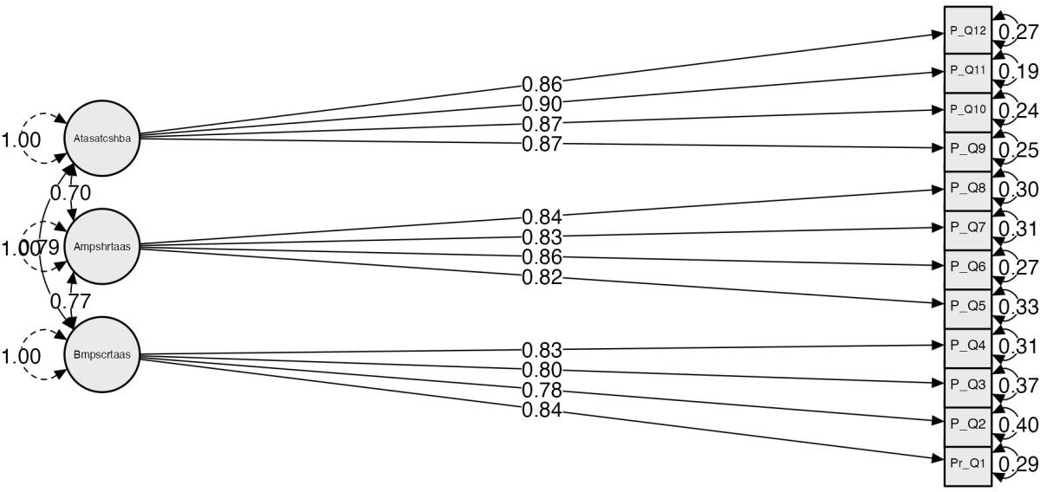

*Misfit plot*

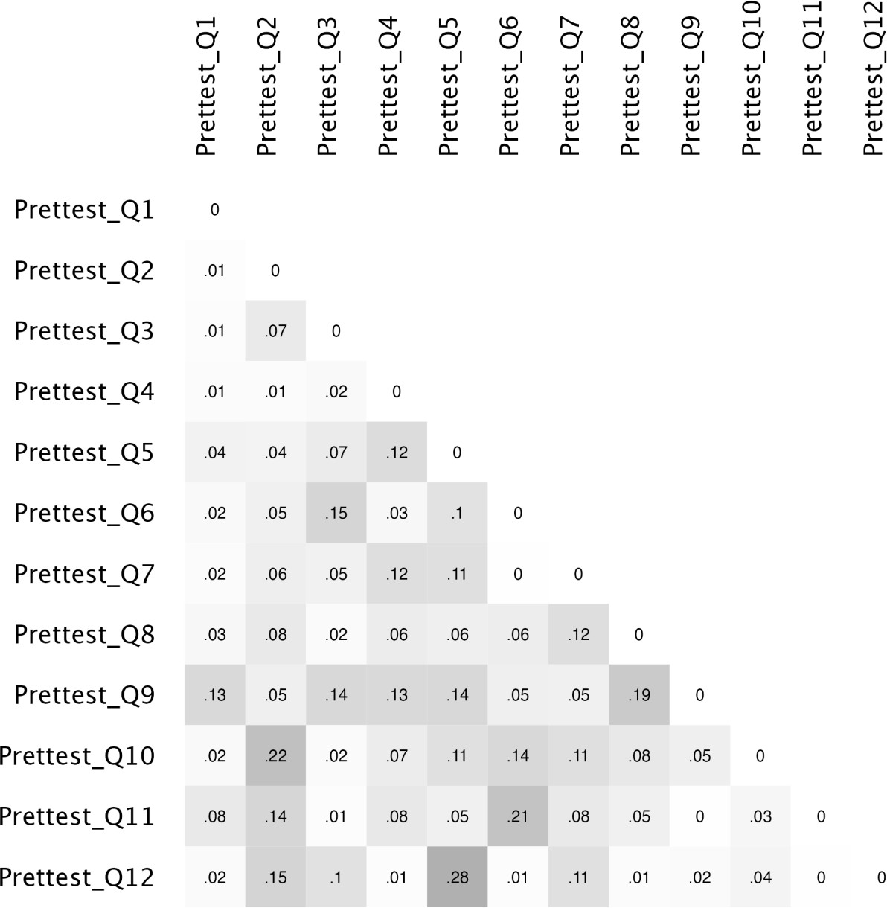

**Item Reliability Analysis**

In Table 4, Cronbach's alpha (α) was calculated for the scale reliability. The interpretation of Cronbach’s α was referenced from Arof, Ismail, and Saleh (2018) as follows: > 0.90, Excellent; 0.80 to 0.89, Good; 0.70 to 0.79, Acceptable; 0.60 to .69, Questionable; 0.50 to 0.59, Poor; and < 0.59, Unacceptable. The range of item-rest correlations must be between .15 and .85 while the average inter-item correlation must be between .15 and .50 (Paulsen & BrckaLorenz, 2017).

The 12 item questionnaire was analyzed between measurements in both intervention group and control group. The “**Before my peers’ system can respond to any academic stressor**” subscale consisted of 4 items (between αOverall = 0.859 – 0.850 ), the “**After my peer’s system has responded to an academic stressor**” subscale consisted of 4 items (between αOverall = 0.888-0.857 ), and the “**After the academic stressor and the client’s system has been addressed**” subscale consisted of 4 items (between αOverall = 0.918 – 0.894). [No items were ≤ .59

### APPENDIX C: Research Instrument

|  |  |  |  |  |  |
| --- | --- | --- | --- | --- | --- |
| **Subscale** | **Mean** |  | ***SD*** | **Interpretation** | **Cronbach's α** |
| **Before my peers’ system**  **can respond to any** |  |  |  |  |  |
| **academic stressor**  1. I provide my | 3.025 | ± | 1.000 | Moderate | 0.850 |
| peers with advice on coping mechanisms and stress management  2. I collaborate | 2.975 | ± | 1.050 | Moderate | 0.854 |
| with my cohort  team to create a therapeutic environment that promotes stress reduction  3. I offer | 2.750 | ± | 0.981 | Moderate | 0.853 |
| relaxation  techniques like deep breathing and guided visualization customized to each patient’s needs.  4. I advise my | 3.075 | ± | 0.971 | Moderate | 0.859 |
| peers to adopt  good living habits and self-  care to reduce stress . |  |  |  |  |  |

|  |  |  |  |  |  |  |
| --- | --- | --- | --- | --- | --- | --- |
| **After my peer’s system has responded to an academic stressor** |  |  |  |  |  |  |
| 5. | I maintain open and ongoing  communication | 3.050 | ± | 0.932 | Moderate | 0.888 |
| 6. | I provide my peers with a safe environment to express their sentiments safely in a way that works for them. | 3.275 | ± | 0.877 | Moderate | 0.857 |
| 7. | I inform my peers about psychological impact to become more  self-aware | 2.975 | ± | 0.832 | Moderate | 0.871 |
| 8. | I educate my peers on resilience building practices. | 2.925 | ± | 0.797 | Moderate | 0.871 |
| **After the** |  |  |  |  |  |  |
| **academic** |  |  |  |  |  |  |
| **stressor** |  |  |  |  |  |  |
| **and the** |  |  |  |  |  |  |
| **client’s** |  |  |  |  |  |  |
| **system** |  |  |  |  |  |  |
| **has been** |  |  |  |  |  |  |
| **addressed**. |  |  |  |  |  |  |
| 9. | I give my peers information and resources to reduce the  stressor. | 2.975 | ± | 0.832 | Moderate | 0.918 |
| 10. | I offer my support to help | 3.225 | ± | 0.800 | Moderate | 0.903 |

my peers with their stressor.

11. I work with my 2.975 ± 0.832 Moderate 0.894

peers to establish a strategy for recovery physically and emotionally.

|  |  |  |  |  |  |
| --- | --- | --- | --- | --- | --- |
| 12. | I emphasize the3.225 | ± | 0.733 | Moderate | 0.907 |
|  | importance of |  |  |  |  |
|  | long term |  |  |  |  |
|  | management |  |  |  |  |
|  | avoid the |  |  |  |  |
|  | initiation of any |  |  |  |  |
|  | future stressor. |  |  |  |  |
|  | **Overall 2.02** | **±** | **0.432** | Moderate | **0.859** |

*Note*. Interpretation: 0 – 1.66, Poorly Caring; 1.67 – 3.33, Moderately Caring; 3.34 – 5.00, Highly Caring.

## Unidimensional Reliability

|  |  |  |  |  |
| --- | --- | --- | --- | --- |
| **Frequentist Scale Reliability Statistics** | | | | |
| **Estimate** | **Cronbach's α** | **Average interitem correlation** | **mean** | **sd** |
| Point estimate | 0.886 | 0.661 | NaN |  |
| 95% CI lower bound | 0.824 | 0.447 | NaN |  |
| 95% CI upper bound | 0.930 | 0.827 | NaN |  |
| *Note.* Of the observations, pairwise complete cases were used. | | |  |  |

|  |  |  |  |  |
| --- | --- | --- | --- | --- |
| **Frequentist Individual Item Reliability Statistics** | | | | |
| **If item dropped** | | | | |
| **Item** | **Cronbach's α** | **Item-rest correlation** | **mean** | **sd** |
| Prettest_Q1 | 0.850 | 0.762 | 3.025 | 1.000 |
| Prettest_Q2 | 0.854 | 0.751 | 2.975 | 1.050 |

|  |  |  |  |  |
| --- | --- | --- | --- | --- |
| **Frequentist Individual Item Reliability Statistics** | | | | |
| **If item dropped** | | | | |
| **Item** | **Cronbach's α** | **Item-rest correlation** | **mean** | **sd** |
| Prettest_Q3 | 0.853 | 0.756 | 2.750 | 0.981 |
| Prettest_Q4 | 0.859 | 0.737 | 3.075 | 0.971 |

**Unidimensional Reliability**

|  |  |  |  |  |
| --- | --- | --- | --- | --- |
| **Frequentist Scale Reliability Statistics** | | | | |
| **Estimate** | **Cronbach's α** | **Average interitem correlation** | **mean** | **sd** |
| Point estimate | 0.901 | 0.694 | NaN |  |
| 95% CI lower bound | 0.844 | 0.550 | NaN |  |
| 95% CI upper bound | 0.939 | 0.809 | NaN |  |
| *Note.* Of the observations, pairwise complete cases were used. | | |  |  |

|  |  |  |  |  |
| --- | --- | --- | --- | --- |
| **Frequentist Individual Item Reliability Statistics** | | | | |
| **If item dropped** | | | | |
| **Item** | **Cronbach's α** | **Item-rest correlation** | **mean** | **sd** |
| Prettest_Q5 | 0.888 | 0.737 | 3.050 | 0.932 |
| Prettest_Q6 | 0.857 | 0.825 | 3.275 | 0.877 |
| Prettest_Q7 | 0.871 | 0.771 | 2.975 | 0.832 |
| Prettest_Q8 | 0.871 | 0.777 | 2.925 | 0.797 |

## Unidimensional Reliability

|  |  |  |  |  |
| --- | --- | --- | --- | --- |
| **Frequentist Scale Reliability Statistics** | | | | |
| **Estimate** | **Cronbach's α** | **Average interitem correlation** | **mean** | **sd** |
| Point estimate | 0.928 | 0.762 | NaN |  |

|  |  |  |  |  |
| --- | --- | --- | --- | --- |
| **Frequentist Scale Reliability Statistics** | | | | |
| **Estimate** | **Cronbach's α** | **Average interitem correlation** | **mean** | **sd** |
| 95% CI lower bound | 0.888 | 0.628 | NaN |  |
| 95% CI upper bound | 0.955 | 0.857 | NaN |  |
| *Note.* Of the observations, pairwise complete cases were used. | | |  |  |

|  |  |  |  |  |
| --- | --- | --- | --- | --- |
| **Frequentist Individual Item Reliability Statistics** | | | | |
| **If item dropped** | | | | |
| **Item** | **Cronbach's α** | **Item-rest correlation** | **mean** | **sd** |
| Prettest_Q9 | 0.918 | 0.793 | 2.975 | 0.832 |
| Prettest_Q10 | 0.903 | 0.839 | 3.225 | 0.800 |
| Prettest_Q11 | 0.894 | 0.868 | 2.975 | 0.832 |
| Prettest_Q12 | 0.907 | 0.825 | 3.225 | 0.733 |

**Independent Samples T-Test**

|  |  |  |  |  |  |
| --- | --- | --- | --- | --- | --- |
| **Independent Samples T-Test** | | | | | |
|  | **t** | **df** | **p** | **Cohen's d** | **SE Cohen's d** |
| Average Pretest | -0.457 | 38 | 0.651 | -0.145 | 0.319 |
| Average Posttest | -0.210 | 38 | 0.835 | -0.067 | 0.318 |
| *Note.* Student's t-test. | |  |  |  |  |

Assumption Checks

|  |  |  |  |
| --- | --- | --- | --- |
| **Test of Normality (Shapiro-Wilk)** | | | |
|  |  | **W** | **p** |
| Average Pretest | Group 1 | 0.920 | 0.128 |
|  | Group 2 | 0.924 | 0.093 |
| Average Posttest | Group 1 | 0.939 | 0.274 |

|  |  |  |
| --- | --- | --- |
| **Test of Normality (Shapiro-Wilk)** |  |  |
|  | **W** | **p** |
| Group 2 | 0.947 | 0.269 |
| *Note.* Significant results suggest a deviation from normality. | | |

|  |  |  |  |  |
| --- | --- | --- | --- | --- |
| **Test of Equality of Variances (Levene's)** | | | | |
|  | **F** | **df1** | **df2** | **p** |
| Average Pretest | 1.861 | 1 | 38 | 0.181 |
| Average Posttest | 0.146 | 1 | 38 | 0.705 |

Descriptives

|  |  |  |  |  |  |  |
| --- | --- | --- | --- | --- | --- | --- |
| **Group Descriptives** | | | | | | |
|  | **Group** | **N** | **Mean** | **SD** | **SE** | **Coefficient of variation** |
| Average Pretest | Group 1 | 18 | 2.982 | 0.790 | 0.186 | 0.265 |
|  | Group 2 | 22 | 3.084 | 0.623 | 0.133 | 0.202 |
| Average Posttest | Group 1 | 18 | 3.388 | 0.411 | 0.097 | 0.121 |
|  | Group 2 | 22 | 3.417 | 0.441 | 0.094 | 0.129 |

*Descriptives Plots*

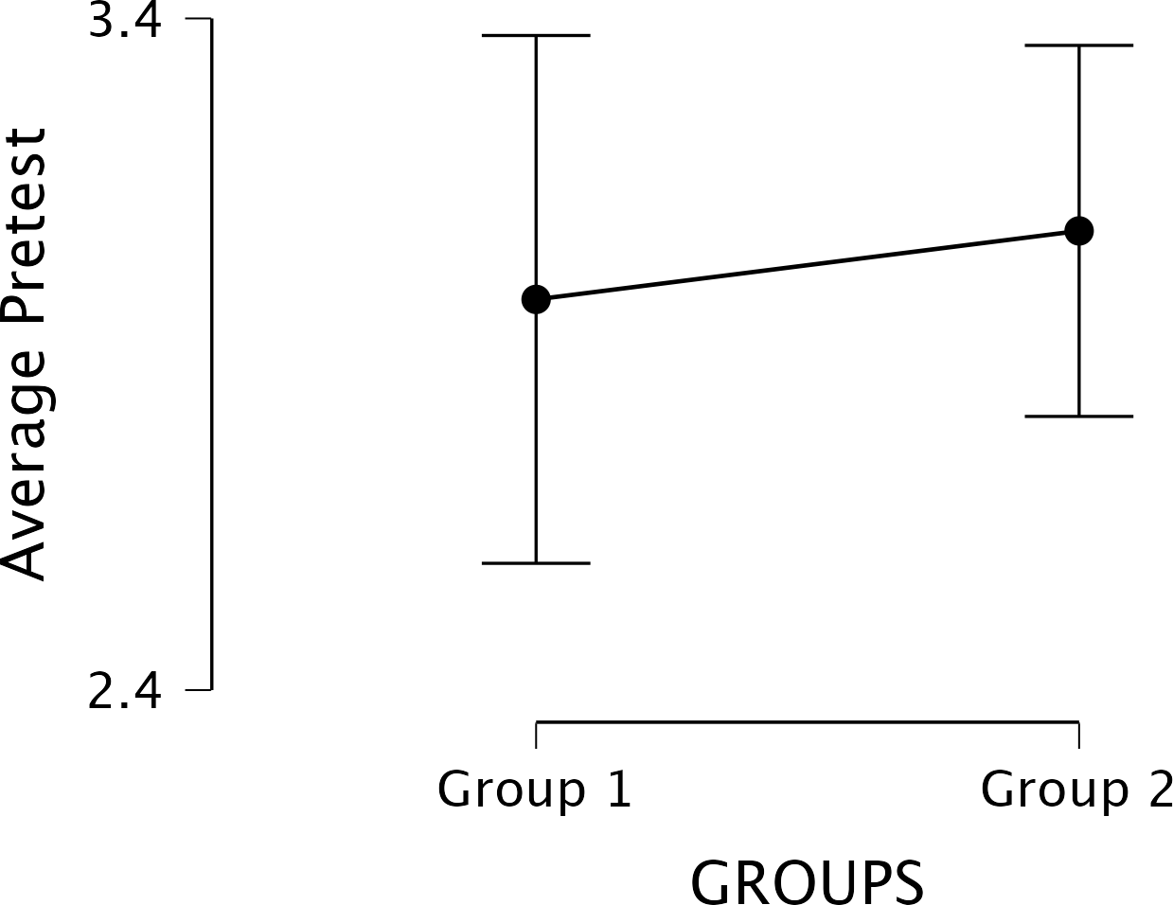Average Pretest

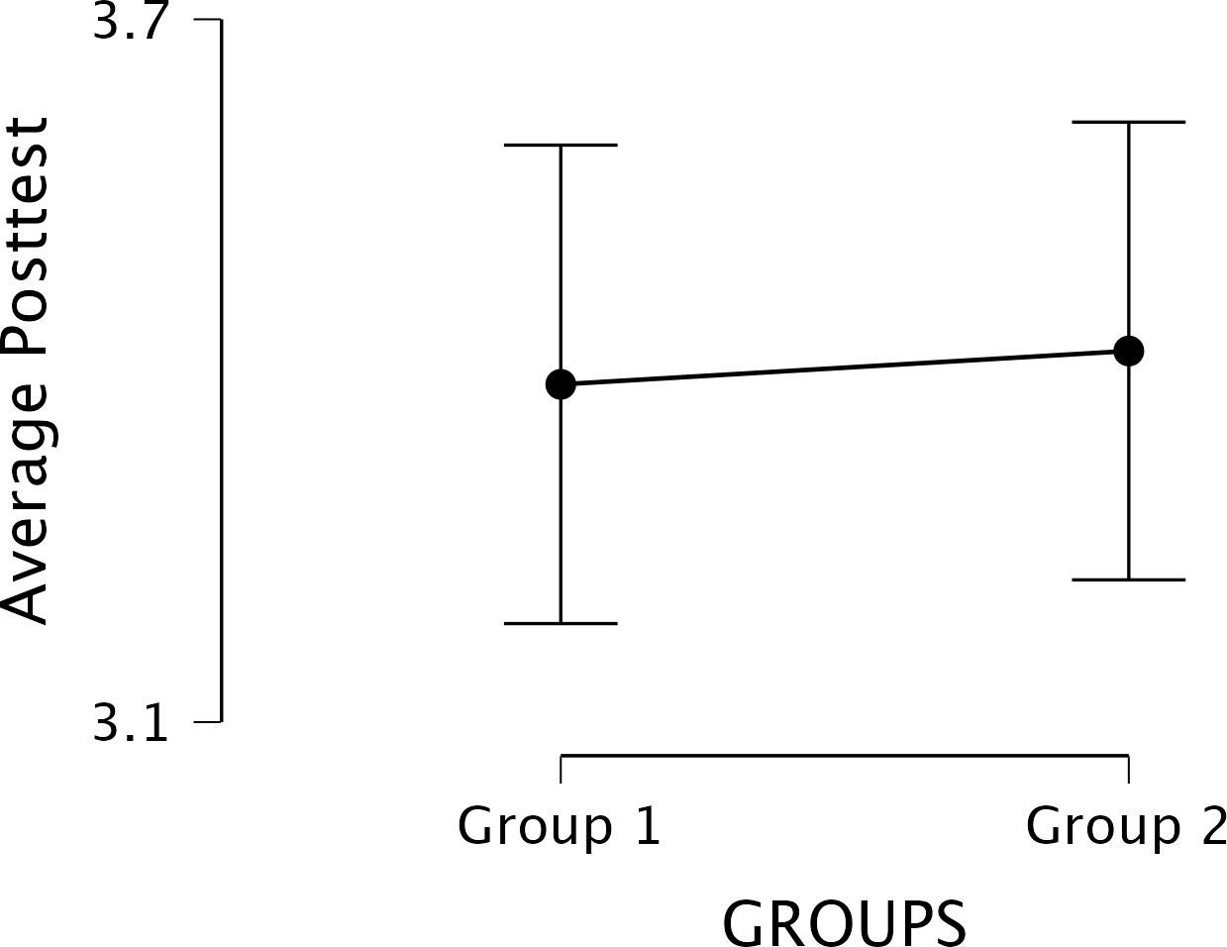Average Posttest

**Discussion:** Our participants have continued to improve up to 4 days. This suggests that by trying to identify stressors while they occurred, and coping mechanisms through peer support, students-maintained stress management behaviors for themselves and fellow students.

### Conclusions

The results may reveal that recorded video podcasts is better than recorded WhatsApp voice messages to improve stress management behaviors. Intervention is effective when it provides health education and promotes development of a certain mindset and coping strategies, for example, organization and/or time management and creating positive environments. The study will underscore the implications for mental health and further research.

### ORCID iDs

Aleah Stewart  <https://orcid.org/0009-0000-4346-8285>

Montrice Darby  <https://orcid.org/0009-0001-3844-4630> Destiny Rodriguez  <https://orcid.org/0009-0006-4643-7111> Diamond Wilson  <https://orcid.org/0009-0003-9915-9061> Sarinna Domercant  <https://orcid.org/0009-0008-5668-8592> Brianna Beaujuin  <https://orcid.org/0009-0001-6911-1863> Ahuoma Chukwueke  <https://orcid.org/0009-0008-2005-7350> Yasly Urbaez  <https://orcid.org/0009-0000-8358-0693>

### References

Admi, H., Moshe-Eilon, Y., Sharon, D., & Mann, M. (2018). Nursing students’ stress and satisfaction in clinical practice along different stages: A cross-sectional study. *Nurse Education Today*, *68*, 86–92. <https://doi.org/10.1016/j.nedt.2018.05.027>

Chesak, S. S., Cutshall, S. M., Bowe, C. L., Montanari, K. M., & Bhagra, A. (2019). *Stress management interventions for nurses: Critical literature review. Journal of Holistic Nursing, 37*(3), 288–295. <https://doi.org/10.1177/0898010119842693>

Contreras, J. A., Edwards‐Maddox, S., Hall, A., & Lee, M. A. (2020). Effects of reflective practice on baccalaureate nursing students’ stress, anxiety and competency: An integrative review. *Worldviews on Evidence-Based Nursing*, *17*(3), 239–245. <https://doi.org/10.1111/wvn.12438>

Drew, B. L., Motter, T., Ross, R., Goliat, L. M., Sharpnack, P. A., Govoni, A. L., Bozeman, M. C., & Rababah, J. (2016). Care for the caregiver. *Holistic Nursing Practice*, *30*(3), 148– 154. <https://doi.org/10.1097/hnp.0000000000000140>

Grove, S. K., Burns, N., & Gray, J. (2023). *The practice of nursing research: Appraisal, synthesis, and generation of evidence* (9th ed.). Saunders.

Jukes, M., & Spencer, P. (2016). Neuman’s Systems Model. *Nursing Times, 112*(27), 20-23.

Kaur, G., Chernomas, W. M., & Scanlan, J. M. (2020). Nursing students’ perceptions of and experiences coping with stress in clinical practice. *International Journal of Nursing Education Scholarship*, *17*(1). <https://doi.org/10.1515/ijnes-2020-0005>

Kulland, E. P. (n.d.). *Nursing student stress a thesis - North Dakota State University*. North Dakota State University Library. [https://library.ndsu.edu/ir/bitstream/handle/10365/27601/Nursing%20Student%20Stress.pd](https://library.ndsu.edu/ir/bitstream/handle/10365/27601/Nursing%20Student%20Stress.pdf?sequence=1) [f?sequence=1](https://library.ndsu.edu/ir/bitstream/handle/10365/27601/Nursing%20Student%20Stress.pdf?sequence=1)

McEwan, M., & Wills, E. M. (2021). *Theoretical basis for nursing* (6th ed.) (ISBN: 9781975175658). Lippincott Williams & Wilkins.

Park, J. H., Kim, J. Y., & Kim, H. O. (2022). Effects of a group poetry therapy program on Stress, anxiety, ego-resilience, and psychological well-being of nursing students. *Archives of Psychiatric Nursing*, *41*, 144–152. <https://doi.org/10.1016/j.apnu.2022.07.027>

Salamonson, Y., Glew, P., Everett, B., Woodmass, J. M., Lynch, J., & Ramjan, L. M. (2019).

Language support improves oral communication skills of undergraduate nursing students: A 6-month follow-up survey. *Nurse Education Today*, *72*, 54–60. <https://doi.org/10.1016/j.nedt.2018.08.027>

Strout, K., Schwartz-Mette, R., McNamara, J., Parsons, K., Walsh, D., Bonnet, J., O’Brien, L. M., Robinson, K., Sibley, S., Smith, A., Sapp, M., Sprague, L., Sabegh, N. S., Robinson, K., & Henderson, A. (2023). Wellness in nursing education to promote resilience and reduce burnout: Protocol for a holistic multidimensional wellness intervention and longitudinal research study design in nursing education. *JMIR Research Protocols*, *12*. <https://doi.org/10.2196/49020>

**Allocation**

Allocated to intervention (n=20)

* Received allocated intervention (n=20)
* Did not receive allocated intervention (give reasons) (n=20)

Allocated to intervention (n=20)

* Received allocated intervention (n=20)
* Did not receive allocated intervention (give reasons) (n=20)

**Follow-Up**

**Analysis**

Analysed (n=20)

* Excluded from analysis (give reasons) (n=20)

Analysed (n=20)

* Excluded from analysis (give reasons) (n=20)

Lost to follow-up (give reasons) (n=20)

Discontinued intervention (give reasons) (n=20)

Lost to follow-up (give reasons) (n=20)

Discontinued intervention (give reasons) (n=20)

Randomized (n=40)

Excluded (n=0)

* Not meeting inclusion criteria (n=0)
* Declined to participate (n=0)
* Other reasons (n=0)

Assessed for eligibility (n=40)

**APPENDIX A: Research Process Flowchart**



**CONSORT 2010 FLOW DIAGRAM**

**Enrollment**

*Flow diagram of research design and procedures*

*Note.* The figure illustrates the three phases of the research study, including the enrollment, intervention, and post-intervention measurements.

### Appendix B: Demographical Profile of Participants

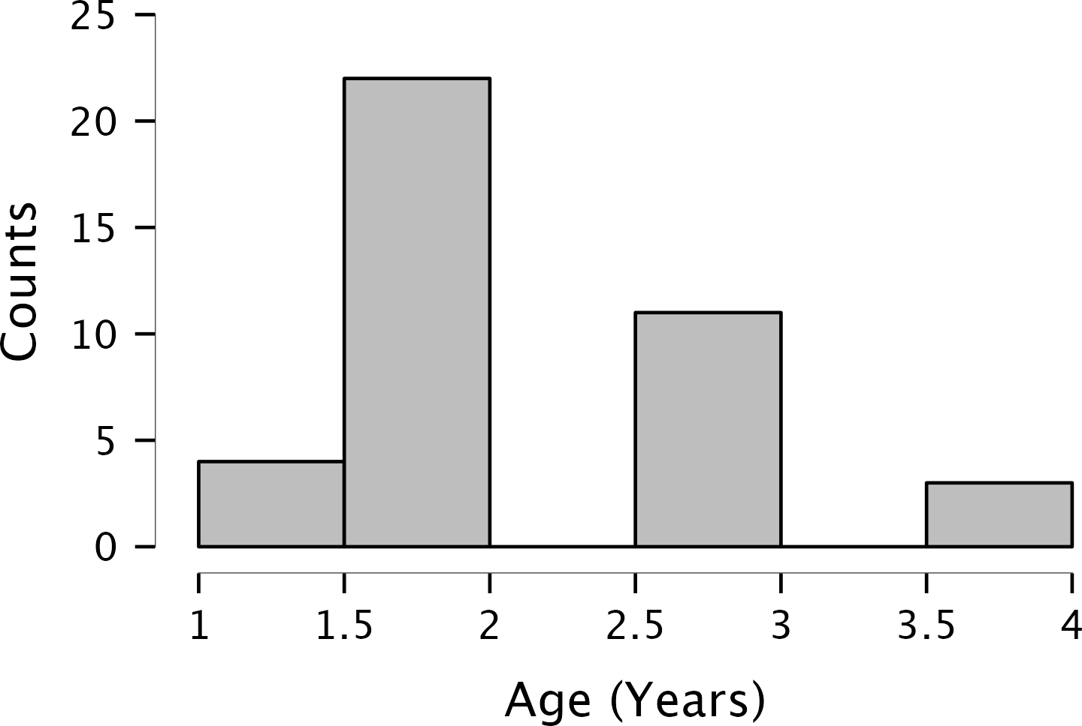

*Age*

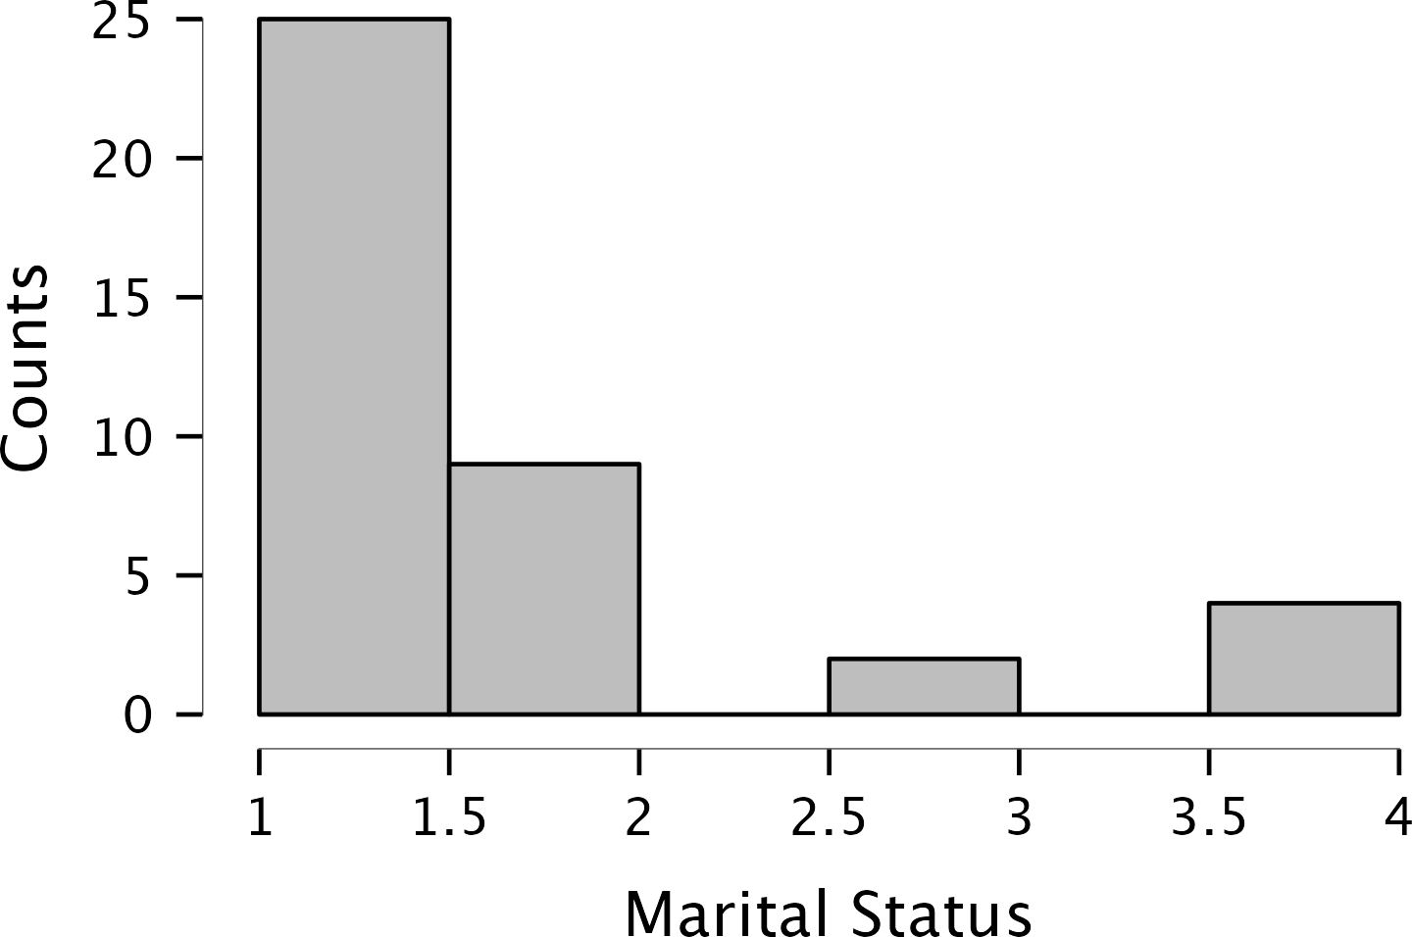

*Marital Status*

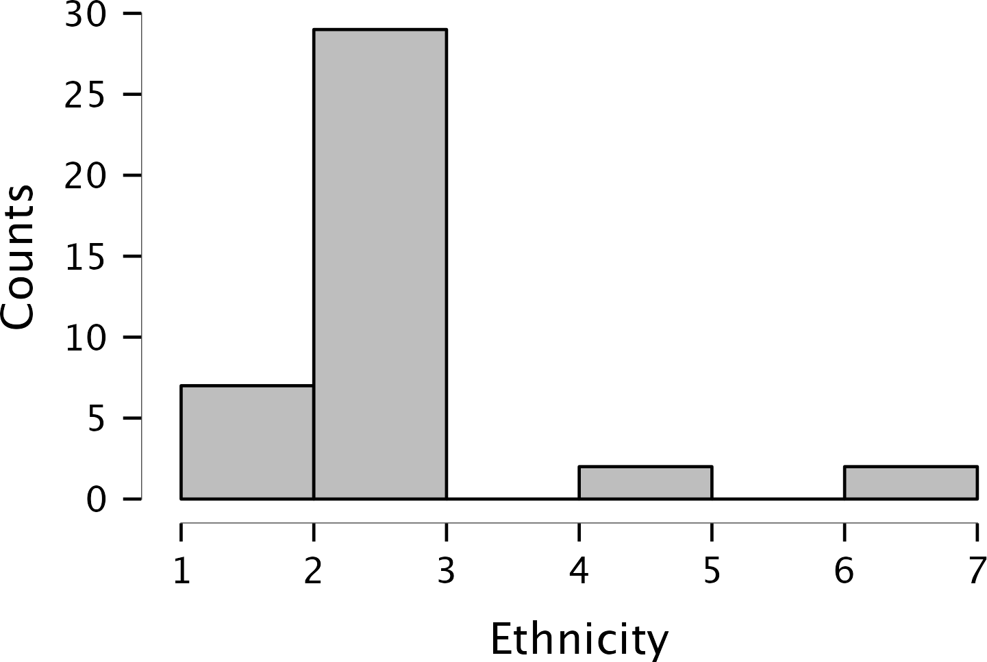

*Ethnicity*

### APPENDIX D: Consent Form

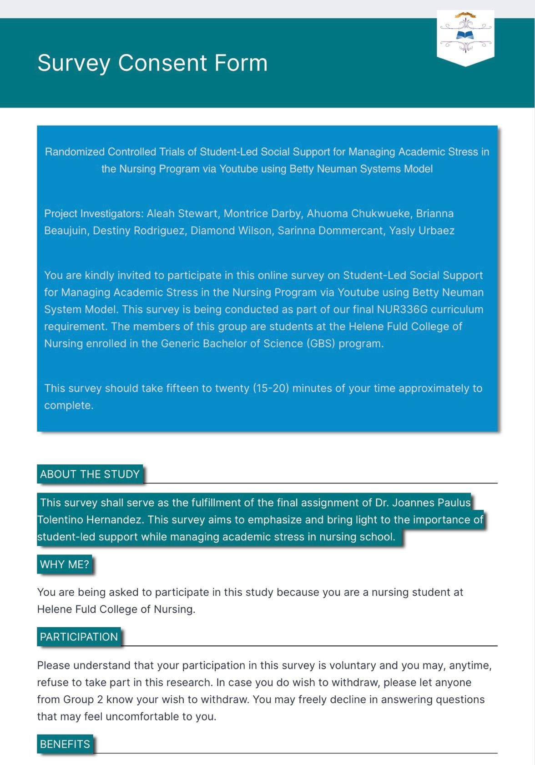

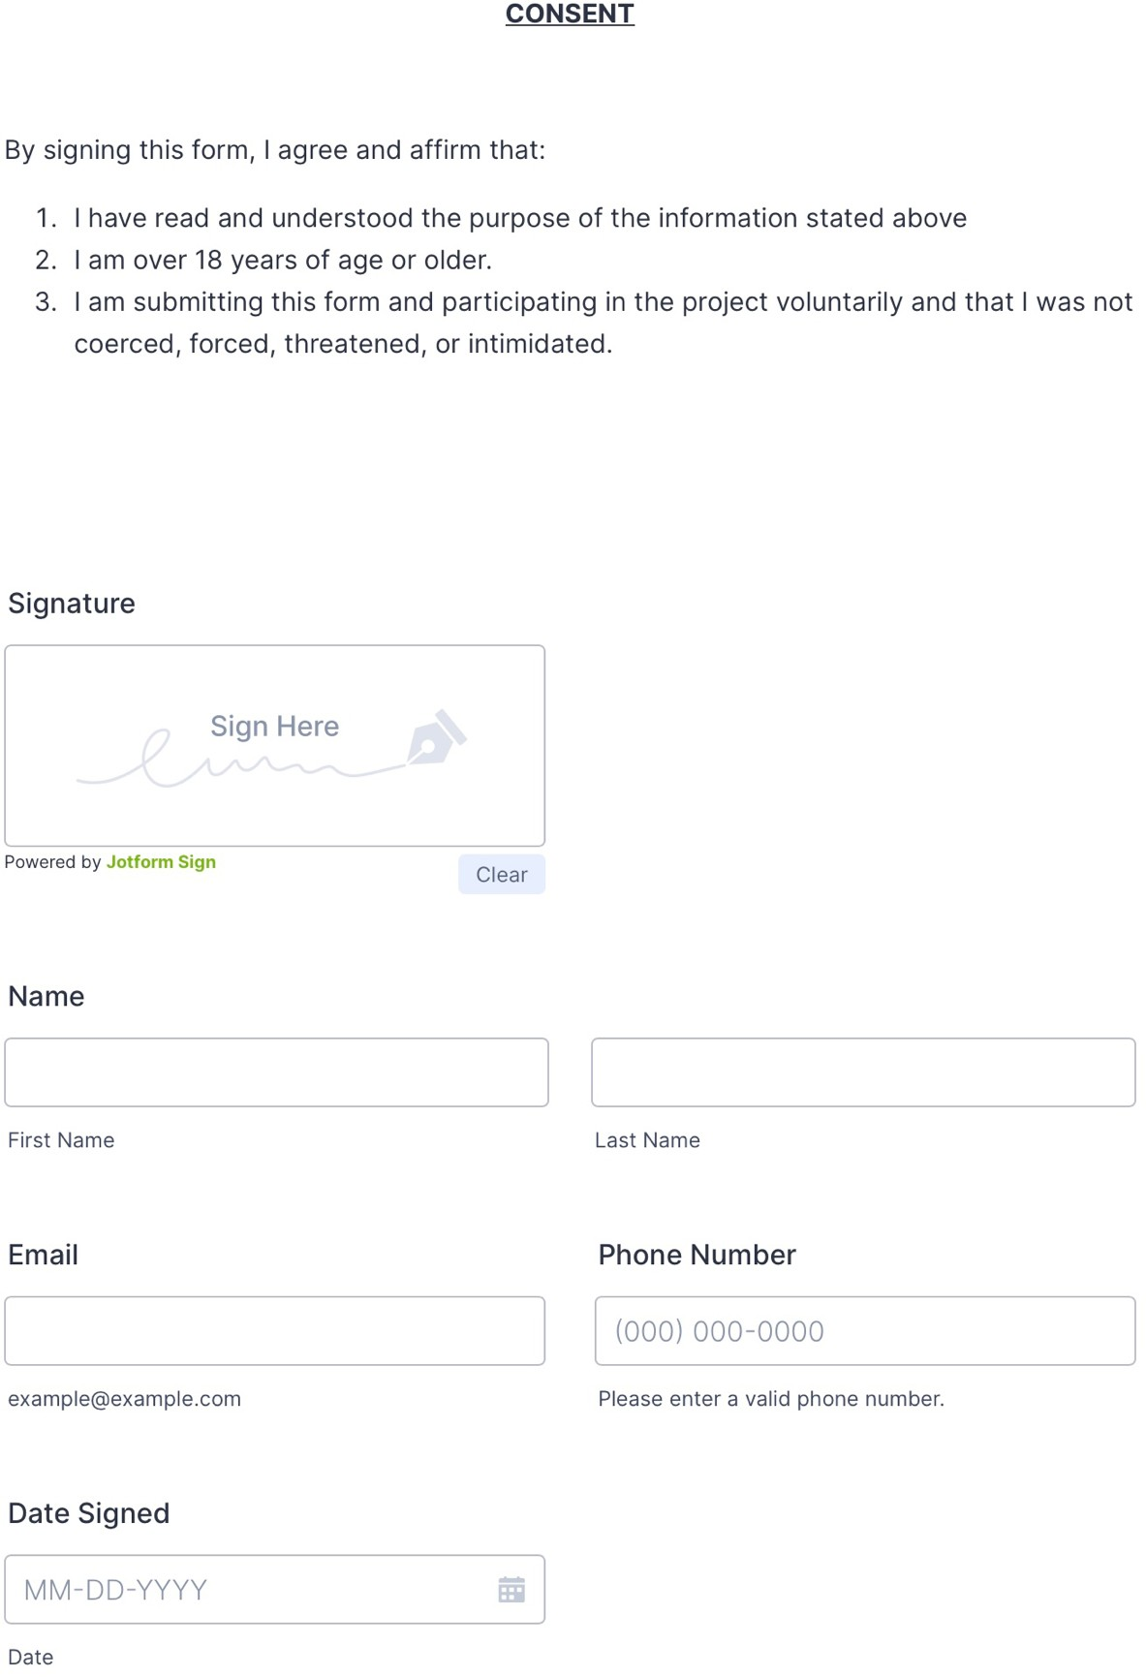

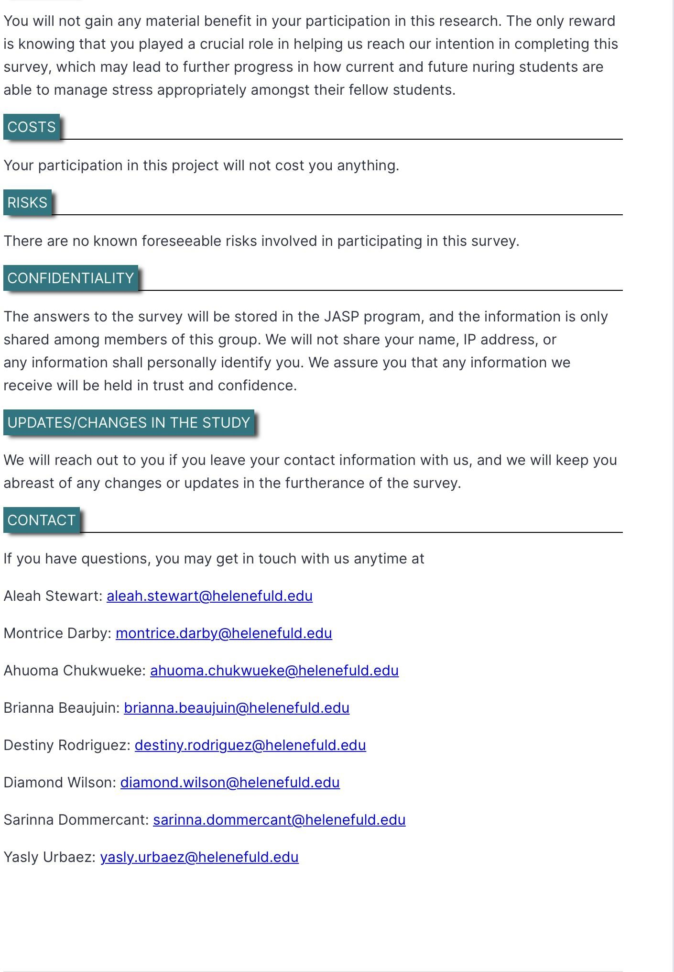

**APPENDIX C: Theoretical Model Figure 2**

*Neuman’s Systems Model*

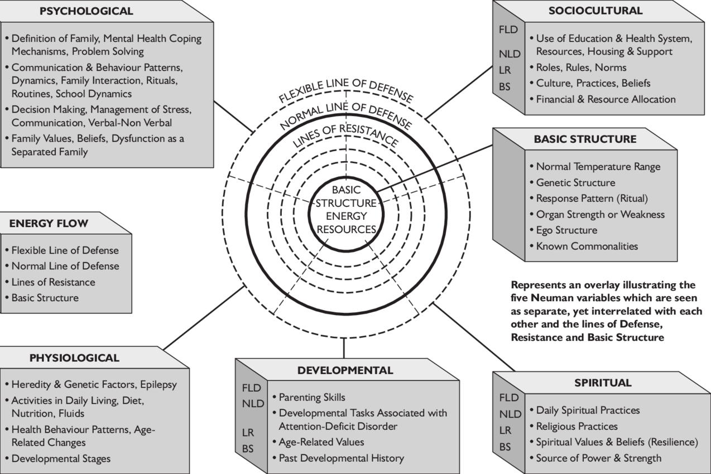SOURCE: Jukes & Spencer, 2016, p. 45

### APPENDIX D: Instructional Design Table 3

Teaching plan focusing on

|  |  |  |  |  |  |  |  |
| --- | --- | --- | --- | --- | --- | --- | --- |
| **Date Started** |  | 12/01/2023 |  | **Date Ended** |  | 12/09/2023 |  |
| **Pre-Requisite/Pre-Entry Competencies** | | BEH 231G, BEH 232G, NUR 221G, SCI 202G | | **Total Hours** |  | 40 |  |
| **Program Outcomes** | | Reduce signs and symptoms of academic stress with recorded video podcasts and voice messages. | | **Target Participants** | | Senior BSN students |  |
| **Goal** | **Objectives/**  **Learning Outcomes** | **Teaching Strategies and Resources to use** | **Learning Activities** | **Content/**  **Topic Outline** | **Timeframe** | **Feedback from the Learner** | **Evaluation** |
| **Psychological**  Students will be able to take care of and be kind to their mind.  **Physiological** | **Psychological**  Prioritize the awareness and quality of mental health to prevent stress.  **Physiological** | Online group sessions – In a recorded podcast, we will discuss goals and outcomes about student- led support when dealing with academic stress in nursing school. The goals will come from Neuman’s system model  (Jukes & | -Pre- questionnaire  -Virtual education  -Post- questionnaire | Mental health Assessment | 10 mins | Students came to an understanding that stress in nursing  school can be managed through their peers. Their peers and themselves are all going through this journey together so it can be easier to go through it together than apart. | |
| Planning therapeutic management | 20 mins |
| Depression Relapse | 10 mins |

|  |  |  |  |  |
| --- | --- | --- | --- | --- |
| Students will engage in stress relieving techniques to prevent frustration.  **Energy Flow**  Students will recognize the importance of a balanced diet and be mindful of unhealthy eating habits.  **Spiritual**  Students will maintain healthy spiritual relationships. | Execute a plan to help reduce hostile responses.  **Energy Flow**  Implement an understanding of healthy nutrition by maintaining a healthy lifestyle through a balanced diet.  **Spiritual**  Devise a positive environment to encourage spiritual practices. | Spencer, 2016,  p. 45)  Mental health resources – school counselor, mental health resources in school community. |  | Students have gained comprehension of how stress can come about in this type of environment and lifestyle and have become able to identify who and when to reach out for help when needed.  The podcast can be an outlet for these third-year nursing students; they can relate to the topics spoken on and can find ways to cope with the stress handed to them during nursing school. |

|  |  |
| --- | --- |
| **Sociocultural**  Students will be able to recognize when to incorporate the expertise of HFCN’s  therapist or outside mental health services.  **Developmental**  Students will set SMART short term and | **Sociocultural**  Identify resources that students can reach out to when dealing with a crisis.  **Developmental** |

|  |  |
| --- | --- |
| long-term goals for themselves. | Articulate short- and long-term school for nursing school  success. |