EngGeol assignment (28 marks total)

In Tutorial 1 we were considering material sources for construction of an earth embankment dam. Particle size and plasticity characteristics of two more samples are presented below:

|  |  |  |  |  |  |
| --- | --- | --- | --- | --- | --- |
| Sieve Size (mm) | Percent Passing by Weight | | Atterberg Limits |  |  |
| Sample #1 | Sample #2 | Sample #1 | Sample #2 |
| 37.5 | 100 | 100 | Liquid Limit (%) | 44 | 30 |
| 26.5 | 100 | 100 | Plastic Limit (%) | 20 | 20 |
| 19.5 | 100 | 100 | Plasticity Index | 24 | 10 |
| 9.5 | 96 | 92 | Linear Shrinkage (%) | 4.5 | 1.0 |
| 4.75 | 90 | 84 |  |  |  |
| 2.36 | 85 | 74 |  |  |  |
| 0.425 | 62 | 30 |  |  |  |
| 0.075 | 48 | 5 |  |  |  |

Question 1. Plot the particle size distribution curve for both samples on the blank particle size distribution graph provided. Which of the two samples is more poorly graded? (2 points)

Question 2. Plot the Atterberg Limit test results for both samples on the blank plasticity graph provided. (2 points)

Question 3) Based on the particle size distributions and Atterberg Limit results, which of the two samples may be most suitable for use in constructing the earth embankment core, and which sample may be most suitable for use in constructing the chimney filter / drainage layer? (1 point)

Question 4) In the tutorial we calculated a hydraulic conductivity for two material sources (a) Borrow 3, k = 7.4 m/day and, (b) Test Pit 3, k = 16.4 m/day. Based on hydraulic conductivity alone, which material would make a better sand filter and why? (2 points)

Question 5) Why does the presence of water in a soil (and excess pore water pressure in particular) cause so many problems? Your answer should cover the concept of stresses carried by soil particles and water. (1 point)

Question 6) In the tutorial on a site investigation, a geological model of the Burswood Peninsula was created. Based on sketch 2 and sketch 3 provided in the answers, recommend six suitable places for your client to build his apartments with minimal potential settlement. List the investigation locations (e.g. CPT134) that are closest to your recommended area (three locations per transect). Two of your six recommendations (re sketch 2) are less feasible, why? (2 points)

Question 7) Your client is pleased with the site investigation work you have completed and tries to create a site layout that places the proposed apartments at one of your recommended locations to minimise settlement. Unfortunately, there are other constraints (this is common in inner-city areas) and so the apartments will have to be placed near where CPT20 and CPT22 were located. Your client still wants to design the apartment complex with shallow foundations! Explain, using some technical expressions, why the client now needs to reconsider the foundation design for the apartment complex. (1 point)

Question 8) Re lecture foundations. You work for an engineering consultancy. A structural engineer calls you, and she says she is designing a strip footing for an industrial site. Her current design is a 1.0 m wide strip footing, embedded to 1.2 m depth. The industrial site is in Malaga. Cone Penetrometer Tests carried out on the site have shown the ground comprises medium dense Bassendean Sand to at least 10 m depth (to beyond the depth of influence of the proposed strip footing). Groundwater was not encountered. You know Bassendean Sand is a relatively clean sand. The unit weight of the sand is 18 kN/m3. She has calculated the bearing pressure on the ground beneath the strip footing will be 180 kPa. Determine whether her design is ok in terms of bearing capacity using the Terzaghi Bearing Capacity equation to calculate qULT. (2 points)  
Then, using a Factor of Safety of 3.0, calculate qallowable. (1 point)

Hints: Look up typical values of phi’ for medium dense clean sand and use your judgement as to which value you’ll select from the typical range of values of phi’ for a medium dense clean sand. Follow the steps in the Foundations lecture to calculate bearing capacity and use the Factors tables presented in the lecture.

Question 9) Re lecture soil strength, the triaxial test result presented here is from a three stage triaxial test. What was the peak normal stress (σ1’) the sample reached at each of the three stages? Draw a straight line on the diagram to estimate the effective cohesion (C’) of the soil tested. What is the effective angle of friction (Ø’)? (3 points)

Question 10) Re tutorial mass movement, name at least two reasons why vegetation clearing may be the cause of increased landslide movement? (2 points)

Question 11) Compare inclinometer data between December 2010 and June 2011. Does installation of the horizontal drains in early 2011 appeared to have helped reduced landslide movement? A simple yes/no is not sufficient. I need to see how you came to your answer by comparing the inclinometer data. (1 point)

Question 12) Name two possible ***natural*** reasons that might be affecting the amount of landslide movement between December and June compared with June to December. (2 points)

Question 13) Re tutorial on rockfall, using the slide provided in Question2 of that tutorial (and the plan view below, oriented with North up), describe the most likely discontinuity/ies mapped at the Nevis Bluff along which the Mt. Malcom landslide is sliding along. (1 point)

Question 14) Name two reasons why rockfalls are more likely to occur after heavy rain events. (2 points)

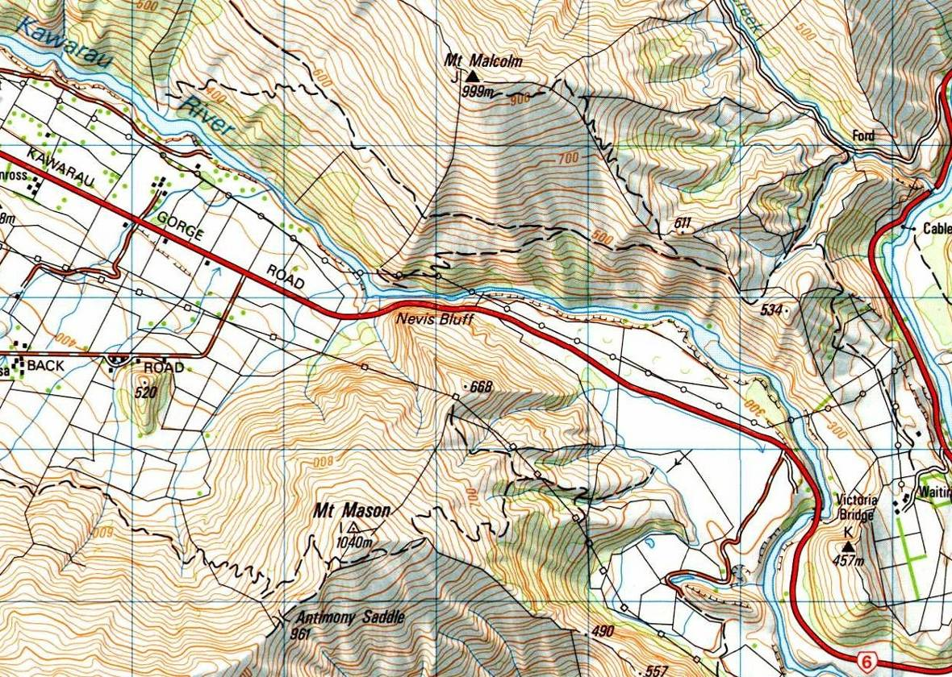

**Mt Malcom**

**Landslide**

**Victoria**

**Flats**

**Gibbston Flats**



**Nevis Bluff**

**Mt Mason Ridgeline**

**Landslide**

Question 15) The initial investigation and analysis suggested a founding level for Pier 2 of 41 mAHD. Our reassessment suggested it should be 35 mAHD (6 m lower). Some of this error is associated with using an inaccurate UCS/PLI multiplier. What is the other main reason for the discrepancy? (2 points)

Question 16) Re tutorial on sinkholes, a 3 m wide depression has suddenly appeared in a suburban neighboorhood in Kalgoorlie. You’ve been asked to investigate the cause of the sinkhole. Even before visiting the site, do you think this sinkhole formed more likely from natural or artificial (man-made) processes? Reason your assumption (1 point)

