# Table of Contents

Question 1 2

Question 2 3

Question 3 5

Question 4 9

Question 5 10

Question 6 11

Question 7 13

Question 8 14

Question 9 15

Question 10 16

**List of tables**

Table 1: Stakeholders in the LAABS company 3

Table 2 main functional requirements for the LAABS 4

Table 3 nonfunctional requirements for the LAABS 5

Table 4 list of use cases for the LAABS 7

Table 5 Event Decomposition technique to identify any additional use cases for the LAABS 9

Table 7 CRUD matrix to check the consistency between domain model class diagram and complete list of use cases 11

Table 8 fully-developed use case description for the use case Book a Flight 13

Table 12 user acceptance test plan for a customer of the LAAB system 18

**List of figures**

Figure 1 domain model class diagram for the LAABS 10

Figure 2 activity diagram 14

Figure 3 sequence diagram for the use case Inspect Balloon 15

Figure 4 state machine diagram to show the possible states and transitions for a Balloon object 16

# Question 1

List the main stakeholders for the new Light-As-Air Ballooning System (LAABS). For each stakeholder, write a brief description of their interest in the system and what aspects of it are of particular relevance to them.

|  |  |
| --- | --- |
| **Stakeholder** | **Description and interest in the system** |
| Government | The LAABS will be of importance to the Malay economy by creating jobs and improving infrastructure around its periphery, hence the government can be an external stakeholder, by permitting the LAABSBS to operate, through issuance of business license and enforcing equitable policies that makes the company run fairly in the market. |
| Shareholders | The companies as well individuals that hold shares in the LAABS are likewise the stakeholders of the company, since each of them own the part of the company, and their funds are one of the main sources of income to the company. |
| Hot air balloon pilot | This is an internal stakeholder playing a crucial role in the company. They are the ones that prepare the balloons for flight, fly the balloons, note down and make the crucial decisions involving the operation of the balloons such as fuel status and local wind data – if its suitable for flight or not. They are the ones that submit the required frequent reports about the balloons’ status. They as well as well interact with the customers during flight by guiding them through the safety measures and actions, and answering any of the technical questions raised. |
| Ground Crew member | They are also a part of the internal stakeholders; for they are ones that help the pilot in the daily ground operation of the balloon flights: such as packing and unpacking the balloon, inflating the balloon, helping the pilots during launch and landing from the ground following the balloon from the ground in the chase vehicles in deflating the balloons after flights. |
| Hospitality staff | These are also one of the crucial internal stakeholders in the company. They are the ones that assist the customers in updating on any matter that the customers may need, as well as taking the required health status of the customers: weights, injuries or surgeries before flights. |
| Owner | The owner of the company is the one that oversees all the operation of the company, so as to ensure that the company is profitable and expands. He is the one that makes decisions based on the reports received, such as ensuring that the business is running even in case of a downtime. He as well sends status of the balloons to manufacturers for maintenance. |
| Maintenance companies | These are the companies that the LAABS send their balloons and equipment for check-up, repairs and necessary replacements. |

Table 1: Stakeholders in the LAABS company

# Question 2

1. List and briefly describe the main functional requirements for the LAABS.

|  |  |
| --- | --- |
| 1 | The system should maintain all information about the customers, as well as the flight sessions |
| 2 | The system should have a clear maintenance record of the assets of the company – balloons and basket, as well as certification of pilots and other workers |
| 3 | The system sends text reminders to customers one week prior to their flight, as well as one day before |
| 4 | The system keeps a record of the customers’ weight, health status such as recent surgery, injury or pregnancy before their respective flights. |
| 5 | The LAABS system needs to have the contact details of the customers upon flight booking, such as name, address, contact phone number |
| 6 | The systems logs the duration, in hours, of each balloon by adding the number of session minutes to the usage log after each flight. |
| 7 | Upon reaching 50 hours of use, the system will flag a balloon as ‘in maintenance’. After check-up and servicing, the system resets the usage hours |
| 8 | The system records the dates, times, and details of each servicing. |
| 9 | The system will be required to have a clear record of all the reports. Is must provide an ad-hoc status report on each balloon and basket, indicating whether it is in use or being serviced. |
| 10 | The system should as well provide a report about mechanical checks and services |
| 11 | The system should generate a report showing the customer usage across the year |
| 12 | The system will have a secure database in which all the activities are stored – from customer bookings, flight details and all reports. |
| 13 | The system will be able to create account for users of the system, such as staff and pilot, in which each staff will be able to log in and able to record any required relevant information based on their jobs. |

Table 2 main functional requirements for the LAABS

1. List and briefly describe the main nonfunctional requirements for the LAABS

|  |  |
| --- | --- |
| **Functionality requirements** | |
| 1 | The site can be accessed via desktops computer, laptop of any known operating system, as well as on tablets and smartphones |
| 2 | The company’s website can be easily accessed using any of the popular web browsers – having no compatibility issues |
| **Usability requirements** | |
| 1 | LAABS interface can allow for the various types of interactivity I/O. Navigation should work with a mouse/trackpad |
| 2 | The interface should be clear and concise, having well defined selection and navigation commands, which can be well understood and interpreted. |
| 3 | The system should have an easily accessible user guide – both technical and general service manuals to be used by relevant people using the site. |
| **Reliability** | |
| 1 | The online system should be accessible/available 24 hours a day for improved accessibility by any user |
| **Performance** | |
| 1 | The site should have a very low latency, of less than 3%. with the overall response time less than 7 seconds |
| **Security requirements** | |
| 1 | All users must have their login ID/username and password before accessing the system account details and actions |
| 2 | The system will use active directory session ID to prevent multiple logins to an account from two different computers |
| 3 | The system should implement captcha methods to ensure that malwares don’t create fake accounts |

Table 3 nonfunctional requirements for the LAABS

Assumption: the LAABS has a website with a login portal that can be accessed by the staff, and customers can as well book flight via that site.

# Question 3

1. Use the User Goal technique to develop a list of use cases for the LAABS.

|  |  |  |
| --- | --- | --- |
| **User** | **Case Name** | **Description** |
| Customers  staff | Flight Booking | Customers have the ability to book for flights online, or at the LAA Singapore city office, using the company’s website, or at the LAA Singapore office |
| Staff  Customers | Check Availability | The concerned staff are able to check if the booked flights are available at the specified times and dates, and give the customers feedback correspondingly |
| Customers  Staff | Cancel Flight Booking | Any client that wishes to cancel their flight can do so through their online accounts. |
| Customers  Staff | Select Experience | The customers, during booking, can select either of the two available experience: flight or deluxe |
| Customers | Flight Status | The staff; issue timely flight reminders, and update the customers in case of any change such as weather.  This can also be done by customer can check the status of their impending flights – dates and times. |
| Staff  Customers | Personal Details Check | Personal details are checked prior to flight: name, address, and contact phone number. |
| Staff  customers | Health Check | The health status’ details given by the customers should be given: weight, recent injury or surgery, or pregnancy |
| Staff | Pre-flight balloon check | Staff inspects each balloon before flight for any possible risk such as physical damage, integrity of equipment, balloon control systems, cleanliness, etc. |
| Staff | Post-flight balloon check | Staff inspects each balloon after flight for any possible risk incurred during flight. |
| Staff  Owner | Market analysis | Owner uses the report showing the customer usage to see the most popular times of year and types of flights and plan for expansion. |
| Staff | Delete Balloon | The authorized user can remove a balloon, such as those flagged ‘for maintenance’ |
| Staff | Update balloon | Different baskets can be attached to various balloons by the user, depending on the available balloons |
| Staff | Flight recording | All flights recorded in a report – number of flights, durations and periods of flights |
| Staff | Add Balloon | The authorized user can add a balloon, after servicing from the manufacturers |
| Owner | Balloon maintenance | All reports compiled about mechanical checks and services and sent to the manufacturers annually by the owner |
| Admin | Add user | The administrator can add users to the system: other staff, such as employees, when hired |

Table 4 list of use cases for the LAABS

1. Use the Event Decomposition technique to identify any additional use cases for the LAABS. These will probably be temporal and state event types

|  |  |  |  |  |
| --- | --- | --- | --- | --- |
| **Actors** | **Event Type** | **Use case name** | **Event** | **Brief description** |
| Customer | Primary | Create account | 1. Customer clicks “create new account” under login page 2. They input their email address and password 3. They sign in to their email address to activate the account though an auto-generated link 4. They are redirected to the LAABS portal with the message “Account created successfully” 5. They go to profiles tab to update their personal and contact details | A new customer creates and activates an account through which they will be able to book for a flight, and provide their personal details |
| Customer | Temporal | Book flight | 1. Customer clocks login button 2. Enters their username and password to log in 3. Upon successful login, they go to “Book a Flight” to check for available flights. There are filters to be applied by month, and number of people to be booked | The customer upon login checks for available flights and books a flight in into the system, their most convenient flight |
| Staff | Primary | Flight availability | 1. Available space is checked 2. Number of people the customer attempts to book is also checked 3. If there is space, they are allowed to proceed with the booking | staff checks for available space on the day specified by the user, and the number of people to the booked. |
| Staff | Temporal | Weather forecast | The weather is recorded a day before the scheduled flight | The weather is recorded every evening and the following day’ forecasted to determine the following day’s suitability |
| Staff | Temporal | Flight update – reminder | 1. If the projected weather is suitable for flight, customers are reminded to be available at the launch site the following day | Customers are informed the night before the booking date if the flight is cancelled due to weather. |
|  |  | Flight update – cancellation | 1. If the projected weather is not suitable for flight, cancellation notice is issued and a reschedule later communicated | Customers are informed the night before the booking date if the flight is cancelled due to weather. |
| Staff | Timely | Flight reminder | 1. checks for the day the flight is booked against the scheduled flight day 2. If the difference is one week, a reminder is sent to the customer’s phone contact via a text message 3. The same is done one say before the flight. | A reminder is sent to the customer, at the end of the week, as well as a day before the scheduled flight. |
| Administration | Temporal | Medical check up | 1. Staff undergo medical check-up every 3 months | As part of the policy, staff members must have, and have passed a medical within the last 3 months |
| Administration | Temporal | Training | First aid training | LAABS ensures that the staff have current first aid certificates and pilot certificates and offering regular training. |
| Administration | State change | Renewal of staff license | 1. Licenses of staff expire 2. The staff are reminded to updating their licenses through renewal | The staffs with outdated licenses are alerted at the appropriate times to renew their licenses. |
| Staff | State change | Balloon servicing | 1. 50 hours passed since last balloon servicing or 2. 3 months since the last balloon servicing 3. The balloon is flagged down as ‘under servicing’ and taken to manufacturers for servicing. | The balloon is taken for servicing after 50 hours or3 months |
| Manufacturer | Change of state | Balloon servicing | 1. Balloon taken to the manufacturer is examined 2. possible appropriate repair/replacement done on the balloon | The balloon at the manufacturer is checked for an extensive servicing. Any repairs are made and relevant replacement done. |
| Staff  Owner | Primary | Report compilation and storage | 1. an ad-hoc status report on each balloon and basket is provided 2. report about mechanical checks and services sent to the manufacturers annually | Reports show the statuses of the balloons, whether or not they can be used, as well as the general progress of the company, and some sent to maintenance companies as part of the maintenance agreement |

Table 5 Event Decomposition technique to identify any additional use cases for the LAABS

# Question 4

Create a domain model class diagram for the LAABS, including all classes, attributes, associations, and multiplicity. Show association classes and generalization hierarchies where appropriate

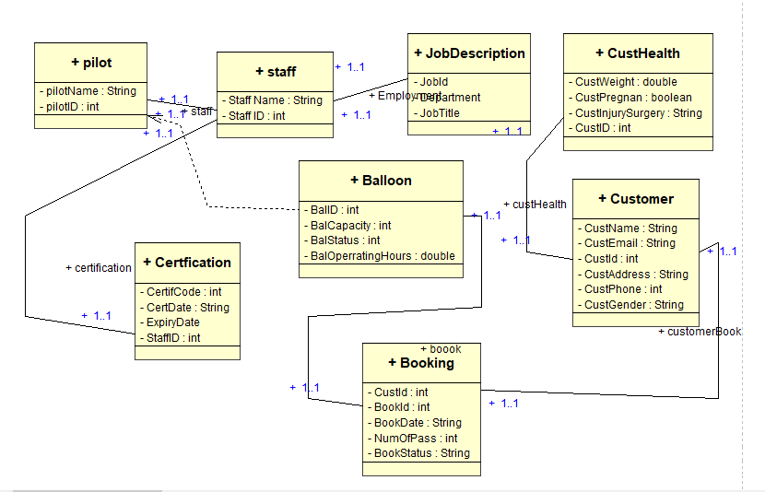

Figure 1 domain model class diagram for the LAABS

Legend

Association

Dependency association

One-One relationship

One-Many relationship

Many-One relationship

Generalization

1…1

1…

…1

# Question 5

Create a CRUD matrix to check the consistency between your domain model class diagram and your complete list of use cases.

|  |  |  |  |  |  |  |  |
| --- | --- | --- | --- | --- | --- | --- | --- |
| **Use case** | **Class** | **Staff** | **Certification** | **Customer** | **CustHealth** | **Booking** | **Balloon** |
| User registration | |  |  | C |  |  |  |
| Customer login | |  |  | R |  |  |  |
| Book Flight | |  |  |  |  | C | R |
| Select Experience | |  |  |  |  | C |  |
| Check availability | |  |  |  |  |  | R |
| Flight Update | |  |  | R |  | U | U |
| Customer Health | |  |  | R | C |  |  |
| Cancel Booking | |  |  | R |  | D |  |
| Add balloon | |  |  |  |  |  | C |
| Remove balloon | |  |  |  |  |  | D |
| Add staff | | C |  |  |  |  |  |
| Update Staff | | RU |  |  |  |  |  |
| Staff Availability | | R |  |  |  |  |  |
| Remove Staff | | D |  |  |  |  |  |
| Staff training | |  | C |  |  |  |  |
| Expiry reminder | | R | R |  |  |  |  |
| Staff medic check-up | | R | U |  |  |  |  |
| Pilot License expires | | R | D |  |  |  |  |
| Pilot License renew | | R | U |  |  |  |  |
| Balloon maintenance | |  |  |  |  |  | U |
| Full Balloon service | |  |  |  |  |  | U |
| Balloon report | |  |  |  |  |  | R |
| Reset Usage hours | |  |  |  |  |  | U |

Table 7 CRUD matrix to check the consistency between domain model class diagram and complete list of use cases

# Question 6

Create a fully-developed use case description for the use case Book a Flight. Follow the template provided at the end of this handout.

|  |  |  |
| --- | --- | --- |
| **Use Case Name:** | Book a flight | |
| **Scenario:** | Book a customer for a new flight | |
| **Triggering Event:** | Initiate a new booking function/request | |
| **Brief Description:** | The customer or staff initiates a new booking request for the customer, for the number of passengers specified by the customer | |
| **Actors:** | Staff, Customer | |
| **Stakeholders:** | Customer, | |
| **Preconditions:** | The user has an account in the system, through which the customer is registered and their request made | |
| **Postconditions:** | The details of balloon availability are updated and availability known before the bookings are made | |
| **Flow of Activities:** | **Actor** | **System** |
| 1. The actor initiates a session on the website  2. User logs in or creates account  3. User initiates the book flight function  4. Actor gives the required information personal and contact information  4.1. The actor enters the client’s preferred date(s) of flight  5. Actor enters the number of passengers booked, and their categories from the available option given by the system  5.1. the actor fills inputs all the details of all the required booked customers.  6. The user is directed to an external site so as to complete the payment transaction | 1. The system prompts them to create account or log in  2. The system displays a welcome message and displays the book flight button  3.1. The system shows the conditions and restrictions of flight based on health status of the customer, to which the customer is expected to consent  3.2. The system prompts the user to enter the required details – personal and contact details  4.1. The system checks for the available flights based of number of spaces remaining and updates the user the available flight experiences for that specified date(s)  5. The system checks all the entered clients, if eligible, and the basket/balloon to be used  5.1. The system provides total price for that book request, on which the user is to accept and provide the payment details.  6.1 once payment is received, the system fulfils the payment by assigning book ID, and a receipt is sent to the customer’s mail; as well as the details and guidelines of the book. |
| **Exception Conditions:** | 3.2 If a user had previously created an account, they will not be prompted to provide personal details again  4.1 If there are no available spaces for the category selected, the system will issue an alert to enable the user change their flight experience or date.  6.1 If payment is not successful, the system will prompt the user to validate their payment details before proceeding. | |

Table 8 fully-developed use case description for the use case Book a Flight

# Question 7

Draw an activity diagram to represent the flow of activities for the use case Inspect Balloon shown at the end of this handout.

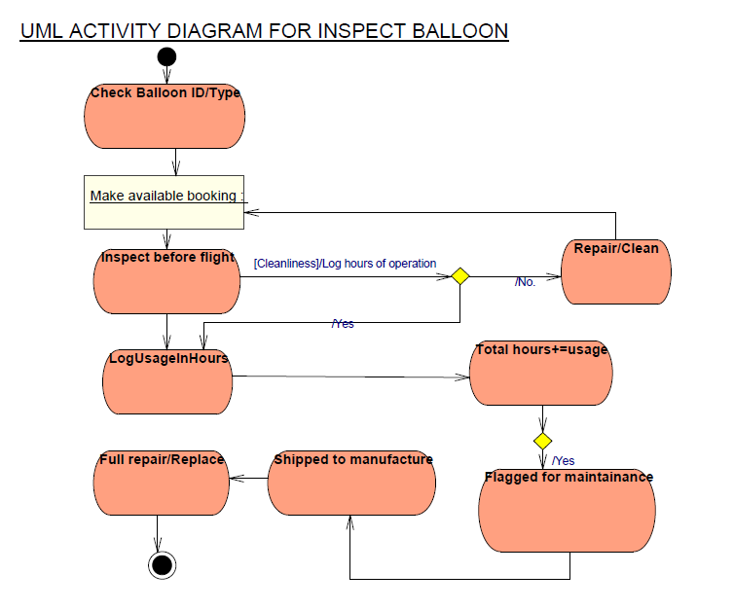

Figure 3 activity diagram

Legend

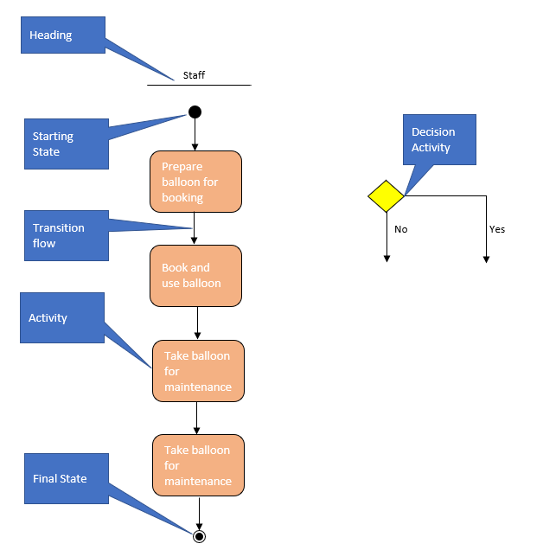

Starting State

Heading

Final State

Activity

Transition flow

Staff

Decision Activity

Take balloon for maintenance

Yes

No

Take balloon for maintenance

Book and use balloon

Prepare balloon for booking

# Question 8

Draw a system sequence diagram for the use case Inspect Balloon

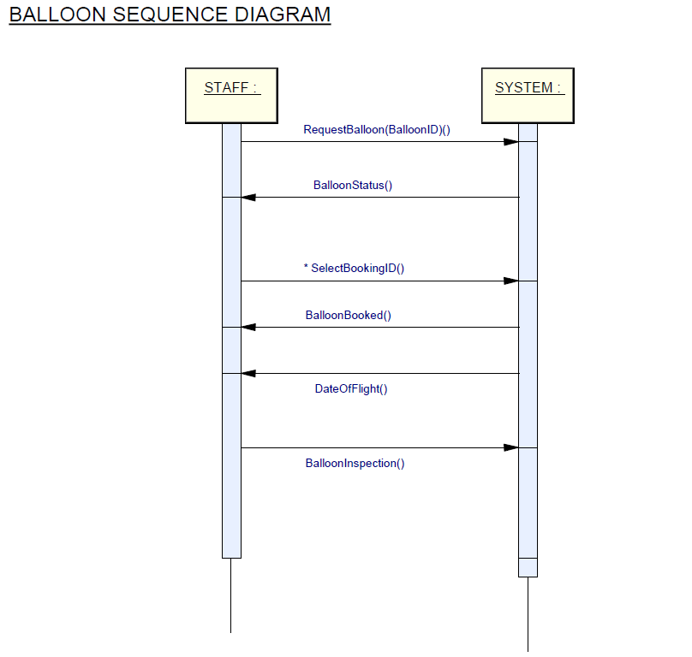

Figure 4 sequence diagram for the use case Inspect Balloon

**Legend:**

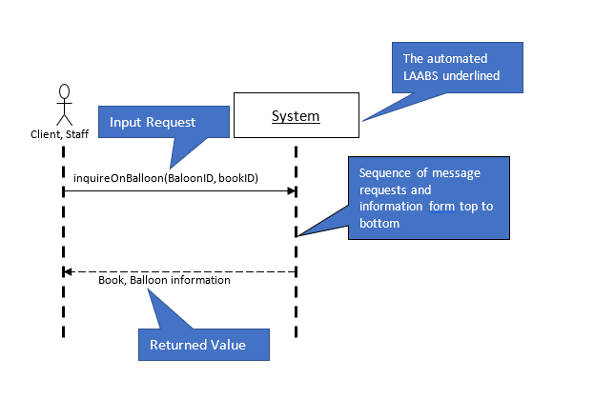

Client, Staff

Book, Balloon information

inquireOnBalloon(BaloonID, bookID)

System

Returned Value

Input Request

The automated LAABS underlined

Sequence of message requests and information form top to bottom

# Question 9

Draw a state machine diagram to show the possible states and transitions for a Balloon object. Label each state with the state name.

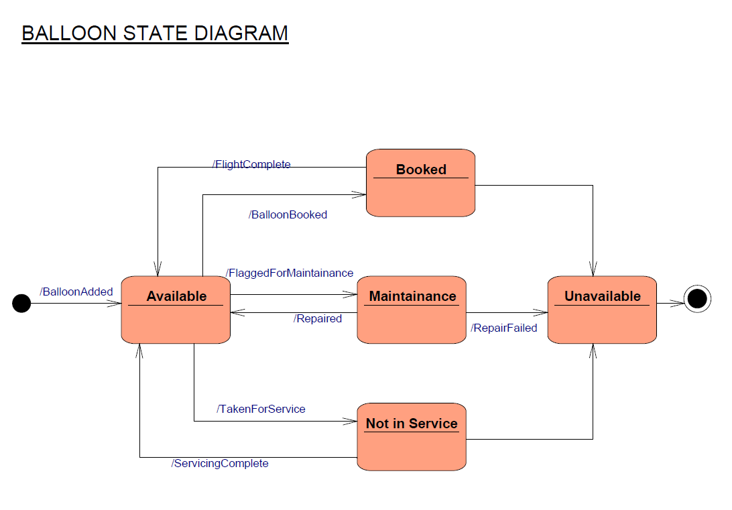

Figure 5 state machine diagram to show the possible states and transitions for a Balloon object

**Legend:**

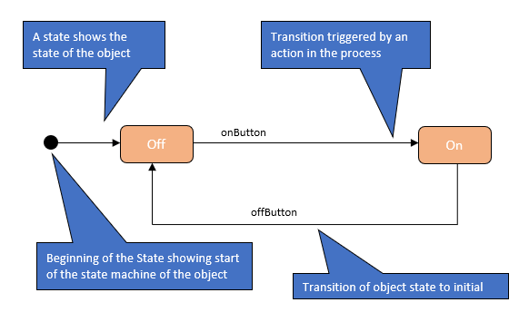

offButton

onButton

Transition triggered by an action in the process

A state shows the state of the object

Transition of object state to initial

Beginning of the State showing start of the state machine of the object

Off

On

# Question 10

Develop a user acceptance test plan for a customer of the LAAB system. Base it on the relevant use cases you have identified. Present your test plan in a table including the fields: use case name, test conditions, expected outcomes.

|  |  |  |
| --- | --- | --- |
| **Use Case Name** | **Test Conditions** | **Expected Outcomes** |
| User registration/log in | The user must have an account so as to be able to book. Delete account not allowed | For those not yet registered, they are to have an account through which they will be able to register. |
| Book flight | Update active book by Add flight, and delete the booking not allowed | New booking status changed to active; other fields |
| Check balloon availability | Read availability, update ad deletion of balloon availability status not allowed | The function enables one to check the availability of the balloon, form the ones already booked. |
| Select balloon size | System gives the balloons available, customer selects desired the size | Size status and availability updated by the system, selection linked to the book ID |
| Cancel booking | Delete book not allowed | All the data, fields, records, and files of the selected record are deleted form the database. A full refund function is triggered if cancellation made 4 weeks before the flight |
| Check book | Customer can check details/status of the existing booking based on the ID | Details of the booking selected based on the ID is displayed. This entails a digital receipt of the booking, in the registered email address |
| Update booking | Updating details of a made yet unfulfilled booking not allowed | This allows the user to modify the details of a booking. All changes made under this function overwrite the previous data and stored in the database. |
| Get help | User sends enquiry about a service or procedure | The function allows the user make an enquiry, providing fields (text area) to fill in the questions desired, and the data input sent to the support team for evaluation. Once a solution is found, is sent to the enquirer’s email address. |

Table 12 user acceptance test plan for a customer of the LAAB system

References

Savage, G. T., Nix, T. W., Whitehead, C. J., & Blair, J. D. (1991). Strategies for assessing and managing organizational stakeholders. *Academy of management perspectives*, *5*(2), 61-75.

Upham, P. J., & Mills, J. N. (2005). Environmental and operational sustainability of airports: Core indicators and stakeholder communication. *Benchmarking: An international journal*, *12*(2), 166-179.

Abrahamsson, P., Salo, O., Ronkainen, J., & Warsta, J. (2017). Agile software development methods: Review and analysis. *arXiv preprint arXiv:1709.08439*.

Houston, R. K. (2018). *U.S. Patent Application No. 13/491,080*.

Martin, R. C. (2017). *Clean architecture: a craftsman's guide to software structure and design*. Prentice Hall Press.