**Case study: The Coppice**

# Overview

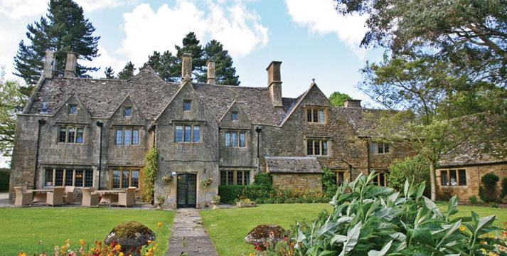

The Coppice, set in 100 acres of unspoilt parkland, has commanded views over the idyllic rural Cotswold countryside for 500 years. Every one of the 30 bedrooms is of the highest standard offering contemporary style bedding, plasma TVs, tea and coffee facilities and, most importantly, fabulous bathrooms. Rooms, including suites and four poster rooms each have their own character, many with private terraces and views over five counties. The Coppice offers unspoilt, elegant country house living at its very best. However, whilst it is a glorious, grand house, it is not run in a formal and stuffy manner and therefore the ideal place to relax. As our guests tell us, ‘it is much more of a home away from home atmosphere!’  
Dine in the intimate restaurant with a seasonal menu that makes the very best of fresh Cotswold produce. The terrace is also used as a dining area during the warmer months of the year. For guests, the heart of England is on the doorstep, with historic houses and world-famous gardens, Shakespeare’s Stratford and the delightful Cotswold towns of Chipping Campden, Broadway and Burford just a short drive away.

The Coppice offers a spa that is totally at one with its surroundings incorporating wood, marble and glass to reflect the warm seasonal hues of the outdoors. The highly trained specialists perform a range of personalised spa treatments in the eight therapy rooms. Take a rejuvenating dip in the stunning 20 metre indoor pool, or the indoor/outdoor hydrotherapy pool offers a tranquil space to relax with views of the arboretum

5 years ago, the hotel underwent a major refurbishment of the rooms and other public spaces. At the time it was decided to retain the oil-fired heating system as the available alternatives were considered not to be cost effective. However, the rising price of oil, and the recent availability of natural gas in the area has meant that the owners are now keen to replace the boiler, which provides both heating and hot water.

It is hoped that whilst this work is taking place there will be an opportunity to install further cost saving measures and reduce the hotels environmental impact. The hotel sector accounts for around 1% of global carbon emissions and this is set to increase. Hospitality, like other industries, has a responsibility to manage its impact on our planet. Notably, the hospitality sector is responsible for over 3.5 million tonnes of CO2 emissions per year. The Carbon Trust estimates that energy savings of up to 20%, equivalent to more than £200 million, are possible across the sector, and the hotel owner wants to feel that she is contributing to this.

The provisional budget the owners have set aside for this work is £ 100,000 and they hope to get the work completed during the “low season” – Jan & Feb. It is also hoped that a number of rooms will still be available but understood that full occupancy during these works is not advisable

Sample Bedrooms and Suites

Public dining areas

Spa, pool and treatment areas

Other public areas

These images are purely for illustrative purposes**.

# Task 1

As the assistant manager of the hotel, you have been tasked with managing this project, due to the fact that your CV stated that you had taken a module as part of your degree, on Hotel Project Management.

You now need to set up a name for your ‘Project team’ and you will be the Project Manager. Please fill in the form before and email to me

**1.1** You have put together a ‘project team’, which will be tasked with producing a list of questions that you would like to ask the owner. This list should be clear and concise, and include any questions that you feel need answering, or comments that you would like to make.

|  |  |  |
| --- | --- | --- |
| Project team Name: |  | |
| Project Manager | Name | Student id |
|  |  |  |
|  |  |  |

Regards Owner