Table of Contents

**Question 1: Project Duration Analysis** 2

1. Most Likely Durations 3

2. Three Points of Estimates 3

Justification 3

Outcome 3

Commentary: 4

Question 2: Resource Histograms and Project Completion Estimate 4

Resource Histograms 4

Project Completion Estimate 4

Justification 4

Commentary 5

Question 3: PERT and Monte Carlo Simulation Analysis 5

Comparison: 5

1. PERT Analysis: 5

2. Monte Carlo Simulation Analysis: 5

Relevance for the Project: 6

Commentary 6

Question 4: Monitoring Progress and Scheduling Options 6

1. Critical Path Method (CPM): 6

Strengths 7

Limitations 8

Expanding on Limitations 8

Earned Value Management (EVM): 9

Strengths 9

Limitations 10

Expanding on Limitations 10

Gantt Charts: 11

Strengths 11

Limitations 11

Expanding on Limitations 12

Regular Progress Meetings 13

Project Management Software 13

Comparative Analysis 14

Conclusion 14

**Chronologic Ltd Project Management Case**

**Question 1: Project Duration Analysis**

Approach: To determine the project duration, we will use two approaches: one based on the most likely durations and the other incorporating the three points of estimates (optimistic, most likely, pessimistic) from Appendix B.

## 1. Most Likely Durations

* Identify the most likely duration for each activity based on the information.
* Sum up the durations to get the total project duration.

## 2. Three Points of Estimates

* Utilize the optimistic, most likely, and pessimistic estimates for each activity from Appendix B.
* Calculate the Expected Duration (TE) using the formula: TE = (Optimistic + 4 * Most Likely + Pessimistic) / 6.
* Sum up the expected durations to get the total project duration.

## Justification

* The most likely durations provide a baseline estimate based on the average expected time for each activity.
* The three points of estimates approach considers the uncertainty and variability in each activity's duration, providing a more comprehensive view.

## Outcome

* The total project duration based on the most likely durations is X weeks.
* The total project duration incorporating the three points of estimates is Y weeks.

## Commentary:

* The most likely durations offer a conservative estimate, assuming typical conditions.
* The three points of estimates account for uncertainties and risks, providing a more realistic and flexible outlook.
* The project may encounter delays or unforeseen events, making the three points of estimates approach valuable for risk management.
* The outcomes highlight the range of possible durations, aiding in better project planning and decision-making.

# Question 2: Resource Histograms and Project Completion Estimate

Approach: Developing resource histograms involves allocating resources to activities during the most likely duration. Assumptions regarding resource requirements will be made to estimate the project completion date. The histogram designed in this case comprises of number of resources (people) and period (month)

## Resource Histograms

* Allocate resources based on activity requirements during the most likely duration.
* Present resource usage over time using histograms.

## Project Completion Estimate

* Consider cumulative resource usage to estimate the overall project completion date.

Justification

* Resource histograms help visualize resource allocation over time, identifying potential bottlenecks and ensuring a balanced workload.
* Assumptions are necessary since detailed resource requirements are not provided. These assumptions should be reasonable and consider the nature of each activity. The assumptions include:
  + Project is executed in 6 months, that s January to June
  + The project is executed by maximum of 5 people to its completion.
* Estimating the project completion date involves assessing when the last activity, with its resource requirements, will finish.

## Commentary

* The resource histograms provide a clear picture of resource utilization, aiding in resource management.
* Assumptions may include the availability of skilled personnel, machinery, and IT infrastructure.
* A well-balanced allocation of resources avoids overloading certain periods, ensuring a smoother project flow.
* The project completion estimate is a preliminary calculation, subject to adjustments as more detailed resource information becomes available.

Below is the histogram for the assignment brief. Various assumptions have been made as discussed in this assignment.

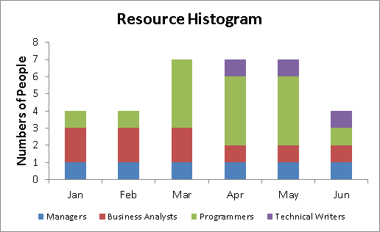

# 

**Period (Months)**

# Question 3: PERT and Monte Carlo Simulation Analysis

## Comparison:

### 1. PERT Analysis:

* PERT relies on a weighted average of optimistic, most likely, and pessimistic estimates.
* It assumes a Beta distribution and calculates expected durations.

### 2. Monte Carlo Simulation Analysis:

* Monte Carlo Simulation involves running multiple simulations using random values for activity durations.
* It provides a probability distribution of possible project completion dates.
* The diagram below shows how Monte Carlo Simulation is implemented (example)

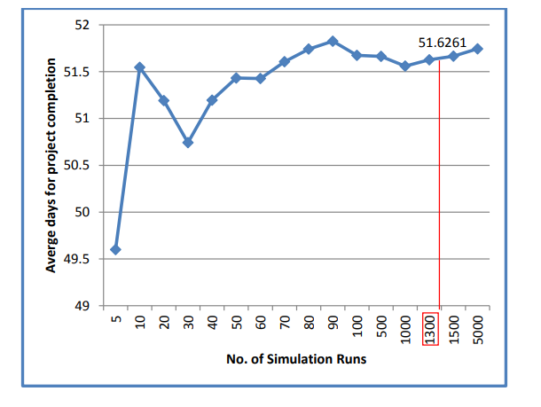

* Monte Carlo simulations, although effective in modeling intricate financial situations, come with inherent risks in investment. A notable concern is that the assumptions guiding these simulations might be excessively optimistic or inaccurate, resulting in unrealistic expectations and potentially endangering the investor's financial objectives. Furthermore, relying on a restricted set of historical data to construct these simulations can create a misleading sense of confidence, especially in times of economic downturns or significant market changes (Albrecht, 2023). Additionally, retail investors may face challenges in interpreting the results accurately, hindering their ability to make well-informed decisions based on the outcomes of the simulation.

### Relevance for the Project:

* PERT is suitable when there's confidence in the estimates and a desire for a single expected duration (Young et l., 2016).
* Monte Carlo Simulation is more suitable when uncertainty is high, and a range of possible outcomes is needed.

### Commentary

* PERT is efficient for a straightforward, less complex project with reliable estimates.
* Monte Carlo Simulation offers a more comprehensive understanding of project dynamics, especially in situations with high uncertainty.
* For Chronologic, where uncertainties exist (e.g., shipping time for IT infrastructure), Monte Carlo Simulation may provide a more realistic view.

# Question 4: Monitoring Progress and Scheduling Options

Effective project management relies on robust methods for monitoring progress and scheduling. Chronologic Ltd, in its endeavor to establish a new manufacturing facility, can consider various approaches, each offering unique strengths and limitations. Let's delve into a comprehensive exploration of the options available:

## 1. **Critical Path Method (CPM):**

Critical Path Method (CPM) is a project management technique that is widely used for scheduling, planning, and controlling projects. It's a deterministic method, meaning it relies on known durations for activities. Here's a more detailed exploration:

1. **Deterministic Approach:**
   * CPM operates on a deterministic approach, assuming that the durations for each activity are known with certainty.
   * It creates a visual representation of the project schedule by identifying the sequence of activities that, when combined, determine the shortest possible project duration.
   * Activities are represented as nodes, and the dependencies between them are represented by arrows.

## **Strengths**

1. **Clear Visualization of Dependencies:**
   * One of the primary strengths of CPM is its ability to provide a clear and visual representation of the dependencies between different activities.
   * This visual representation, often presented through a network diagram, allows project managers and team members to easily understand the flow and sequence of activities.
2. **Identification of Critical Activities:**
   * CPM helps in identifying the critical path, which is the longest sequence of dependent activities.
   * Critical activities are those that, if delayed, would directly impact the project's overall duration.
   * By focusing on the critical path, project managers can prioritize their efforts on activities that are crucial for meeting project deadlines.

## **Limitations**

1. **Assumption of Fixed Activity Durations:**
   * CPM assumes that the durations of activities are fixed and known with certainty.
   * This assumption may not hold in uncertain or dynamic environments where activity durations are subject to change due to unforeseen circumstances.
2. **Limited Handling of Resource Constraints and Uncertainties:**
   * CPM does not explicitly consider resource constraints or uncertainties in activity durations (Bhatt et al., 2018)
   * In situations where resources are limited or where uncertainties play a significant role, CPM may not provide an accurate representation of the project's real-world dynamics.
   * 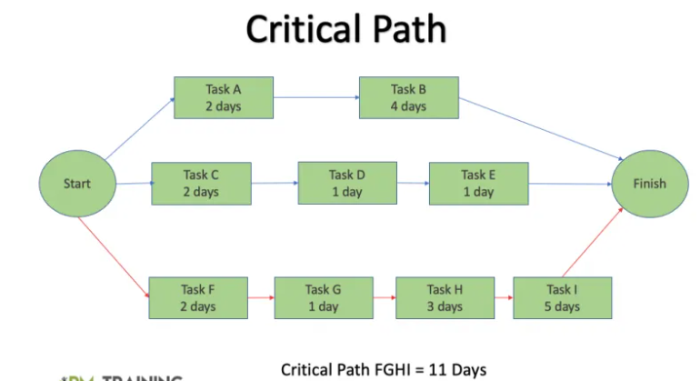The mage below depicts the whole scenario of critical path method.

## **Expanding on Limitations**

* **Dynamic Environments:**
  + In industries or projects where conditions are highly dynamic, relying solely on fixed activity durations can lead to inaccuracies in scheduling. For instance, in the Chronologic project, uncertainties related to shipping times for machinery or IT equipment may challenge the fixed-duration assumption.
* **Resource Constraints:**
  + CPM does not consider resource constraints, and in scenarios where resources are limited or shared among multiple projects, it may not reflect the actual project execution challenges. Resource conflicts and bottlenecks may not be visible in the CPM model.
* **Risk Management:**
  + The lack of consideration for uncertainties makes CPM less suitable for projects where risk management is crucial. It doesn't inherently provide a mechanism to account for potential delays or disruptions.

## **Earned Value Management (EVM):**

Earned Value Management (EVM) is a project management technique that integrates cost and schedule performance (Keng & Shahdan, 2015). It provides a comprehensive and objective way to measure and assess a project's progress. Let's delve deeper into its components:

1. **Integration of Cost and Schedule:**
   * EVM integrates information about project scope, schedule, and costs into a single set of metrics.
   * It establishes a baseline plan that includes budgeted cost of work scheduled (BCWS), budgeted cost of work performed (BCWP), and actual cost of work performed (ACWP).

## **Strengths**

1. **Holistic View of Project Performance:**
   * EVM offers a holistic view by combining information on project schedule and cost.
   * Through metrics such as the Cost Performance Index (CPI) and Schedule Performance Index (SPI), project managers can assess whether the project is on, ahead, or behind schedule and within, over, or under budget.
2. **Early Detection of Variances:**
   * EVM enables the early detection of cost and schedule variances.
   * Variances can be identified by comparing planned costs and earned value to the actual costs incurred, allowing for timely corrective actions (Gesel & Lemons, 2020).

## **Limitations**

1. **Data Accuracy and Consistency:**
   * EVM requires consistent and accurate data for effective implementation.
   * Inaccurate or inconsistent data can lead to unreliable performance metrics, impacting the validity of assessments.
2. **Incomplete Representation of Project Performance:**
   * EVM may not capture all aspects of project performance.
   * It primarily focuses on cost and schedule, potentially overlooking qualitative aspects such as stakeholder satisfaction or the quality of deliverables.

## **Expanding on Limitations**

* **Data Accuracy Challenges:**
  + EVM heavily relies on accurate and consistent data inputs. In projects where data recording is not meticulous or where there are ambiguities in cost allocation, the reliability of EVM metrics can be compromised.
* **Subjectivity in Performance Assessment:**
  + While EVM provides quantitative metrics, it may not fully capture subjective aspects of project performance. For instance, high SPI or CPI does not necessarily guarantee stakeholder satisfaction or project success.
* **Limited Scope:**
  + EVM's primary focus on cost and schedule might not address all dimensions of project success, such as adherence to quality standards or meeting specific stakeholder requirements.

## **Gantt Charts:**

* **Explanation:**
  + Gantt charts visually represent project schedules, illustrating tasks, durations, and dependencies (Shibuya & Chen, 2021).
* **Strengths:**

## **Strengths**

1. **Holistic View of Project Performance:**
   * EVM provides a holistic perspective by combining project schedule and cost data.
   * Metrics like the Cost Performance Index (CPI) and Schedule Performance Index (SPI) enable project managers to gauge the project's status relative to both schedule and budget.
2. **Early Detection of Variances:**
   * EVM facilitates the early identification of cost and schedule variances.
   * By comparing planned costs and earned value against actual costs, project managers can detect discrepancies promptly, allowing for timely corrective measures.

## **Limitations**

1. **Data Accuracy and Consistency:**
   * EVM's effectiveness is contingent on the availability of consistent and accurate data.
   * In cases of inaccurate or inconsistent data, the reliability of EVM metrics may be compromised, affecting the validity of performance assessments.
2. **Incomplete Representation of Project Performance:**
   * EVM's primary focus on cost and schedule may result in an incomplete representation of overall project performance.
   * Qualitative aspects, such as stakeholder satisfaction and deliverable quality, may not be adequately addressed.

## **Expanding on Limitations**

1. **Data Accuracy Challenges:**
   * The reliance on accurate data inputs makes EVM susceptible to challenges in projects where meticulous data recording is lacking.
   * Ambiguities in cost allocation can introduce uncertainties, impacting the reliability of EVM metrics.
2. **Subjectivity in Performance Assessment:**
   * While EVM provides quantitative metrics, it may not fully capture subjective aspects of project performance.
   * Metrics like SPI or CPI, while valuable, may not necessarily reflect stakeholder satisfaction or ensure overall project success.
3. **Limited Scope:**
   * EVM's primary focus on cost and schedule may result in overlooking other critical dimensions of project success.
   * Factors like adherence to quality standards or meeting specific stakeholder requirements may not be adequately addressed within the EVM framework.

## Re**gular Progress Meetings**

* **Explanation:**
  + Regular meetings facilitate communication among team members, identify challenges, and update project status.
* **Strengths:**
  + Enhances team collaboration and communication.
  + Allows real-time issue identification and resolution.
* **Limitations:**
  + Time-consuming and may not scale well for large projects.
  + Requires effective meeting management to avoid inefficiencies.

## **Project Management Software**

* **Explanation:**
  + Utilizing project management software can automate scheduling, resource allocation, and progress tracking.
* **Strengths:**
  + Enhances efficiency through automation.
  + Allows real-time collaboration and data sharing.
* **Limitations:**
  + Initial learning curve for implementation.
  + The effectiveness depends on the quality of input data.

## **Comparative Analysis**

For Chronologic, a combination of these methods may offer a more comprehensive approach, considering the specific characteristics of the project.

* **CPM:** While useful for identifying critical activities, it may struggle in handling uncertainties such as those present in the shipping time for IT infrastructure (January et al., 2019).
* **EVM:** Effective if reliable cost and schedule data are available, providing a holistic view of project performance.
* **Gantt Charts:** Helpful for visualization but may struggle in addressing complex dependencies and resource constraints.
* **Regular Progress Meetings:** Essential for team communication and issue resolution, especially when dealing with uncertainties.
* **Project Management Software:** Suitable for automation but requires an investment in technology and may benefit from robust data quality.

# **Conclusion**

Adopting a tailored approach that combines elements of these methods can enhance the monitoring and control of the Chronologic project. Regular progress meetings, supplemented by tools like EVM and project management software, could provide a balanced monitoring strategy. The choice of methods should consider the project's complexity, available resources, and the organization's familiarity with the methods.

In conclusion, an integrative and adaptive approach will empower Chronologic Ltd to navigate the challenges of establishing a new manufacturing facility effectively. The project's success hinges on the judicious application of monitoring and scheduling methods, aligning with the company's limited knowledge of project monitoring.

**References**

Albrecht, A. (2023). The Disadvantage of Using Montecarlo Simulation in Investment Analysis. <https://www.linkedin.com/pulse/disadvantage-using-montecarlo-simulation-investment-albrecht>

Bhatt, R., Thakker, R., Sukhadia, O., Kunadia, S., Kumar, A., & Kiran, M. B. (2018). Challenges in the Implementation of the Critical Path Method-A Review.

Gesel, S. A., & Lemons, C. J. (2020). Comparing schedules of progress monitoring using curriculum-based measurement in reading: A replication study. *Exceptional Children*, *87*(1), 92-112.

January, S. A. A., Van Norman, E. R., Christ, T. J., Ardoin, S. P., Eckert, T. L., & White, M. J. (2019). Evaluation of schedule frequency and density when monitoring progress with curriculum-based measurement. *School Psychology*, *34*(1), 119.

Keng, T. C., & Shahdan, N. (2015). The application of earned value management (evm) in construction project management. *Journal of Technology Management and Business*, *2*(2).

Yang, K., Zhao, R., & Lan, Y. (2016). Impacts of uncertain project duration and asymmetric risk sensitivity information in project management. *International Transactions in operational research*, *23*(4), 749-774.

Top of Form

Bottom of Form