# UML

1. **Use Case**

The use case Diagram is the use case for a Gym Facilities Subscription and Notification system

Actors:

* Gym (Publisher)
* Individual (Subscriber)

Use Cases:

* Subscribe to Exercise Facility
* Unsubscribe from Exercise Facility
* Publish Facility Availability
* View Available Facilities
* Manage Facility Notifications (for Gym)

Include:

* View Exercise Facility Details
* Modify Facility Availability Information (for Gym)
* Set Notification Preferences (for Individual)
* Receive Emergency Notifications (for Individual)

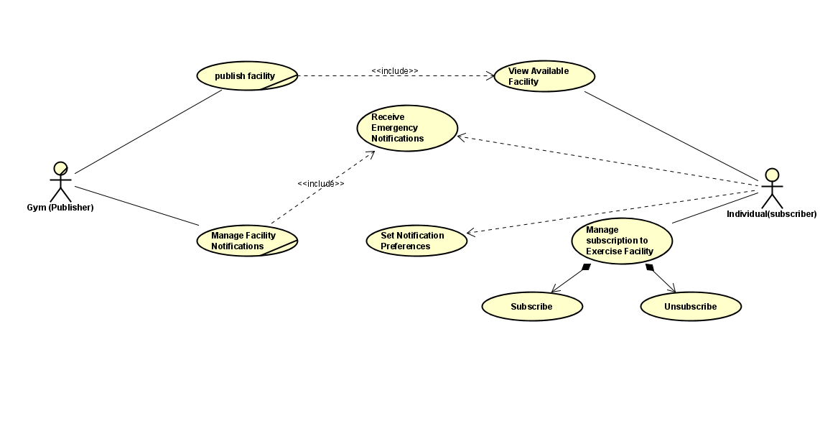

1. **Class Diagram**

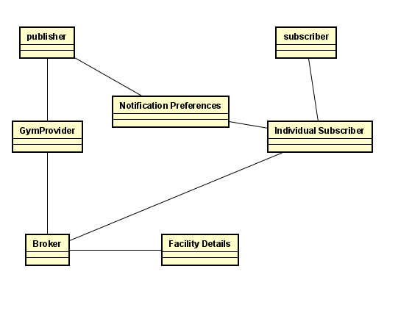

1. **Sequence Diagram**

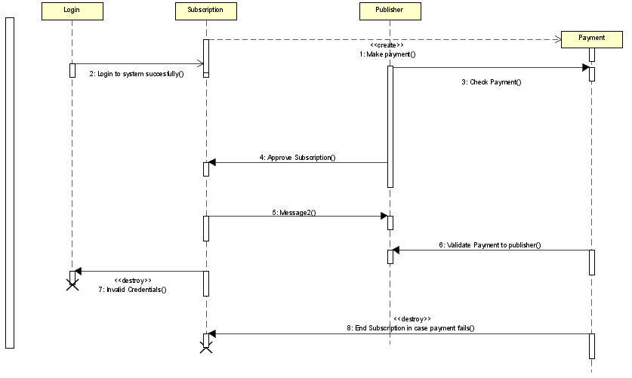

1. **State Machine Diagram**

