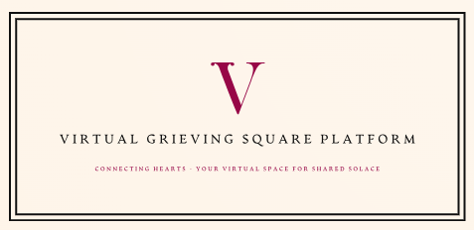

**Executive Summary**

The Virtual Grieving Square project is a huge venture that seeks to redefine the digital commemoration landscape. This platform provides a unique space where friends and families can celebrate the life of their departed individual or pet. This is a transformational idea that redefines remembrance as friends and family can be immersed into digital experiences such as live streaming the funeral service, interactive memorial features, and photo sharing.

This paper is a comprehensive analysis of the technical and operational aspects that are required to transform this vision into a global product. The report looks into the most suitable technological infrastructures such as Google Cloud, Amazon Web services, and self-hosted cloud solutions to evaluate which would bring the grieving square to fruition in a cost-efficient manner while upholding high technical standards. The report will further provide a high-level overview of the database selection, critical network, and server infrastructure to ensure the scalability and robustness of the platform.

Cost analysis and a detailed budget are fundamental in ensuring that the financial viability of a project can be assessed easily. The report provides a detailed budget proposal, encompassing development costs, subscription models, and maintenance expenses. Furthermore, the projected development timeline will help in developing the product’s roadmap including key milestones and deliverables. This report acts as the blueprint for the creation of a technological innovation and a generational transformation in the way people offer solace and connect in times of grief.

**Project Overview**

The Virtual Grieving Square platform will offer a groundbreaking digital sanctuary for commemorating the lives of departed loved ones, including cherished pets. At its core, the platform provides a supportive and interactive environment for the friends and family of the deceased to honor and grieve. Secondly, it will also act as an acknowledgement of the impact that pets have on their surviving family members and friends. It is without a doubt that as the world becomes a global village, important social events such as funerals become less accessible physically. As a result, this platform wants to provide an inclusive means of mourning that transcends geographical and physical boundaries. To achieve this vision, the platform will implement the following features and functionalities:

* **Interactive memorial rooms** complete with photo galleries, tribute videos, and biographical timelines.
* **Live streaming of funeral services** to ensure that friends and family members, irrespective of their location, can partake in the solemn ceremonies.
* **Flower dedication and donations** to bereaved families or charities in honor of the deceased.
* **A memory feed** displaying recent updates, memories shared by other users, and significant dates like anniversaries.
* **The Celebrity Memorial Section** resembles a virtual museum, chronicling the lives and legacies of notable personalities.
* A unique **Pet Memorials** section to share memories and post tributes to deceased pets.

**Technical Infrastructure**

The platform requires a robust and scalable technical infrastructure that can support all the diverse functionalities mentioned in the project overview.

**Cloud Providers**

There are several cloud computing options available in the market for this project as discussed below:

* Amazon Web Services (AWS)- this offers cost-effective and efficient global coverage through its large number of data centers situated in different locations all over the world. As a result, the service guarantees reduced latency and almost zero downtime for any user across the world. Furthermore, AWS provides key services such as elastic load balancing for traffic distribution, RDS for managed databases, and EC2 for virtual servers ensuring reliable performance.
* Microsoft Azure - While Azure has almost similar offerings as AWS, it has the advantage of easy and native integration to the Microsoft array of products. Some of the key services offered are Azure load balancer, Azure SQL database, and Azure virtual machines.
* Google Cloud Platform (GCP) - this solution comes with the added advantage of high-performance computing and data analytics capabilities, which are native to Google’s products; This means that there is also easy integration to Google products. The key services offered are Google Cloud load balancing, Google Cloud SQL, and Google Compute Engine.

In the case of this project, AWS cloud will be preferred as it offers a lot of benefits and flexibility to support more ecosystems.

**Server setup and Load Balancers**

The server configuration will make use of cloud-based virtual servers which are scalable and easier to manage. Furthermore, the system will have the option of autoscaling to allow the provision of extra computing resources on the go based on demand. Furthermore, the platform will implement load balancing across multiple servers to manage varying traffic and ensure the reliability of the platform.

**Database**

A database is important in storing and managing data on the platform. A combination of both SQL and no-SQL database configurations will be used in this project to handle the different data types effectively. PostgreSQL will be used in the management of structured data while MongoDB will be used to offer scalability and flexibility for unstructured data. The choices made here are based on active community support, third-party services integration, and scalability options offered.

**Development Timeline**

The development of the platform is projected to be split into two sections. At first, the Minimum Viable Product will be developed in the first phase then the incremental improvements will be provided in the second phase which will be iterative. The timeline for the first phase of the project is described in the table below:

|  |  |  |  |
| --- | --- | --- | --- |
| **Phase** | **Duration** | **Key Milestones** | **Deliverables** |
| Conceptualization | 1 month | Project scope definition, feasibility study | Project proposal, initial design specifications |
| Planning | 2 months | Resource allocation, detailed planning | Project plan, resource list |
| Development | 6-8 months | Coding, unit testing | Alpha and beta versions |
| Testing & QA | 3 months | System testing, bug fixing | Release candidate |
| Deployment | 1 month | Final deployment, user training | Live platform |
| Post-Deployment | Ongoing | Maintenance, updates | Iterative feature increments, Periodic updates, support documentation |

**Cost Analysis**

A comprehensive cost analysis is essential in the successful implementation of this project within scope, budget, and time. Furthermore, it also sets the precedence for the long-term financial sustainability of the platform. The assumption made is that the team will be composed of 8 engineers. A detailed breakdown of the technical infrastructure and estimates of the total project cost, including development and maintenance are as below.

**Cost Breakdown for Each Cloud Provider**

|  |  |  |  |
| --- | --- | --- | --- |
| **Cost Component** | **AWS** | **Azure** | **Google Cloud** |
| Compute (VMs) | 4 x m5 large EC2 instances: $800 | 4 x D2s_v3 virtual machines: 4 x $315 per month = $1,260 | 4 x e2-medium VM instances: 4 x $150 per month = $600 |
| Storage | 200GB RDS storage: $40 | 200GB SQL Database storage: $15 | 200GB Cloud SQL storage: $18 |
| Database Services | 10TB data transfer: $900 | Azure SQL Database - $500 | Data transfer: 50TB - $600 |
| Additional Services | CI/CD: AWS Code Pipeline - $1 | CI/CD: Azure DevOps - $42 | CI/CD: Cloud Build - $120 |
| **Total Monthly Cost** | **$1741** | **$1817** | **$1338** |

**Estimation of Total Project Cost**

It is important to come up with a comprehensive cost analysis which ensures that the project is implemented within the budget constraints. In order to provide flexibility, below is a cost breakdown for middle-tier infrastructure for the project. A more economical approach that leverages lower cost of services and scaling would make the following assumptions: a smaller development team of about 5 developers, lower tier infrastructure from AWS, and gradual scaling of resources based on traffic on the site.

From the cost breakdown above, it is apparent that from the monthly costs, Google cloud offers the cheapest offer. However, while taking scalability and third-party integration AWS is the preferred platform.

* Development Costs: the development team will be assigned an average budget of **$315,000** which includes software development, testing, and deployment. The budget estimates that 5 developers working for 9 months with a monthly estimated salary of $7000 per month
* Maintenance Costs: Estimated monthly maintenance cost of about $2000, covering cloud services, support, and updates after the development team hand over the system for 3 months which sums up to $6000.
* Infrastructure costs: The infrastructure cost above will be **$15669**. This assumes that AWS will be used for 9 months.
* Total Estimated Project Cost: The sum of development and maintenance costs over a one year is **$336,699.**
* Ongoing annual costs would be approximately $98,000.

**Sources:**

* AWS Pricing Calculator: https://aws.amazon.com/pricing/
* Average developer salaries: https://www.payscale.com
* Sample operational budgets from comps: https://craft.co

**Software Development Requirements**

The success of the platform will be based on the delivery of efficiently working and usable software. The first and most important requirement hinges on the use of a proficient and experienced software development team. The team will be made up of individuals with different skill sets to develop the different modules of the platform. The team will require a group of full-stack developers with competency in both front-end and back-end technologies. Developers with cloud computing skills will also be required to set up an efficient, secure, and scalable cloud infrastructure. Cybersecurity experts will also be needed to provide a deeper understanding of the security protocols that will help safeguard the integrity of the system. Database management administrators and developers will be required to design, build, and maintain the SQL & NoSQL databases. UI/UX designers will also be required to come up with magical, intuitive, and visually appealing interfaces that will define the user experience of the entire platform.

Apart from the development team, there will also be software requirements documentation that will act as the blueprint of the entire development process. Functional requirements will provide a detailed description of the system’s functionalities such as the access control, live streaming feature, and interactive memorial rooms. Non-functional software requirements will act as the performance and security criteria that do not directly relate to specific functionalities of the platform. Use cases and user stories documentation will describe how users will interact with the platforms with the expected outcomes.

There is also the design specification which will be used to translate the software requirements mentioned above into technical specifications that the development team will use to develop the platform. The system architecture contains diagrams that illustrate the server setups, databases, and external service integrations. On the other hand, the database schema will provide a detailed structure of the database including the tables, data types used and relationships. There is also the API specification which defines the API endpoints that will be integrated into the system to provide third-party integration such as payment systems to help in achieving donation functionality. Finally, the design specification will also include user interface mockups to provide a visual representation of the platform for the development team and stakeholders to guide in the development.

**System Architecture and Design**

The architecture of the platform is designed to provide optimal performance, easy scalability, and a wonderful user experience.

**Front End web interface**

The front-end interface will be built using JavaScript.; specifically, ReactJS framework-built responsive online application will make up the front end. Users will be able to interact with the platform's capabilities through an easy-to-use and aesthetically pleasing interface. Building encapsulated components that are reusable throughout the website is made possible with React. Below is a sample of the UI.   
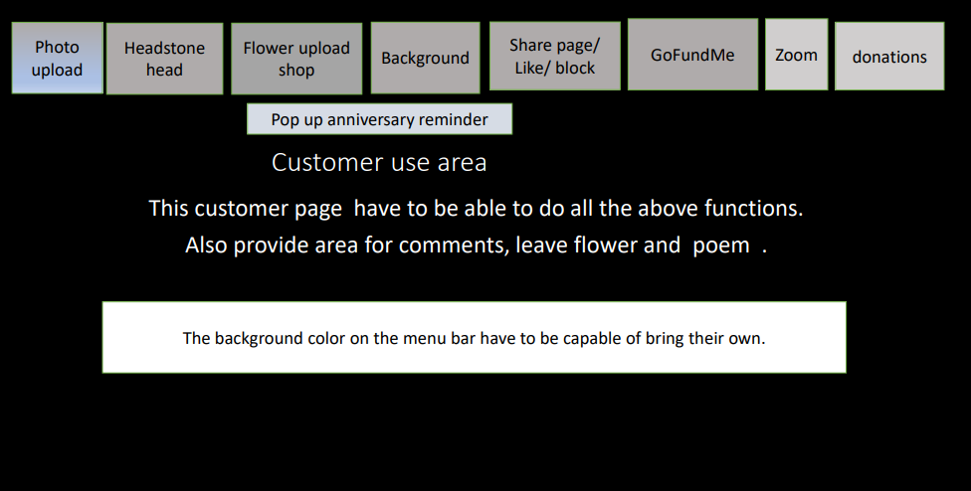

**Load Balancer and cloud storage**

Elastic Load Balancing on AWS will be used to split traffic among several application servers. S3 buckets will be used to store static content like pictures and movies. When using a CDN such as CloudFront, content is cached at edge locations to reduce latency. The diagram below shows a sample implementation of the load balancer and cloud storage.

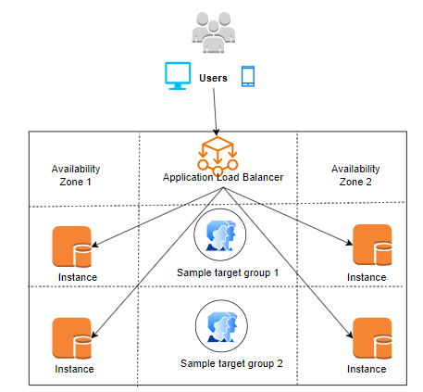

**Application Servers**

There will be NodeJS and Express middle wares used for application logic. To process requests, a number of server instances will be positioned behind the load balancer. High performance and scalability are offered by NodeJS for real-time feeds and interactions.

**Database Design**

User data that is structured will be kept in a relational PostgreSQL database. NoSQL database Unstructured material, such as comments and memorial pages, will be handled by MongoDB. To achieve high availability, databases will be duplicated among several availability zones.

**External service integration**

Microservices and APIs will be used to manage third-party integrations. For instance: WebRTC video streaming, Stripe payments. Below is a sample payment integration to the system that will be used in handling payments for the donations and purchase of flowers.

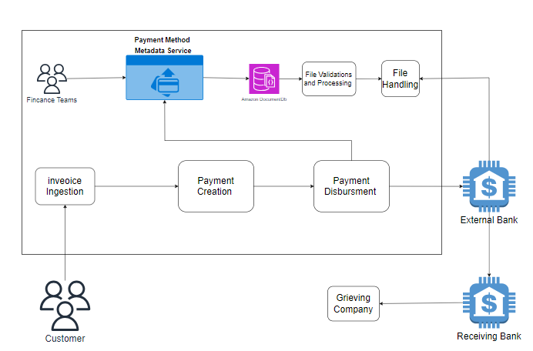

The backend of the platform will be strong and scalable thanks to the integration of cloud infrastructure, microservices, SQL, and NoSQL databases. Every layer will have security features like SSL encryption in place.

**Data Retention and Subscription Policies**

The platform will provide a subscription-based model which includes users' data storage. This means that users will be able to access different features and additional benefits based on the subscription status to help ensure a sustainable revenue model. This will go a long way in maintaining and improving the platform. Furthermore, it is important to note that based on the subscription model, it is apparent that the data of the users will be stored longer. This calls for the need to develop a data retention policy that balances between user experience journey and takes into consideration user privacy. The platform is committed to ensuring that user-generated content such as photos and condolences are saved while at the same time respecting user preference and regulatory requirements. Users will have control over the content they generate on the platform with an option to delete or archive them.

Furthermore, inactive accounts will be purged or archived to save on space and manage resources optimally.

Another important consideration for the platform is compliance with GDPR and similar regulations which is not limited to consent mechanism, right to erasure, and transparent data processing practices. Post-send-off, the Virtual Grieving Square stage will carry out an extensive support model to guarantee consistent activity and client satisfaction. The support system incorporates committed staff and functional designs for continuous upkeep. A group of talented experts will be accessible to address client requests, give specialized help, and speedily resolve any issues.

**Future Enhancements and Conclusion**

The Virtual Grieving Square platform is designed with scalability and adaptability in mind to ensure that evolving future user needs will be accommodated. An example of a future consideration is the integration of a virtual merchandise store that will provide loved ones with an opportunity to purchase tangible and physical items such as tombstones, flowers, commemorative items, or even customized personal merchandise. The Virtual Grieving Square platform is designed with scalability and adaptability in mind.

In conclusion, the meticulous planning and implementation of the platform could be the reason loved ones will enjoy the send-off of an individual or a pet. It will make a tectonic shift in the way society undertakes grieving and remembrance of loved ones. It will not only act as a technological marvel but also as a compassionate connection between the living and the departed by offering innovative features within the digital space.