I choose food.

Although the question is very broad and extensive, it needs to focus on a specific issue, such as the affordability of purchasing food, the quality and safety of the food supply chain, and so on

<https://impact.economist.com/sustainability/project/food-security-index/>

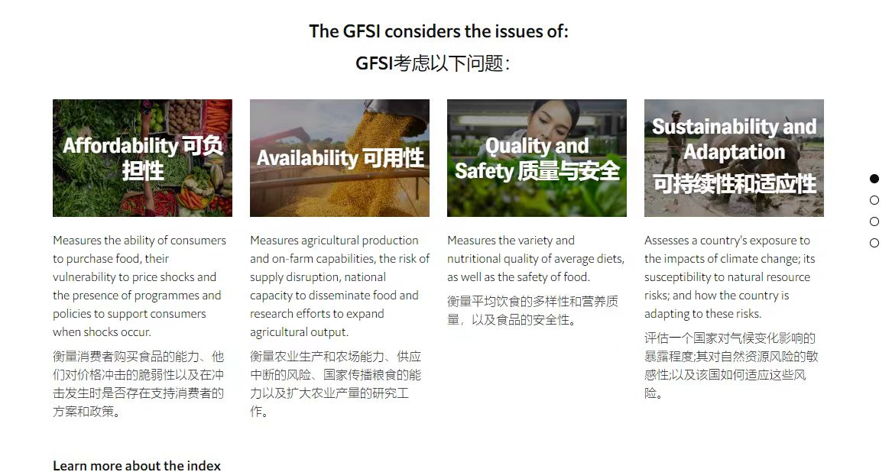

Just need to complete the first three milestones in the pictures.

For case study 2, milestone 4 is about learning outcome 9, which will be covered in week 11 and onwards, whereas the case study submission is in week 10. For this reason, it is decided to make it optional and future work; hence, it is up to you whether to submit it as part of your case study 2 report. If you include it in your report, it will not be considered in the word count or any references under milestone 4's section.

Below are some Q&A

