Supply Chain Analytics Group Assignment Planning

2 Scenario

2.1 Description of Case Study

* Berlin Brewery – Berlin beer brand
  + Small, traditional, handmade beer
* Currently have 1 brewery (factory) and 1 DC (distribution centre) in Berlin
* They have 50 customers in 8 countries
* Problems:
  + German beer market (primary market) has the highest sales – characterised as a mature market with strong prices and pressure from competition
  + A sales crisis has been ongoing for years and competition is intensifying as a result of consolidation processes implemented by international brewing companies
* Context:
  + Trend of beer brands in Germany is rising, although consumption is decreasing
  + Market for beer products and the German brewing industry charactered by strong prices and competition
  + The supply chain of a brewery is highly complex

2.2 Problem Statement

* Currently, the berlin brewery’s brewhouse consists of 5 tanks with total capacity of 20hl
* Demand for beer is rising – berlin brewery has the option to expand its brewhouse with more tanks
* Whole process from original brewing to finished product requires 4-6 weeks depending on how long each type of beer must be stored
* As location of production in Berlin is small, all beer produced stored in the only DC in Berlin
* An external service provider takes care of all logistical requirements
* Currently, most of the beer berlin brewery sells is sold in Berlin
  + Though the beer is also sold to wholesalers all over Germany
* Since 2018, customer locations include Switzerland, Austria, Sweden, Norway, France, Italy, and Spain
* Berlin brewery collaborates with 3 suppliers in Germany who deliver empty beer bottles in crates, as well as the hops and mats
  + Empty bottles in crates are delivered from close to Nuremberg
  + Hops come from Koblenz
  + Malt is delivered by a supply from close to Dresden
* Berlin Brewery’s current sales
* One-off acquisition costs for the brewing equipment is $300,000
* Maintenance costs (including energy and electricity) for the location of factory are $80,000 per month or $2,630 per day
* One beer crate consists of 20 bottles – the whole cost for one crate is $10
  + A product “Beer” in anyLogistix model = 1 beer crate

* Carrying costs (including warehousing costs, handling inside inventory, and inventory costs) are estimated to be $0.005 per beer crate ($0.2 per pallet) per day
* Transportation from Berlin brewery factory to the DCs are calculated as product-distance based transport and costs are $0.00175 per km/beer crate ($0.07 per pallet).
  + Transport from 3 suppliers to the Berlin brewery factory is paid by suppliers
* Inbound & outbound costs are shipment processing costs
  + Outbound costs - $0.66 per beer crate ($26.40 per pallet)
  + Inbound costs - $1 per crate ($40 per pallet)
* Hops and malt are delivered in a 1kg packaging unit: one pallet of malt or hops = 40 packaging units
* Problems that must be overcome:
  + Beer consumption in Germany, Berlin Brewery’s main market, is decreasing and the market as a whole is highly competitive
  + German beer market is mature, nearly saturated market
* Two potential solutions exist:
  + Expansion into other countries or increased sales to existing customers
* Summary:
  + Berlin brewery is to expand their distribution network, serve their customers as efficiently and satisfying as possible, raise their sales numbers, and increase profit
    - This is possible by optimising their SC: an optimal number of DCs as well as good locations for these DCs must be found to save as much logistics costs as possible
    - Loss of quality and delivery problems should be avoided
* Current situation
  + Production is in the center of Berlin
  + Raw ingredients are shipped by truck directly from Dresden, Nuremberg, and Koblenz
  + To store as little as possible, raw materials are delivered on demand and used direction (JIT-just-in-time) for the production
  + The beer is delivered to 50 customers all over Europe

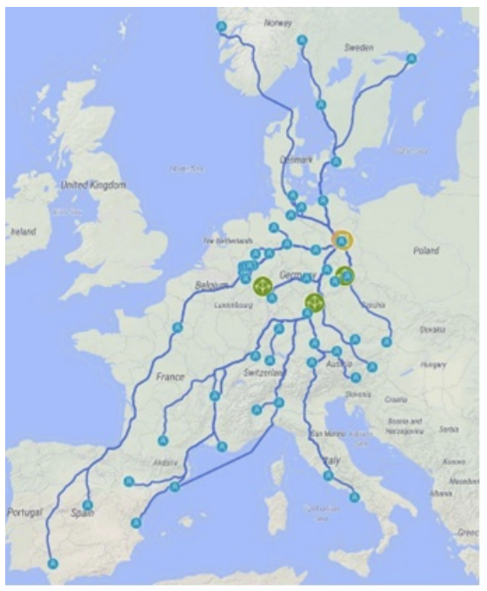

* Assumptions:
  + Main customers are beverage retailers, which purvey to smaller retailers or restaurants
    - Considered that only one wholesaler is supplied per city
    - This wholesaler makes resales independently
    - As a result, no further storage costs are incurred as no further DC is required
  + Transportation to the wholesalers and handling is currently being handles entirely by a logistics service provider as Berlin brewery does not yet have the necessary capacity and occupancy rate for profitable shipment
    - This service provider picks up the goods in the brewery, stores them in their own warehouse, and launches directly to the distributor as needed

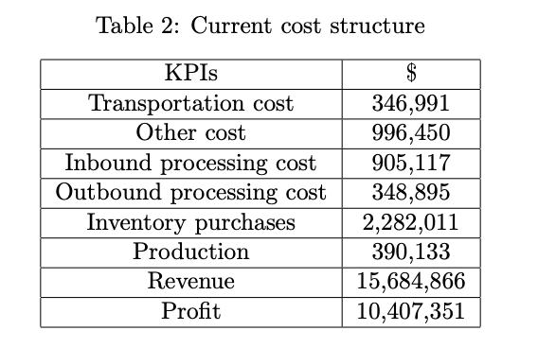

2.4 Network Optimization

* Solutions of the GFA will be taken into account to optimize the SC
* Some of the GFA suggested locations are moved due to additional factors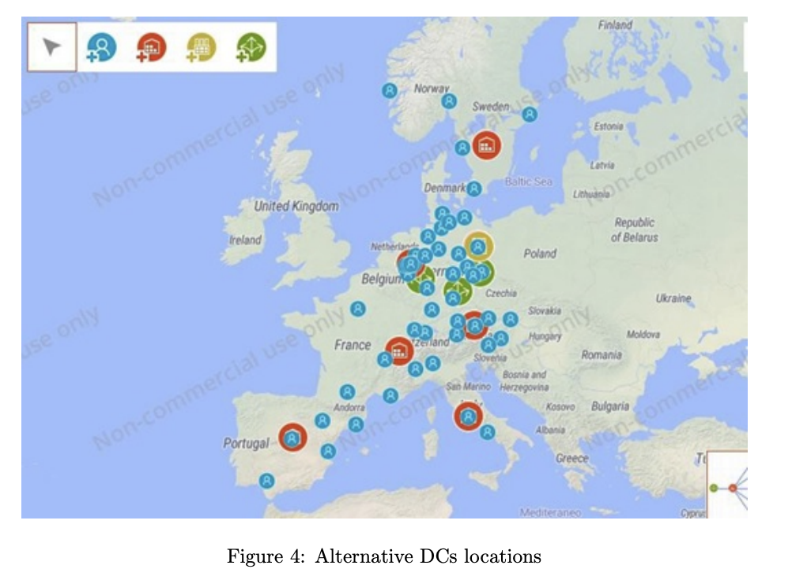
* NO goal is to find the SC design with the highest possible profit
* To define the NO problem from a math perspective, several parameters must be input as data
* Each of the DCs has an inventory capacity of:
  + Minimum 5,800 beer crates
  + Maximum 11,600 beer crates
* The brewery can:
  + Stock 10,000 crates max
  + Carry an inventory of at least 5,000 crates
* Customers and their demands remain the same as in the GFA
* The DCs are now marked as red icons
* Green icons are added to symbolise suppliers of beer ingredients
  + Suppliers are located in Nuremberg, Koblenz, and Dresden
* Figure 5 contains the costs of the sites
  + These numbers have been adjusted to the income ratios of each country. Two of them, Berlin and Bochum, are in Germany, and the overall prices in Berlin are cheaper than in western Germany

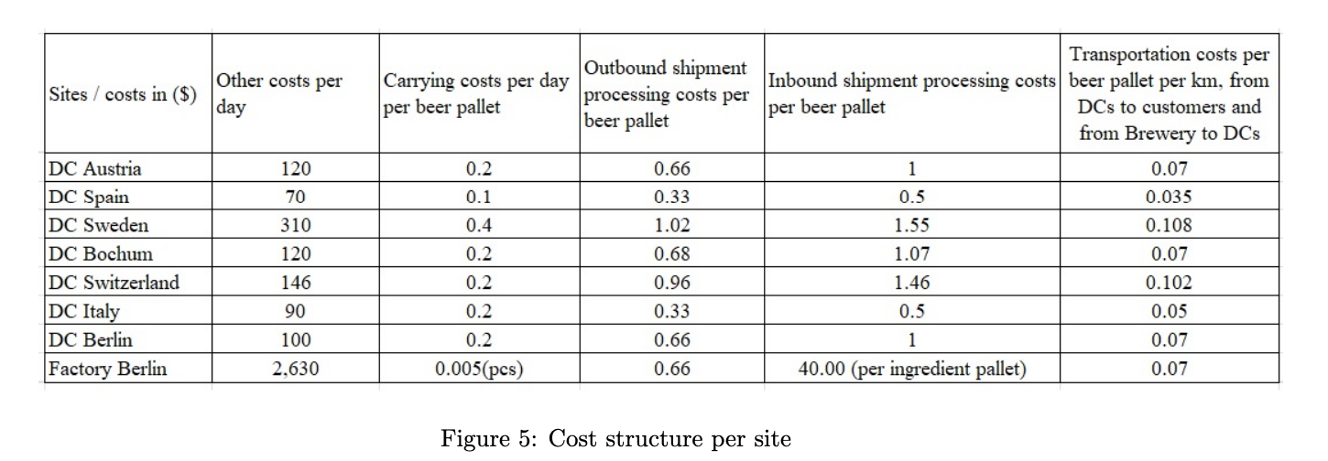

2.10 Important notes and helpful hints

* Do not repeat and write the steps in your report and just write the results of your analysis with corresponding figures, tables, etc. In analysing results you can also use other stats, KPIs and output tables in ALX if you think it is necessary in addition to the aforementioned ones in different steps of the assignment
* Develop your own diagrams
* Do not get bogged down analysing numbers – focus on the key strategic, tactical, and operational issues you can identify. The organisational strategy will influence their capacity, inventory, and other operational decisions in supply chain management.
* Do not use descriptive sentences and paragraphs. Instead be critical and provide insight. Constantly ask yourself ‘why’ they do what they are doing and ‘what if’ they change
* Audience of the report is senior management
* Record minutes and include these as part of your submission (use an appendix). There should be evidence of discussions, disputes, and resolution of problems

2.11 General guidelines for writing final report

* At least 10 peer-reviewed publications to support your report
  + Need to also read and refer to non-peer reviewed documents such as books, trade journals, and articles to substantiate your discussion
* 4000-4500 words – this includes only the body of the report excluding executive summary, tables, figures, diagrams, cover page, table of contents and references
* Size 12, Font Times New Roman. Double-spaced. Margin 2.54 cm all around
* Chicago referencing style
* Use illustrations, diagrams, charts and table to enhance your report

1. How can you validate the simulation modeling results using the previous network optimization experiments?