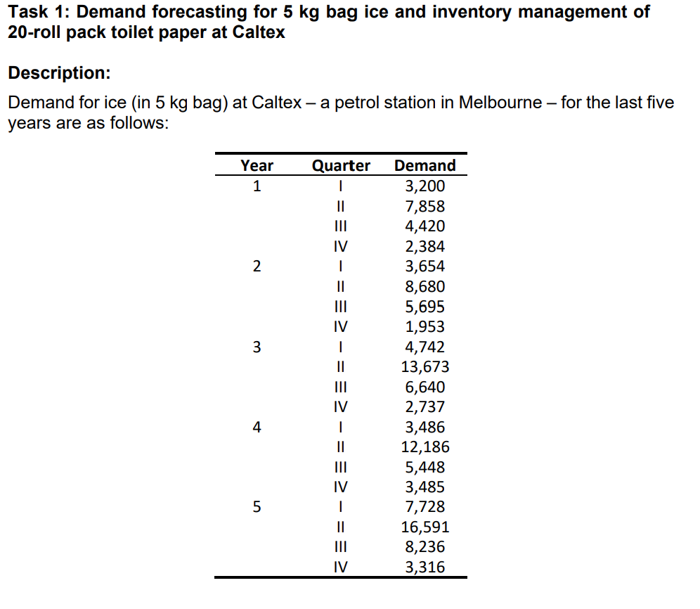

**Task Questions to be done in Excel:**

a) Estimate the demands for Quarters I, II, III, and IV in Year 6 using a 3-quarter

moving average method.

b) Estimate the demand for Quarters I, II, III, and IV in Year 6 using the static

method.

c) Evaluate the MAD, MAPE and TS (i.e., the KPIs) in each case and compare

them in the format as shown below.

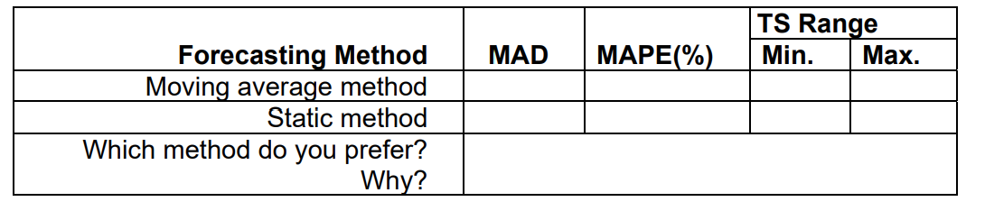

d) Based on the findings from (b), which of the two methods do you prefer? Why, using answers from (c)?

**Task Done in Word**

e) Caltex also sells toilet paper (in 20-roll pack), among other things. The average

demand is 1,500 packs each month The petrol station incurs a fixed order

placement, transportation, and receiving cost of $200 each time an order is placed

with the supplier. It also incurs a holding cost of 10 per cent of the unit cost of the

product. The normal wholesale price is $8 per pack. Recently, the supplier offered

all-unit quantity discount to Caltex to promote sales. The price schedule is as

follows:

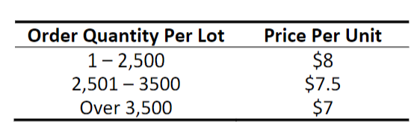

1) What is the economic order quantity (EOQ) of 20-roll toilet paper packs per lot

for Caltex if there is no volume discount?

2) What is the total annual cost for Caltex assuming there is no volume discount

from the supplier and the price per pack is $8?

3) What is the optimal order quantity if Caltex decides to take the volume

discount? You need to show the calculations of EOQs and total costs at all the

three prices.

4) What is the new total annual cost for Caltex upon taking the volume discount?

5) What is the annual saving for Caltex upon taking the quantity discount in

comparison with the normal situation when there is no volume discount?

f) Conduct your own research and find out what the sanitary paper product

manufacturing industry usually does in forecasting demand. You may wish to

analyse and discuss based on product value, product volume, and product flow

as different product characteristics may require different methods to forecast the

demand accurately. Give examples and use up-to-date references to support

your arguments.