Assignment 1

Deadline: Day 17/07/2024 @ 23:59

**[Total Mark for this Assignment is #]**

**Introduction to Database**

**CS350**

**Instructions:**

* You must submit two separate copies **(one Word file and one PDF file)** using the Assignment Template on Blackboard via the allocated folder. These files **must not be in compressed format**.
* It is your responsibility to check and make sure that you have uploaded both the correct files.
* Zero mark will be given if you try to bypass the SafeAssign (e.g. misspell words, remove spaces between words, hide characters, use different character sets, convert text into image or languages other than English or any kind of manipulation).
* Email submission will not be accepted.
* You are advised to make your work clear and well-presented. This includes filling your information on the cover page.
* You must use this template, failing which will result in zero mark.
* You MUST show all your work, and text must not be converted into an image, unless specified otherwise by the question.
* Late submission will result in ZERO mark.
* The work should be your own, copying from students or other resources will result in ZERO mark.
* Use **Times New Roman** font for all your answers.

Student Details:

|  |  |  |
| --- | --- | --- |
|  |  |  |
| **Name:** ###  **CRN:** ### |  | **ID:** ### |
|  |  |  |

# Question One

***3 Marks***

*Learning Outcome(s):3*

Create Entity-Relationship model, Relational model, and write SQL queries.

**Library Management System**

**Scenario:** You are tasked with designing a database for a library management system. The system needs to track books, authors, members, and book loans. The requirements are as follows:

* Each book has a unique ISBN, title, publication year, and genre. A book can have multiple authors.
* Each author has a unique author ID, name, and nationality.
* Each member has a unique member ID, name, address, and membership date.
* Each loan records the loan of a book to a member and includes the loan date and return date.
* Authors can write multiple books, and a book can have multiple authors.
* Members can borrow multiple books, but a book can only be borrowed by one member at a time.

Given the scenario above, design the relational schema for the library management system. Identify the tables, their attributes, primary keys, and foreign keys. Explain the constraints you would apply to ensure data integrity.

# Question Two

***3 Marks***

*Learning Outcome(s):3*

Create Entity-Relationship model, Relational model, and write SQL queries.

Based on the library management system scenario, create an Entity-Relationship (ER) diagram. Include entities, relationships, attributes, and keys. Explain the design choices for the relationships and any constraints applied.

# Question Three

***3 Marks***

*Learning Outcome(s):3*

Create Entity-Relationship model, Relational model, and write SQL queries.

Extend the ER diagram created in Module 4 to include subclass and superclass relationships. Specifically, include subclasses for different types of books (e.g., Fiction and Non-Fiction) and different types of members (e.g., Student and Faculty). Explain the rationale behind your design choices.

# Question Four

***3 Marks***

*Learning Outcome(s): 4*

Design a database starting from the conceptual design to the implementation of database schemas.

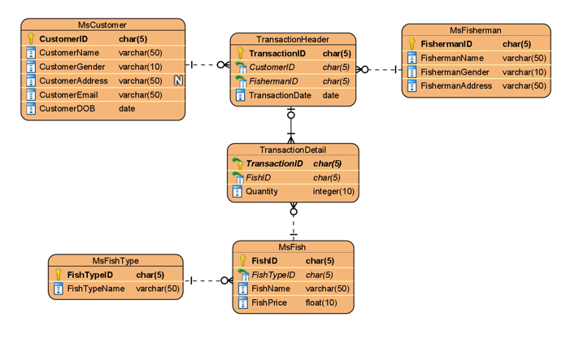Based on the given ERD, create two tables one for the relations metadate and the other for the columns metadata (for TransactionDetail, MsFish, and MsFishType) in a simplified database catalog.

# Question Five

***3 Marks***

*Learning Outcome(s): 1*

*Explain the concepts and architectures involved in the database development.*

Using your own words, explain the advantages of the Three-Tier Client-Server Architecture over the Three-Tier Architecture in terms of security, scalability, and data integrity.

.