NBP2 — NBP2 Task 1: Critical Analysis

Current and Emerging Technologies — C962

Requirements

Your submission must be your original work. No more than a combined total of 30% of the submission and no more than a 10% match to any one individual source can be directly quoted or closely paraphrased from sources, even if cited correctly. An originality report is provided when you submit your task that can be used as a guide.
You must use the rubric to direct the creation of your submission because it provides detailed criteria that will be used to evaluate your work. Each requirement below may be evaluated by more than one rubric aspect. The rubric aspect titles may contain hyperlinks to relevant portions of the course.
Critical Analysis for Each Topic
Write a critical analysis for each of the three books you have selected related to the corresponding topics.
- Summarize each trend and its impact on society as supported by each publication.
- Summarize risks described in each publication that are associated with each trend’s implementation, including the likelihood, severity, and mitigation strategies for each of the risks identified.
- Describe how each trend applies to the experiences you have had in your academic or professional life.
- Justify how aspects of each trend can be implemented in an organization, using research to support your claims.
- Identify the indicators of successful application of each trend, including any organizational strategies, goals, or key performance indicators (KPIs) that would be positively affected if the trend were successfully implemented in an organization.
- Evaluate the short-term benefit or long-term application, the level of market applicability, and organizational relevance for each trend, providing details from each publication to support your claims.
- Acknowledge sources, using in-text citations and references, for content that is quoted, paraphrased, or summarized.
- Demonstrate professional communication in the content and presentation of your submission.
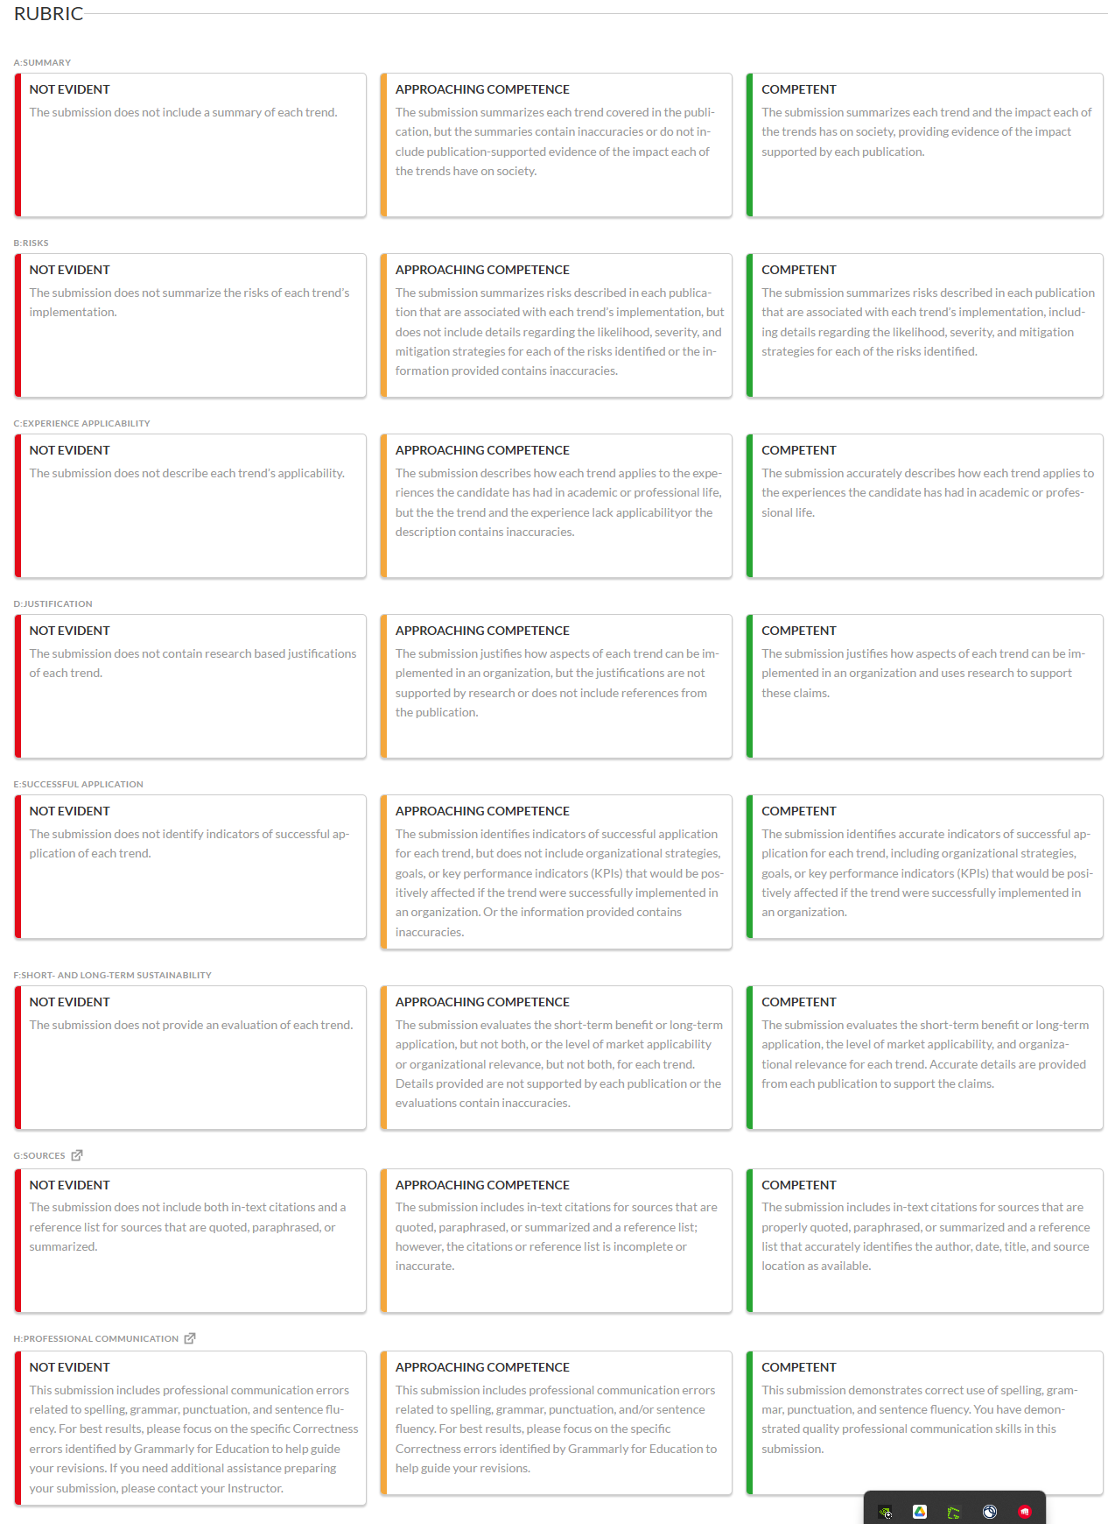

C962 Current and Emerging Technologies: NBP2 Books

Organizational Leadership
- All-In on AI: How Smart Companies Win Big with Artificial Intelligence
- The AI-Savvy Leader: Nine Ways to Take Back Control and Make AI Work
- The Front-Line Leader: Building a High-Performance Organization from the Ground Up
- Rocket Man: Elon Musk In His Own Words
- Digital Wars: Apple, Google, Microsoft and the Battle for the Internet – 2nd edition
- Disruptive Leadership

Principles and Processes
- Emerging Technologies in Business: Innovation Strategies for Competitive Advantage
- Systems Thinking for Business and Management: Principles and Practice
- What to Do When Machines Do Everything: How to Get Ahead in a World of AI, Algorithms, Bots, and Big Data
- Building the Internet of Things: Implement New Business Models, Disrupt Competitors, Transform Your Industry
- Leading Change

Technologies

- Internet of Production: Fundamentals, Methods and Applications
- The Future Is BIG : How Emerging Technologies Are Transforming Industry and Societies
- Disruptive Technologies
- The Second Machine Age - Work, Progress and Prosperity in a Time of Brilliant Technologies
- The Innovator's Dilemma: When New Technologies Cause Great Firms to Fail

- Transform: How Leading Companies are Winning with Disruptive Social Technology

