**PPD583 – Risk Analysis**

**Instructor: Ali Nowroozi**

**Fall 2024**

**Homework Assignment #2**

**DUE: 10/06/2024 11.59 PM**

**(30 Points)**

**Instructions:**

1. Answer all the questions in this file. Do not delete the questions. Type in your answers below the question, using the sample structure (if provided)
2. We expect precise and succinct answers. Add citations, references, and screenshots wherevernecessary.
3. Follow the deadline for submission. Late submissions will not be accepted and will receive azero.
4. Name the file as the **last four digits of your USC ID**and submit it **as aPDF(1) File**. (For Example, if myUSC ID is 123456789, the file name becomes: 6789.pdf).**Do not put your name anywhere on this document or on the file name or you will lose 2 points**.
5. Not following the instructions will result in penalties.
6. *To convert this document to a PDF file, go to “file”, “save As”, choose “PDF(*.PDF)” and the file will be saved at the same location as your WORD file.*

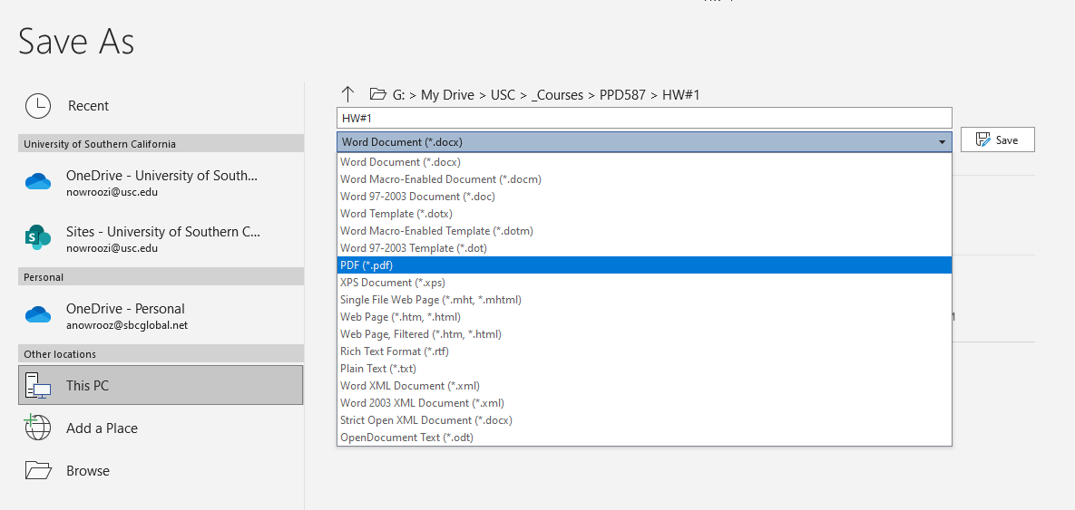

1. Which pair of possibilities is “Mutually Exclusive”, but not “Collectively Exhaustive”? Draw the correct MECE diagram (**for the answer only**) from the attached model.
   1. The temperature outside is: under 10 oC , Over 20 oC
   2. The temperature outside is: under 20 oC , Over 10 oC
   3. The temperature outside is: under 20 oC , Over 20 oC
   4. The temperature outside is: under 10 oC , Under 20 oC

***Tip: Refer to Lecture 2-Slide 16, also see the attached models***

1. Sara has three coins which you believe to be fair, and are labeled #1, #2, and #3. Suppose Sara flips all three coins and tells you that **at least** 2 of them landed heads. Given that you believe each coin's probability of landing heads is ½ and it is irrelevant to how the other coins land, use an event tree model with all consequences listed to show that the probability that coin #1 landed on Head is ¾.

***Tip: flipping 3 coins is the same as flipping the same coin 3 times, for the purpose of this experiment. So, you can use our model in slide 22 of lecture 3. No equation is necessary, just count the outcomes with the desired features.***

1. What is the probability of drawing 2 Aces from 52 cards?

***Tip #1: The probability of one item in a group of N items is 1/N***

***Tip #2: This is the probability that the first card is an ACE (say event A), AND the second card is an ACE (say event B) 🡺 , but A & B are independent so P(B|A) = P(B)***

1. Use Bayesian law to show that **there is a 64% chance** that a driver who is over age 35 wears a seat belt regularly in the following scenario:

***ABC Insurance Co. estimates that 80% of drivers wear seat belts regularly. They also estimate that 50% of drivers are over age 35. A study showed that 40% of those drivers who wear seat belts regularly are over age 35.***

***Tip: Event A = Wear Seatbelt, Event B = Over age 35, find P(A|B)***

1. See attached a fault tree example with calculations. Identify a **different** problem on your own, develop a **simple** fault tree (with less than 10 nodes, like the attached example) and assign some probabilities to each node and calculate the overall probability of the event (e.g. a house getting on fire in one year in UK). Now investigate the actual probability data on the internet (e.g. [this](https://locket.insure/expert-advice/house-fires-are-more-dangerous-than-they-used-to-be/#:~:text=Considering%20there%20are%20~24%20million,chance%20in%20an%20entire%20lifetime.) is what I found for my example). If you see a big difference, revisit your assumptions on the individual probabilities, adjust them, and explain your adjustments briefly.

***Tip #1: If you model your problem in Excel, the adjustments will be very easy and quick***

***Tip #2: In the example, P(A ꓴ B) is calculated differently. Please ignore this method and use the simple formula discussed in the class: P(A ꓴ B) = P(A) + P(B) , A and B are independent***

*Source:* [*https://careerinconsulting.com/wp-content/uploads/2021/03/Capture-MECE-Diagram-1024x577.png*](https://careerinconsulting.com/wp-content/uploads/2021/03/Capture-MECE-Diagram-1024x577.png)

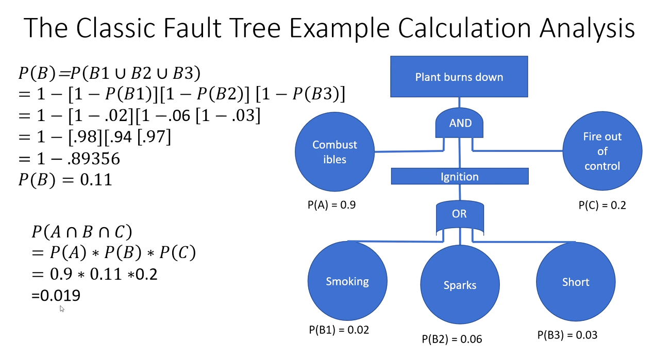

*Source:* [*https://youtu.be/Eq8-m6Faobo?si=MGm9iGOLQJb-FNV8*](https://youtu.be/Eq8-m6Faobo?si=MGm9iGOLQJb-FNV8)