Professor Forbes
September 15, 2022
Card Sorting Exercise
APGFCU Mortgage Sign up:
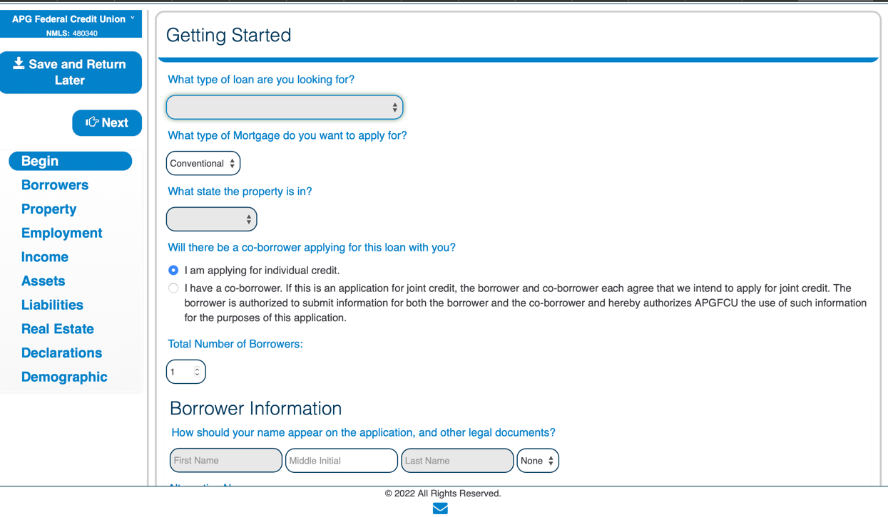
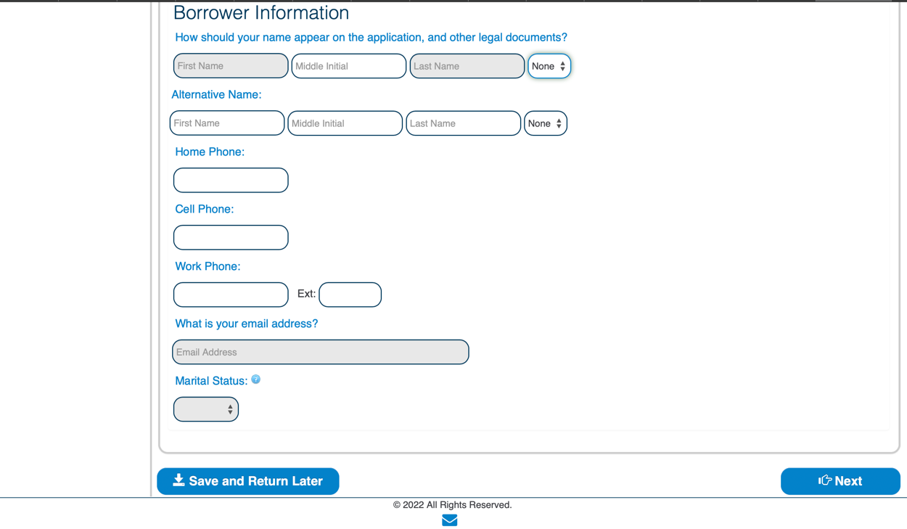
Drop Down Options:
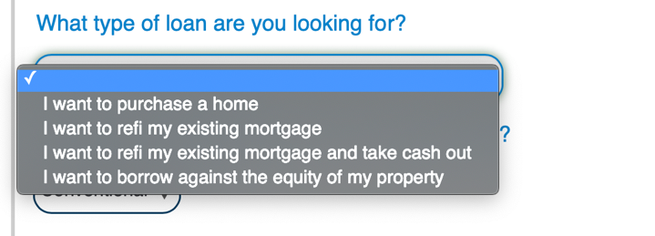
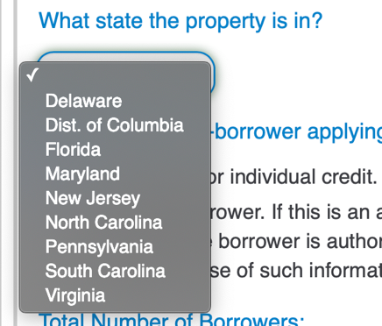


For this assignment, I selected the APG Federal Credit Union Mortgage application through the APG website. I think the form, although simplistic, is not detailed enough to show the user filling this application out what they are getting themselves into. I think the form was more designed for an older audience, while that may not be a bad thing, this can frustrate younger audiences and force them to go to another website that is not as simplistic. I also just think that website looks outdated, it reminds me of basic HTML and has little to no JavaScript incorporated into the website, which would actually not be adding to the simplicity aspect of the website. I don’t like how the form makes the user get sent to a new tab every time they click an option, or the design. Overall, I think the website is just very outdated.
Card Sorting Exercise
Card Sorting Color Key:
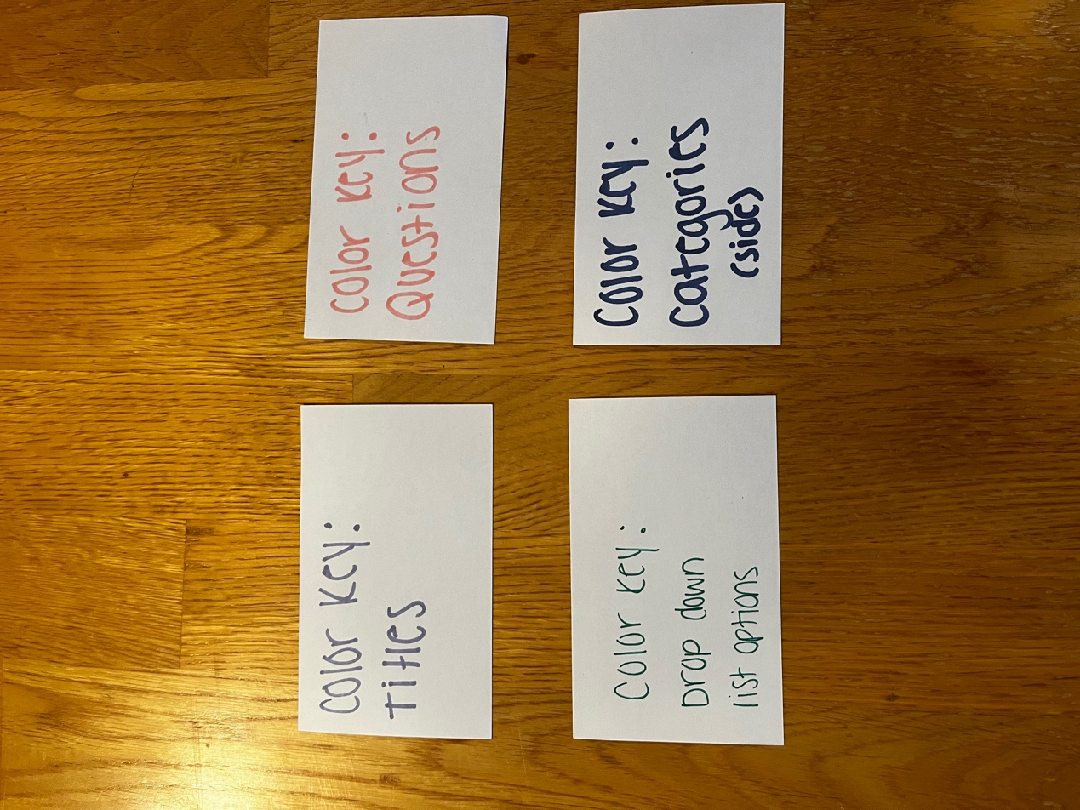

Card Layout in alignment with current form:
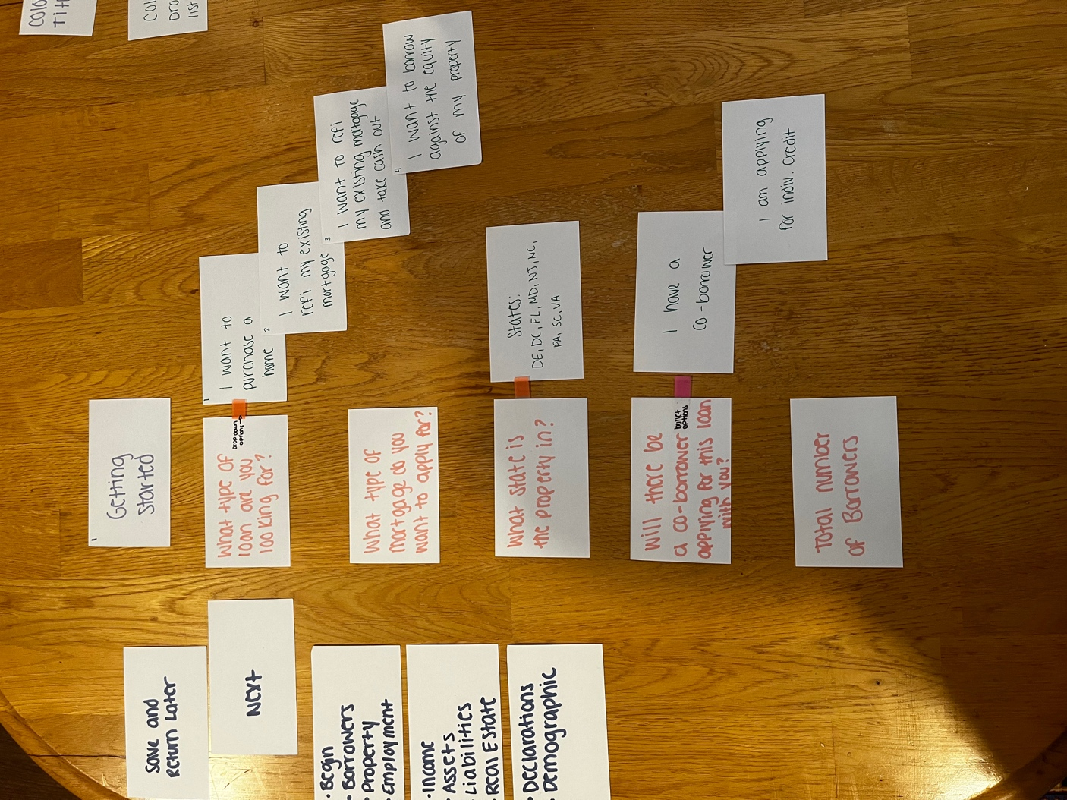
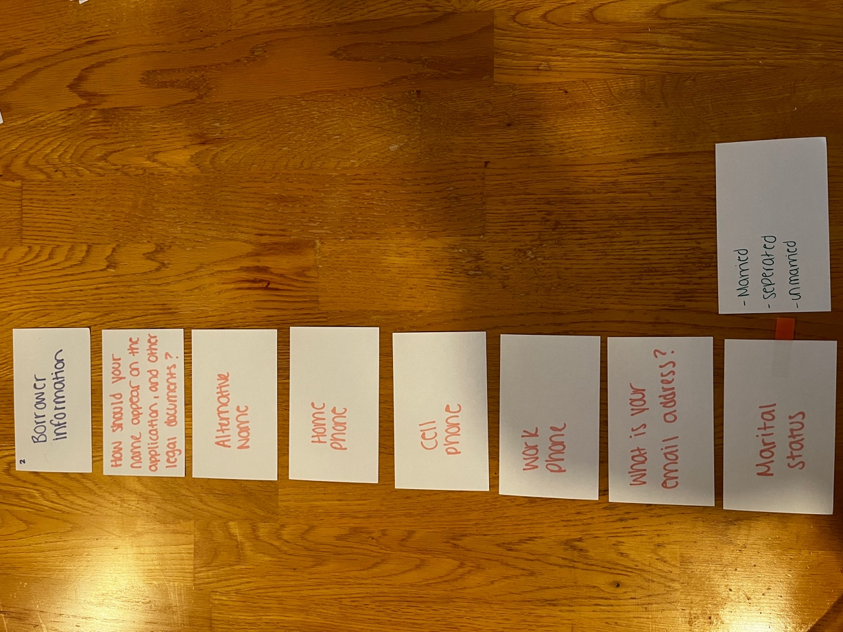

Card Sorting Feedback User one:
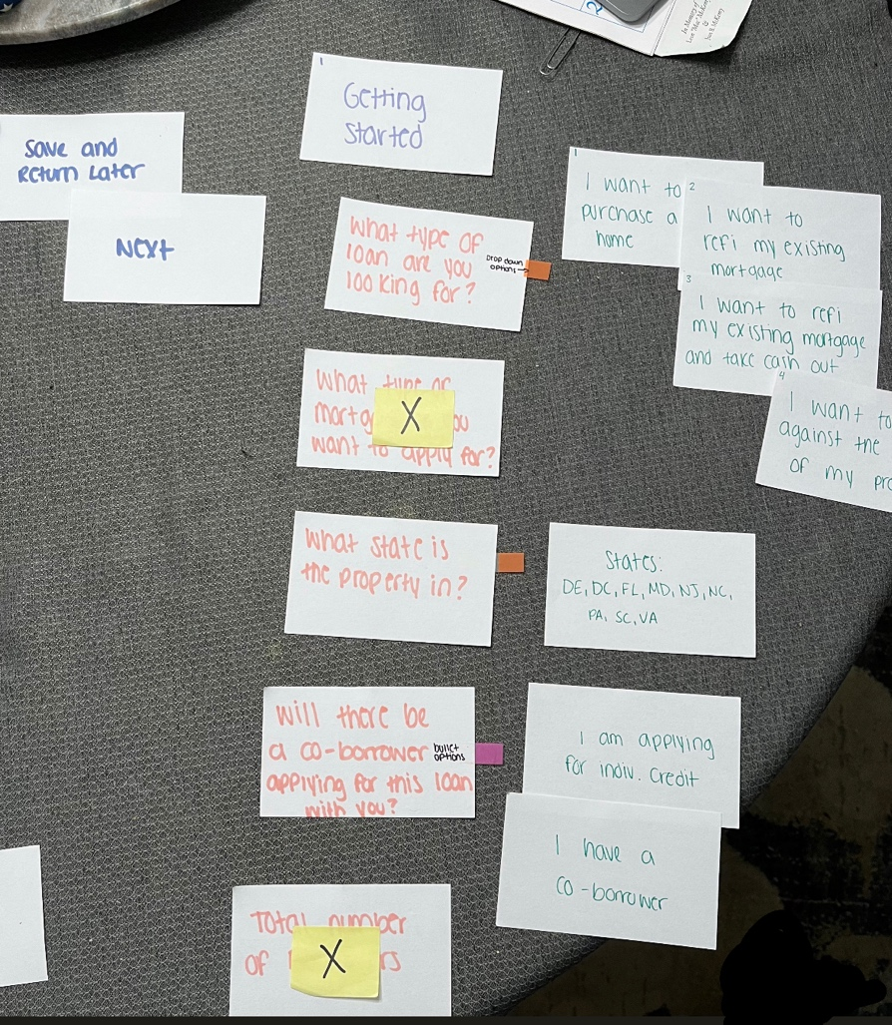
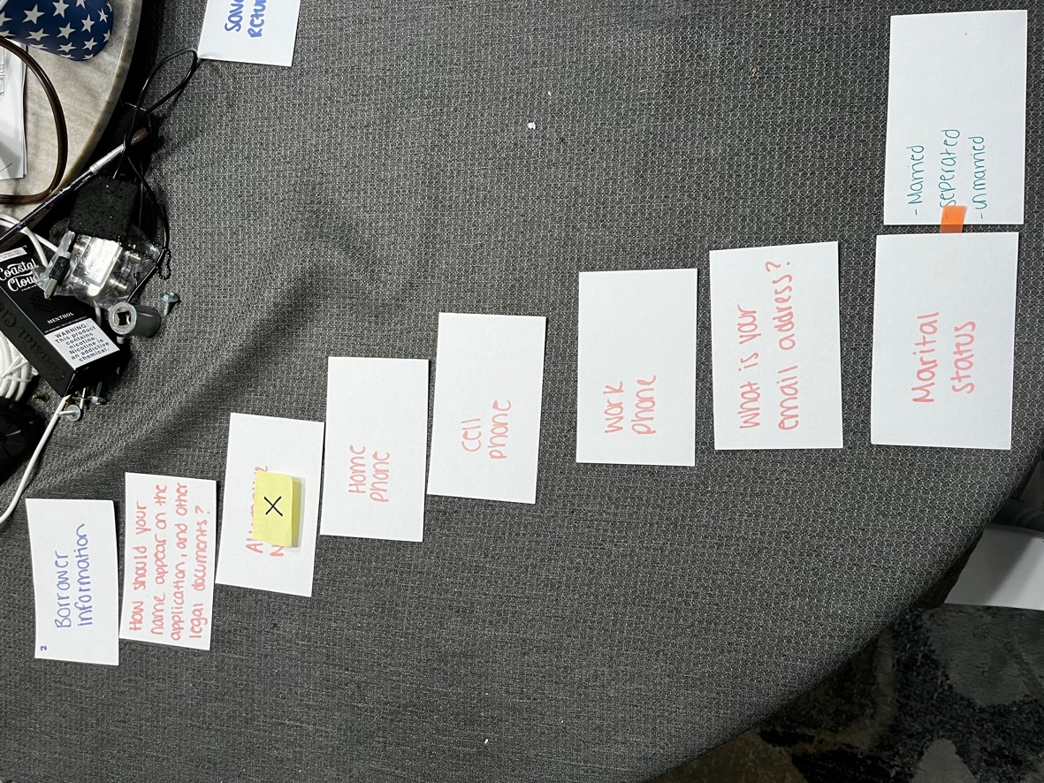
User 1 comments about the interface:
“Pretty simplistic, some options were a bit repetitive in my opinion. I think that side bar was a bit too much for the application, I like to focus on one thing at a time when filling out an application. Overall I liked the website.”

Card Sorting Feedback User 2:
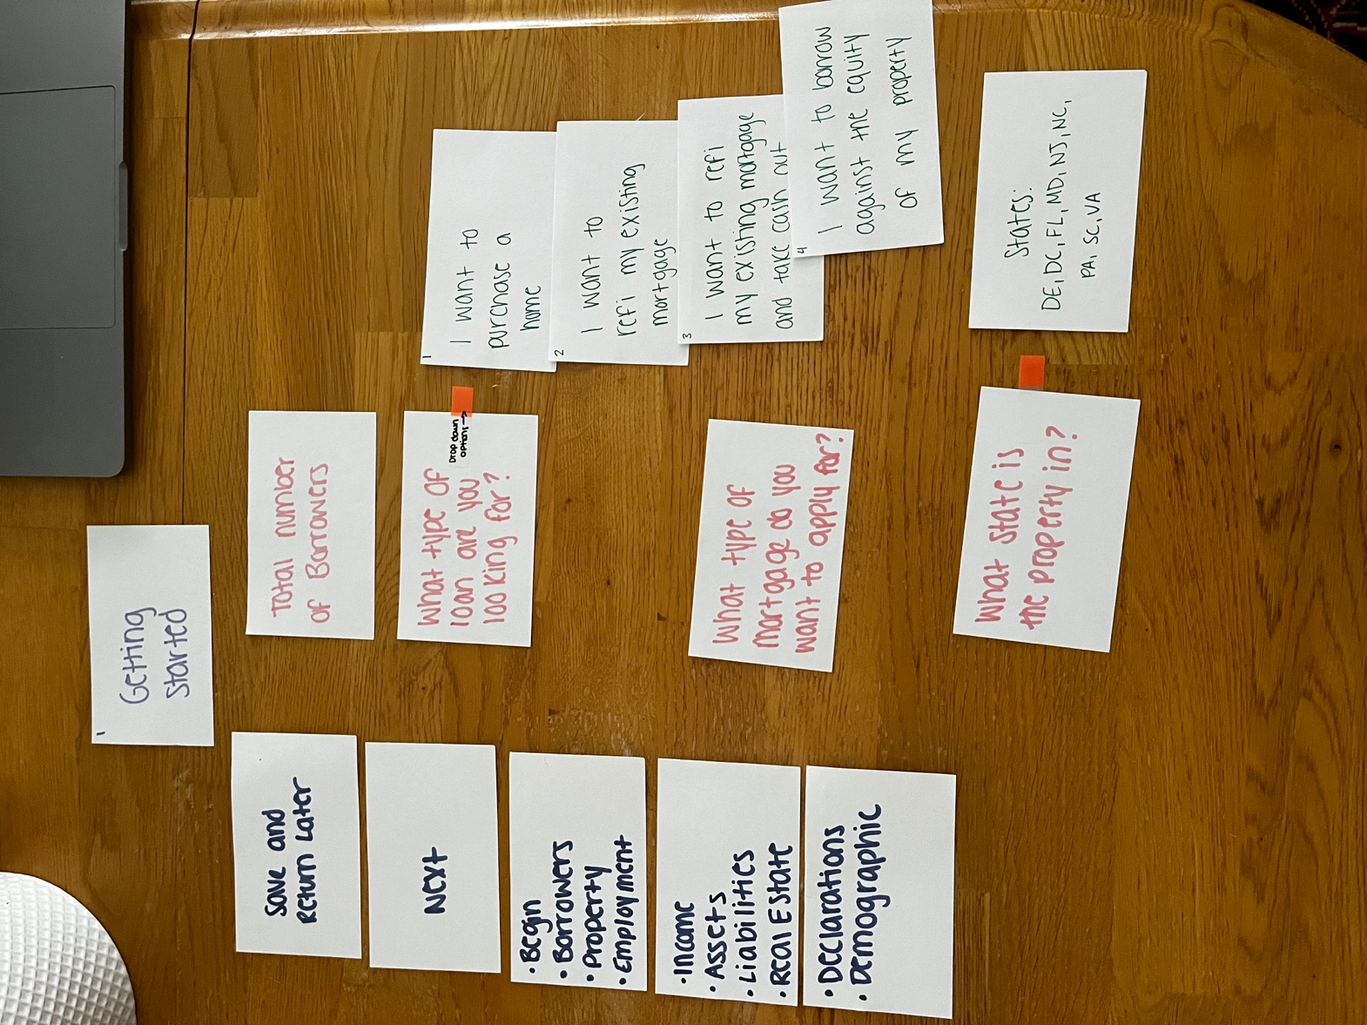
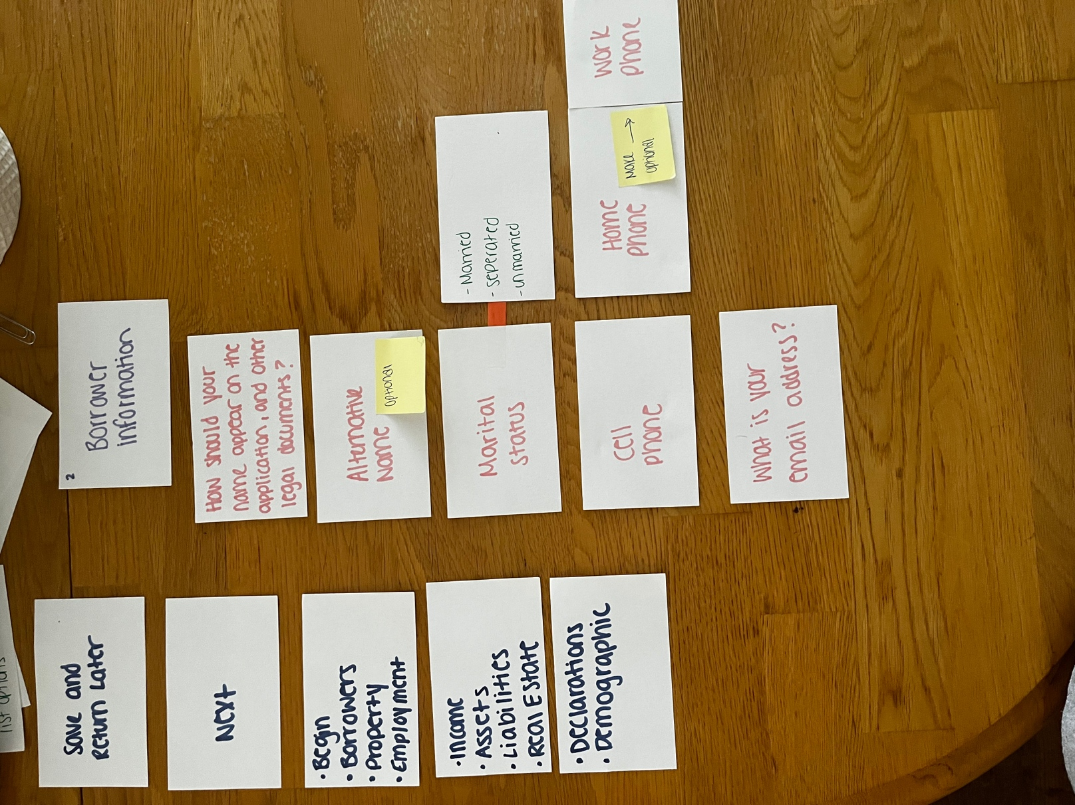
User 2 Comments:
“I don’t like the overall design because it doesn’t follow more complex and it’s not as technical as I would like for it to be. I also don’t like how the side tab doesn’t follow the user when they scroll down. Some things are not optional either, and I think they ought to be.”
Card Sorting Exercise Overall:
I performed the card sorting exercise by putting on the cards everything that was important to the user, such as the options, the questions, and the sidebar menu. I did not add the unnecessary details such as some of the excessive tabs and such. The typical user for this website would be within the older demographic. The main reason I believe this is because the website itself is very simplistic, the boldness in the text, the ease of design, a lot of things are in factor for the older generation to be at sort of ease for this mortgage website. Overall, I learned from the card sorting that the website is overall pretty simple, but repetitive in ways. I liked the card sorting because I could see from a different point of view.

Redesigned Form:
Got rid of APGFCU here because it looked sloppy
Moved it up here
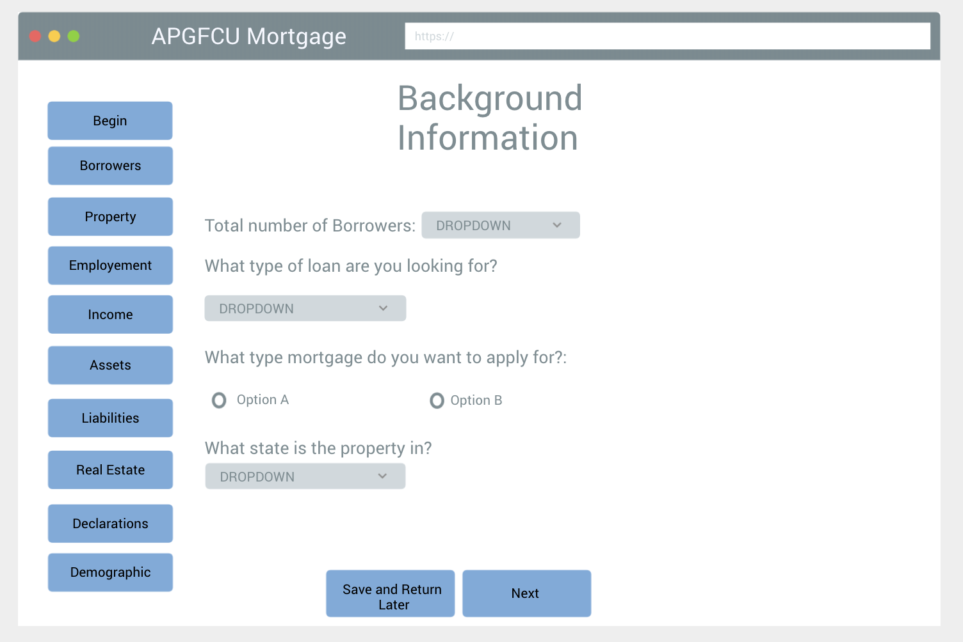
Put these at bottom for more simplistic approach
When you scroll, side bar follows you
Organized website better
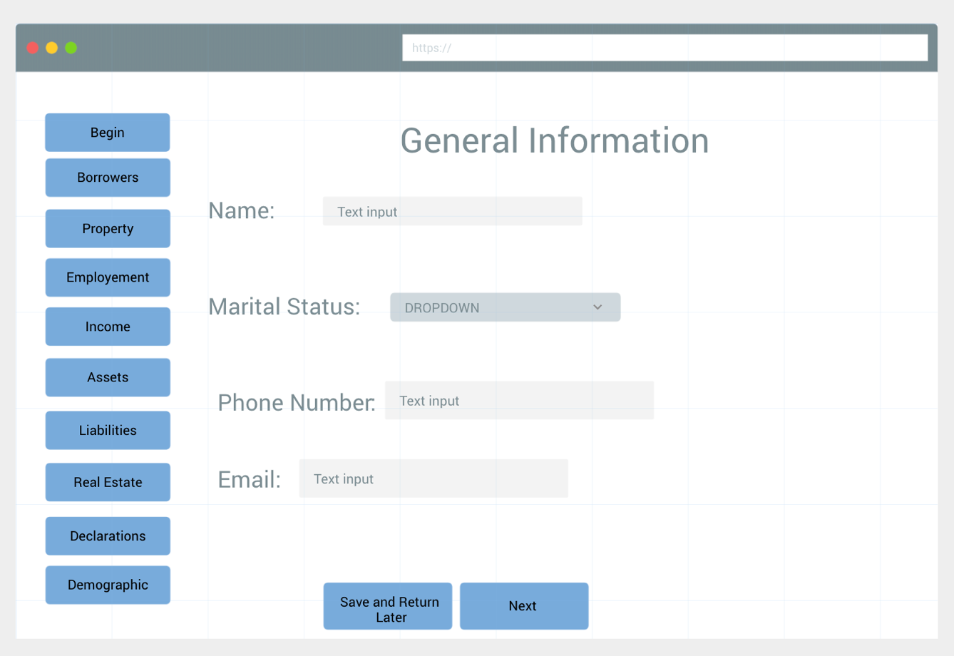
Most only have 1 phone number
Prototype Drawing Reasoning:
Specific improvements made on this website are as follows: the questions for the user are less cluttered, and are more spaced out for the user to focus on one at a time. I also changed the side bar to follow the user wherever they go, this was actually brought about by user 2 in their feedback, and I agreed that it is something that should be implemented in the design. I got rid of the multiple phone numbers, as I felt that it was a bit repetitive, especially if the user only has one phone number. Put the save and return and the next option also at the bottom, to have some ‘empty’ space to make side bar options a bit bigger. Also moved the name/logo to the top of screen, to avoid taking up even more space on the actual website itself. Overall, I would be more likely to use my website, because its less repetitive and more so designed for simplicity.

