Q1:
1.1:
The non-functional requirement is Availability. The streaming service is to ensure that users would be able to access the service all the time and the goal is for the uptime 99.9% for the user satisfaction, as the downtime could be crucial for the users satisfaction and company negatively.

1.2:
This non-functional requirement can be restated as, 99.9% should be achieved on uptime by the system of the online streaming service. Which make sure the users will be able to use the service all the time with no issue with less downtime for the maintenance or unexpected errors. This will increase the satisfaction of the users which will reflect positively toward the company

Q.2:
2.1:
Budget Limit: The total cost for building, launching, and maintaining the system must stay within a budget of $100,000. This includes expenses for software development, licensing, streaming setup, security, and marketing.
2.2:
1:
All users must create an account with there name, email address and payment information. A creating the account the user have to conform the account by the email they received.
Type: Business process
2:
The discount should be based on if the customer regular on new user. The regular user has rented before 5 or more times and should be eligible for the 10% discount for the new purchase. The user who has rented less than 5 times will charge the full amount
Type: Business rule
3:
The single user should be able to stream the movie on one device at the time, if the customer is currently streaming the movie on his phone, he can’t stream it on another device, unless he stope streaming on the device and started to stream the movie on another device.
Type: Business Rule

4:
The user can add the movies to his cart. In the cart can continue to rent the movies or delete the a movie then procced to complete the payment and receive the movies he added to the cart.
Type: business process

2.3:
1:
The interface should be easy to use and have a clear button logo, such as home page logo should be a home, cart should be cart and the account should be a person, so the user can easily understand
Type: NFR, Look-and-Feel
2:
The payment process should be completed in 5 seconds.
Type: NFR, Performance
3:
All movie listed must be legal to stream by the regulation of the Minatory of Media.
Type: NFR, Legal
4:
The system must encrypted the user date for the unauthorized users.
Type; NFR, security

2.4:

2.5:
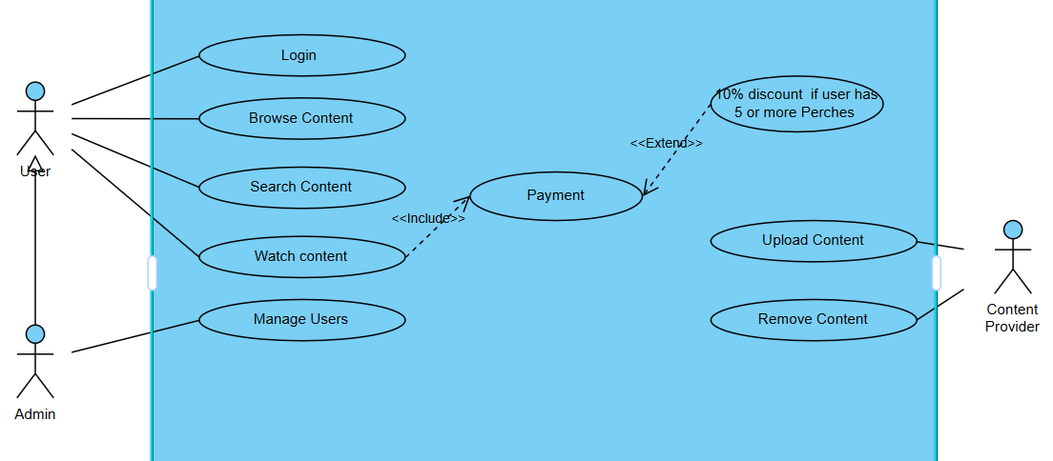
2.6:
I have used two <<include>> and <<extend>>, the <<include>> used for payment to watch contact, which indicate that to what the content you have to finish payment to procced with what the content, which make is it essential to start the watch content case.
The <<extend>> used for payment to 10% discount for users has 5 or more parches. In that case the this is optional and we can procced with the payment case without the extend case, but we use apply 10% in case the condition were applied.
The Stereotypes helps with clarity. The Stereotypes helps the stakeholders to have idea of the dependencies and optional on structure way, and help to understand the essential and optional actions.
Also the Stereotypes helps the developers to modify or updating the actions without changing the main functions, for example, we can remove or change the discount without disrupting the watch contact. Also we can make the watch contact for free just by removing the payment .
2.7:
- Identifier and Name: Watch Content
- Initiator: User
- Goal: Watch content on the streaming service website.
- Preconditions:
  - The user must be logged in to his account.
  - The user has browsed for the contact to watch .
- Postconditions:
  - successfully streaming the content.
- Assumptions:
  - The streaming with no technical issue.
  - The user has a stable internet connection.

Main Success Scenario:
- The user selects content to watch from the browsing.
- The system checks if the user has successfully completed the payment.
- If the user meets the requirements, the system initiates the streaming process.
- The content start streaming, and the user is able to watch the content with no issue.

Extensions :
- User payment failed:
  - The system prompts the user to the payment has failed and try to pay again.
  - The user can choose to pay again, after which they are redirected to watch the content.
- Technical issue in streaming:
  - The system prompts an error if it detects an issue (e.g., poor connection).
  - The user can choose to retry.

